ABMU doctors to help run medical clinic in refugee camp tent
Friday, 30 June 2017
Two ABMU doctors are flying to Turkey to provide medical aid to thousands of people in a refugee camp near the Syrian border.

Zubair Wani and Haroon Ali, both from Swansea, will spend six days in the Adana camp as part of a humanitarian mission with the United Aid Network.
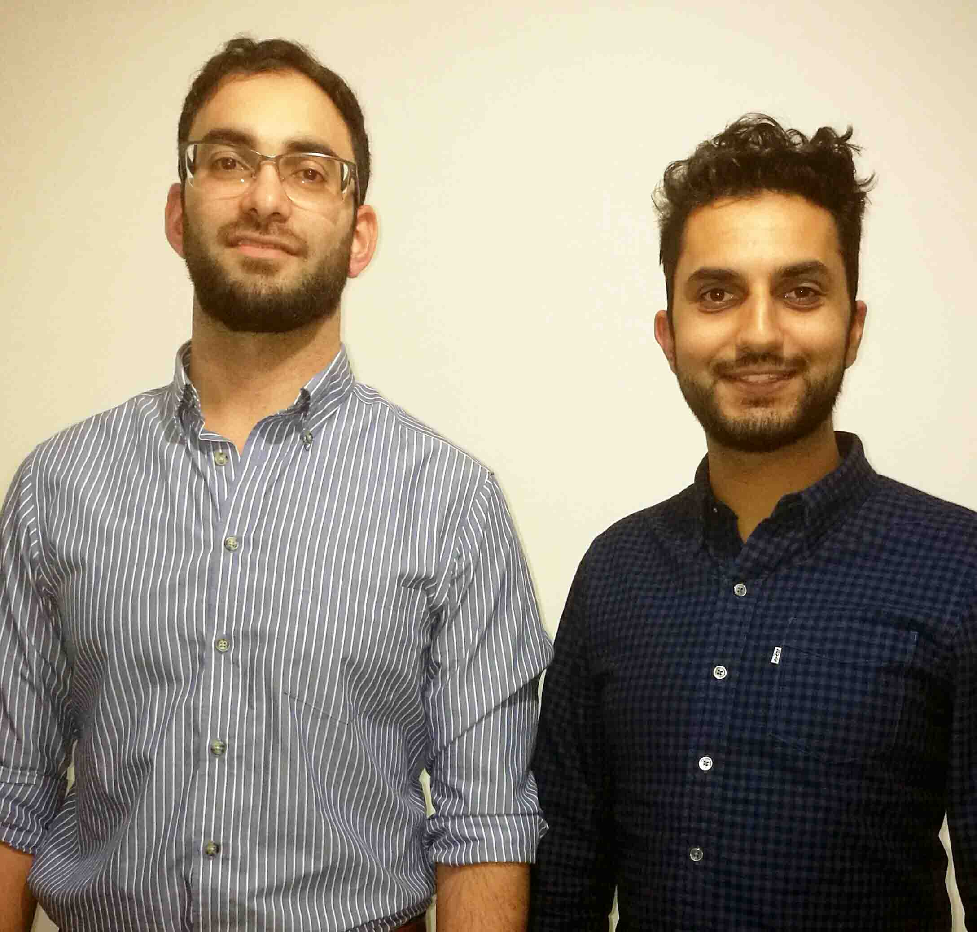
They fly out next Thursday (July 6th) and will set up a small clinic in basic conditions with limited supplies.

United Aid Network, a non-profit organisation, will also provide food packs and educational supplies, and undertake sanitation projects including toilet and water system installations to reduce the risk of disease.

Dr Wani (left in picture), a trainee GP currently working in palliative care in Princess of Wales Hospital, and Dr Ali, a junior doctor in orthopaedics in

Morriston Hospital, are going to Turkey in their own time and at their own expense.

They have both been fundraising to help buy medical equipment, antibiotics and other medication, food packages and any other supplies which are in short supply on the ground.

Dr Wani, who is from Swansea but now lives in Cardiff, said: “It’s the first time either of us has been out there.

“One of my friends went in February. I saw some of the work he did and wanted to get involved.

“It’s a very large camp and they rarely see any doctors. My friend went last time and he was inundated because he was the only medic there.

“Hopefully it will be less stressful this time because there will be five medics and two nurses so we will be able to plan things better.

“We will be working in a tent with limited, basic resources, but at least it provides them with more than they are getting now.”

There are now 4.9 million refugees as a result of the Syrian conflict and poverty, poor sanitation and risk of disease are rife in camps such as Adana, which is located in southern Turkey, an hour from the border.

It is home to around 7,000 men, women and children.

Dr Ali said: “These are the most desperate of people, having been forced from their homes in the last six years.

“They have been left in what is essentially a campsite, with no realistic prospect of being rehoused.

“They have no access to jobs and hence rely almost entirely on donations to survive.

“There is a desperate shortage of food, medicines and medical staff.”

Each doctor has up a JustGiving page to raise money for the mission. Dr Wani’s is https://www.justgiving.com/crowdfunding/adana, while Dr Ali’s is https://www.justgiving.com/crowdfunding/medicalaidadana.

The two doctors have also organised cash collections in their respective hospitals.

Dr Ali added: “Please dig deeply and give whatever you can to help those who are desperately in need.”

Source: Abertawe Bro Morgannwg University Health Board

