Summer’s been a ‘baarmy’ and ‘bats’ time for hospitals in Bridgend
Friday, 27 July 2018
Health staff are used to dealing with the unexpected during a normal shift.
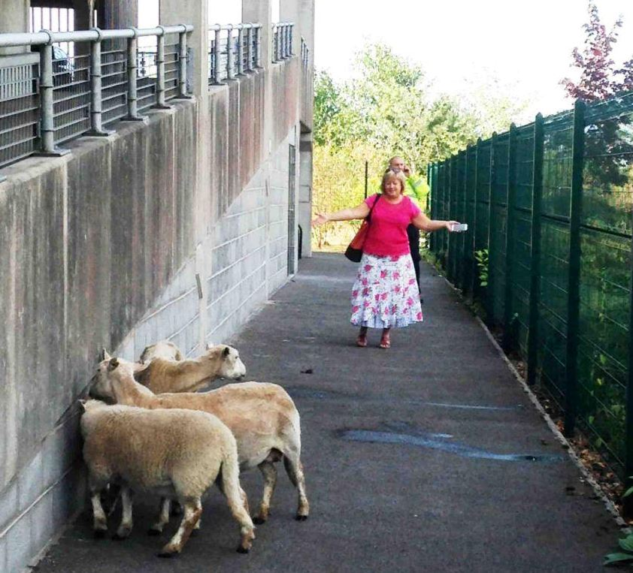
But it’s usually humans who pose the challenges, not wandering wildlife.

Herding was an added extra on two senior nurses’ job descriptions when they arrived at work.

Lead anticoagulation nurse Andrea Croft became aware that she was being watched by four sheep as she parked her car in the multi-storey car park before her shift at the Princess of Wales Hospital.

Left: POW Hospital staff stage their own version of ‘One Man and His Dog’

With the livestock hiding behind a stairwell, Andrea was concerned for the safety of both the sheep and other staff, so she attempted to manoeuvre them into a narrow area whilst calling security.

The sheep however had other ideas and headed off across the busy car park.

And at Glanrhyd Hospital just up the road, a bat was found floating in a toilet bowl.
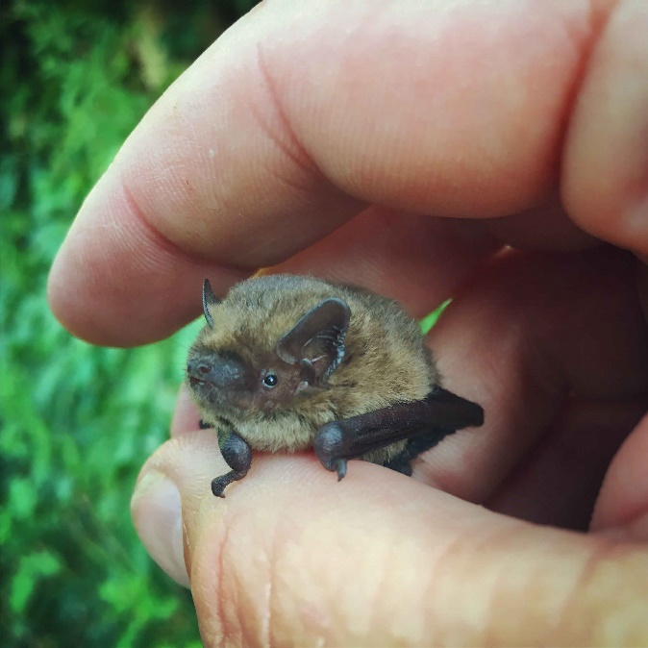
Right: Bertie the bat

Bertie – as he was dubbed by staff – was found by nurses in the ladies’ loos.

It is believed the male common pipistrelle got into trouble while searching for drinking water, which has become scarce in the heatwave.

Unfazed, staff on both sites took action to ensure the safety of the animals during the encounters earlier this month.

Andrea worked with critical care matron Amanda Jackson to move the sheep to a safer spot.

Andrea said “Using the evidence-based practice and knowledge gained from the likes of ‘One Man and His Dog’ and Amanda waving her arms in an assertive manner, we managed to corral the four sheep before security guard Patrick arrived.”

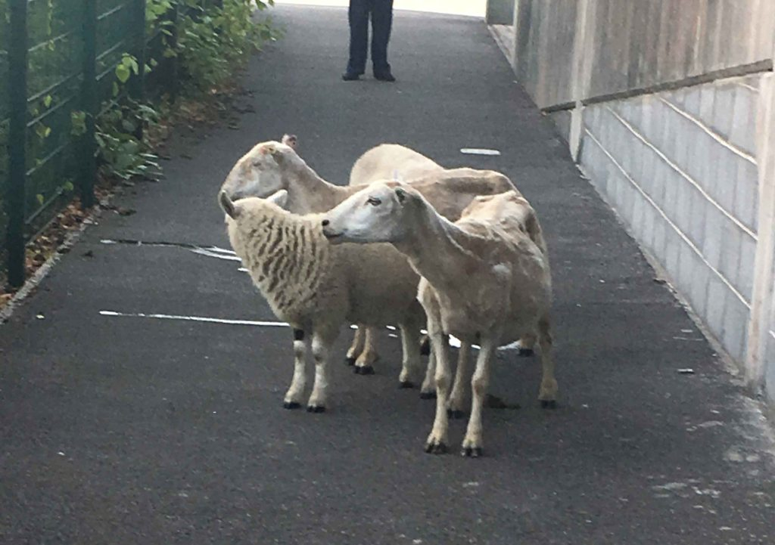
Amanda said; “Between the two of us, three large rubbish bins, a plastic railing and several porters guarding the sheep along with Patrick, we kept them in one place until a local Pencoed farmer arrived to retrieve them.”

“We later found out that several agencies had been looking for the woolly quartet all night, but the sheep were just too clever for them”

Left: The woolly wanderers

At Glanrhyd one of the staff that manages the site put gloves on before fishing Bertie out of the toilet and placing him safely inside a shoe box which had air holes in it.

Then they called licensed bat ecologist Dan Lock, who works at nearby Bryngarw Park.

He said bats normally drink from rivers, ponds and streams.There is a river nearby, but if it was desperate and sensed there was water to be had, that’s probably what happened.

“There is no other reason for it to end up in the toilet bowl.”
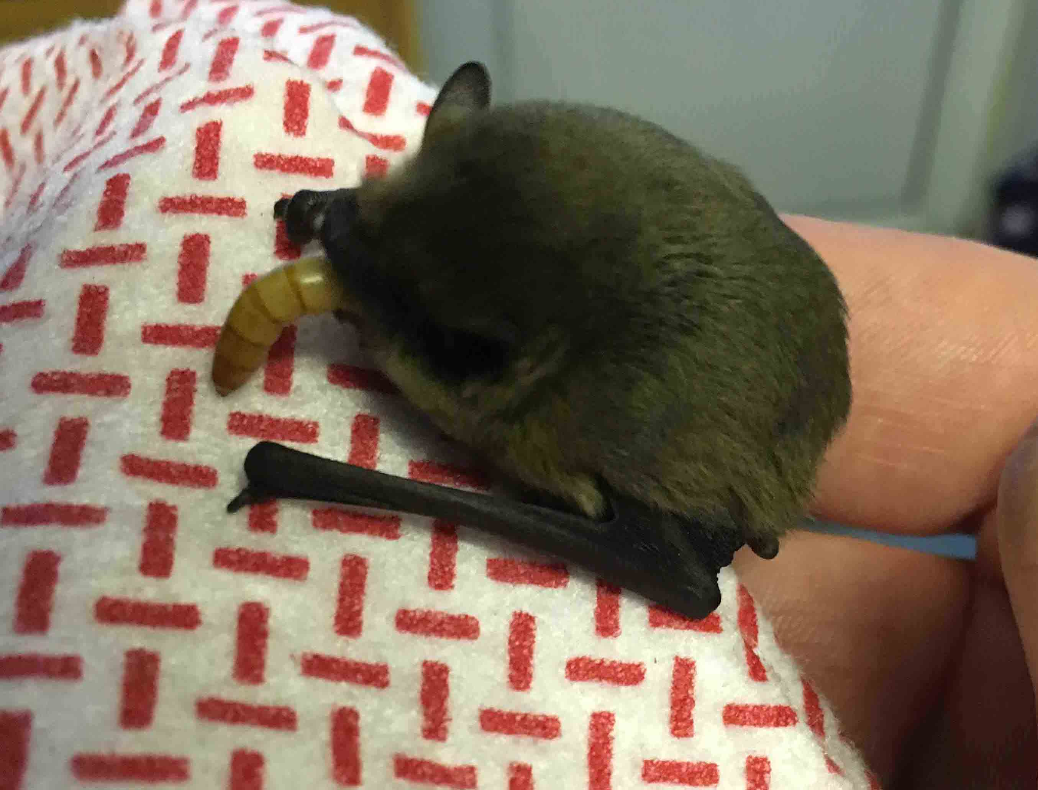
Right: Dan fed Bertie some meal worms to build up his strength

It’s assumed that Bertie got trapped during a night time flight and was found the following day.

“He was in generally good nick,” said Dan, development manager for natural heritage with Awen Cultural Trust.

“I went to the local reptile shop and bought some meal worms for him. Then I brought him home and fed him up.”

Dan, his wife and daughter Seren, 10, returned to Glanrhyd at dusk the following day and released Bertie next to the hospital’s 120-year-old lime tree, which was near to the toilets where he had been found.

“He did a few circles to get his bearings and then he was off,” added Dan.

He said that Bertie was a young bat, possibly one of last year’s juveniles and one of potentially more than 100 on the site, which has just become the first hospital in Wales and only the second in the UK to be awarded the Green Flag, which recognises green spaces that meet the highest standards.

Dan said Bertie and the other bats on site are crucial to the eco system.

“One bat like Bertie will eat up to 3,000 midges in one night, so they are hugely important for us in terms of pest control.”

Source: Abertawe Bro Morgannwg University Health Board

