Michael Sheen supports ABMU book celebrating 70 years of the NHS
Tuesday, 3 July 2018
Hollywood star Michael Sheen is supporting a special book published by ABMU Health Board in celebration of the 70th anniversary of the NHS.
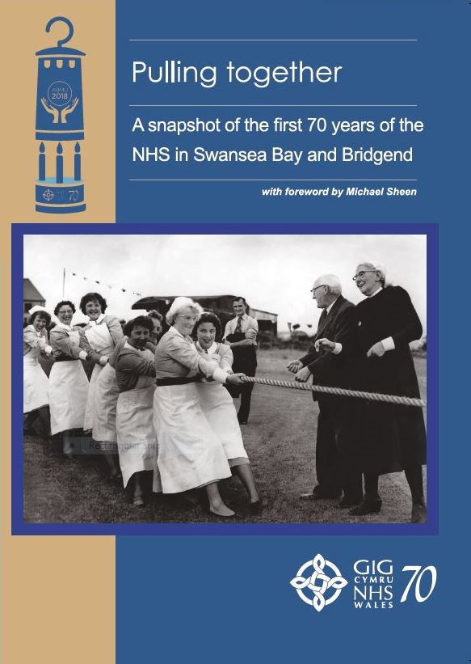
In his foreword, the award-winning Port Talbot actor hailed the NHS as “the best of who we are”.

He praised the “glorious vision” of “universal donation during fitness for universal provision during illness” which grew of out the mining community from which NHS founder Aneurin Bevan came.

In the foreword of Pulling Together – a snapshot of the first 70 years of the NHS in Swansea Bay and Bridgend, he also states his belief that “there’s life in it yet”.

Published by ABMU Health Board this week - with proceeds going to NHS charitable funds - it’s not a history but an affectionate collection of pictures and personal anecdotes from patients, health workers and the public.

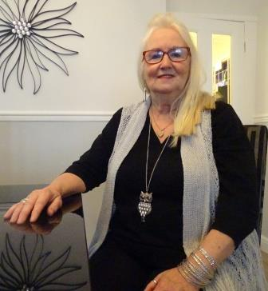
From its first seconds on July 5, 1948 and the birth of the NHS’ first baby Aneira Thomas (right) from Gorseinon, to cutting edge developments in 2018 such as the use of the latest 3D printing technology, the book provides a fascinating insight into 70 years of local health services.

There are also dozens of pictures from the archives, including Hollywood golden couple Richard Burton and Elizabeth Taylor with a group of Swansea nurses (see below right) and the picture of Cefn Coed Hospital staff enjoying a tug of war in July 1960, which graces the book’s front cover.

Since 1948 more than 2.6 million babies have been born in Wales alone.

Aneira Thomas made history as the first child delivered by the NHS – and it really was a matter of timing.

In Pulling Together, she recalls how doctors and nurses urged her mother Edna, who had been in labour for hours, not to push as the time approached midnight on Sunday, July 4, 1948.

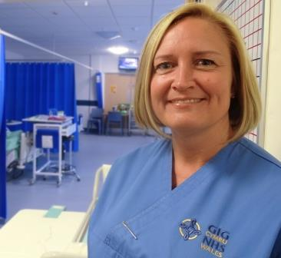
“So I was eventually born one minute past midnight and became the first NHS baby,” said Aneira.

Her unusual name is a tribute to the NHS founder and, although she did not like it as a child, she soon realised its significance and became immensely proud of it.

Amanda Hopkins (left) from Swansea recalls how almost losing her life twice after a serious accident led her to retrain as a nurse.

She suffered multiple injuries including a fractured skull, a broken leg and two broken arms after the accident which happened while she crossed the road in Pontarddulais in 2006.

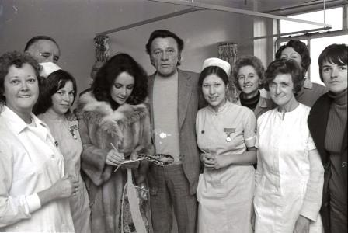
She was resuscitated at the roadside by paramedics and again in the emergency department at Morriston Hospital.

The mum of two was so impressed with the care she received that she decided to give up her job in a bank.

And, despite being told that her injuries meant she would not be able to work full-time in any job that kept her on her feet or be able to study for a degree, she graduated in 2014 and now works 12-hour shifts on the surgical ward T in Morriston.

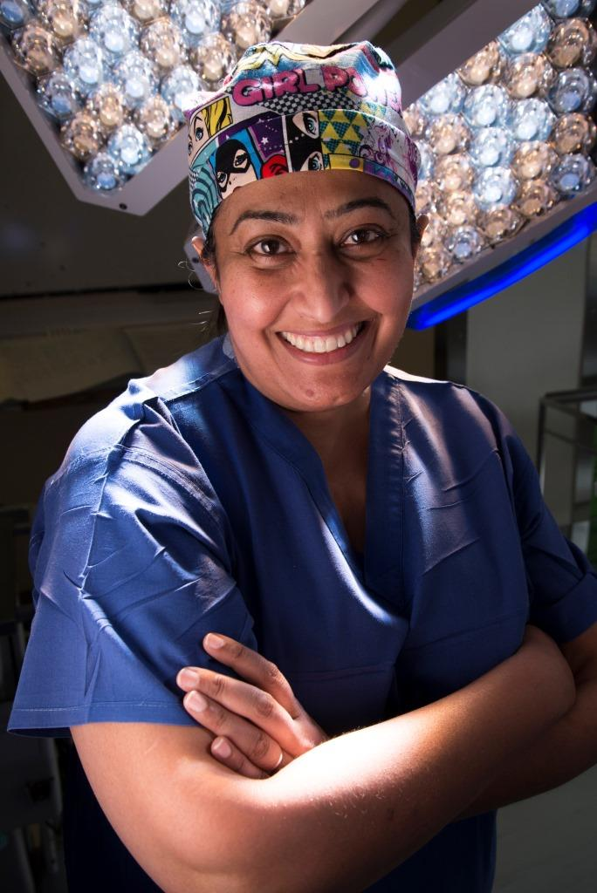
And while many would acknowledge the sentiment about the NHS holding a special place in their hearts, consultant cardiothoracic surgeon Professor Farah Bhatti (left) reveals how her job means that can quite literally be the case.

“I would like to say that it is a privilege to hold a person’s heart in your hand and be able to ‘fix it’ – so thanks to my family for getting me here and to my patients for allowing me to do what is one of the most rewarding jobs in the world! Diolch.”

• Pulling Together, A snapshot of the first 70 years of the NHS in Swansea Bay and Bridgend, costs just £10 (plus p&p) for almost 180 A4 pages. It will be available to buy this week from Amazon, with proceeds going to the health board's charitable funds.

Source: Abertawe Bro Morgannwg University Health Board

