Sharing healthy messages at family fun day
Friday, 28 July 2017
Colourful costumes and familiar faces from favourite TV shows helped provide family fun and deliver a few healthy messages.

Colleagues from various ABMU teams dressed up for the occasion and helped make this year’s annual Teddy Bears’ Picnic at Swansea’s National Waterfront Museum a big hit with young visitors.

The event, organised by Swansea Council, celebrated the work of the Flying Start programme and brought together organisations such as the police and fire service along with community health teams to provide activities, information and goodies.
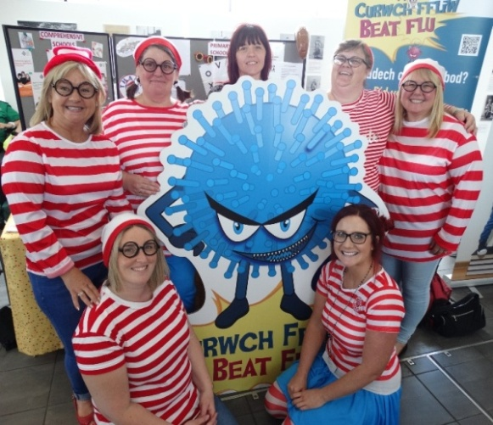
Among those who used the event to pass on health care advice were school nurses from around Swansea, Neath Port Talbot and Bridgend.

Dressed as the character from the Where’s Wally books (right) they were on hand to explain to the importance of keeping children vaccinated.

School nurse Penny Kieft, who is based in Swansea, said: “We are here today to remind parents about why it is so vital they protect their children.

“We’ve got the flu bug with us to help spread the word about this year’s flu vaccination programme and we have been able show the nasal spray we use for children.”

This winter children in reception, years 1, 2, 3 and 4 will be offered the vaccine by school nurses while children aged two and three will be vaccinated at their GPs’ practice.

Penny said she and her colleagues were also providing information about the MMR booster which is due when a child hits 3 years four months old.

The event has become a useful occasion when health staff can offer support and education about family health to the public.

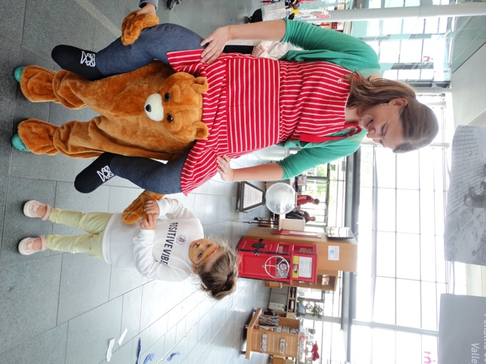
Joining in the fun – and paying tribute to CBeebies’ favourite Raa Raa the Noisy Lion - were speech therapy staff who passed on tips about how families can develop youngsters’ language skills by encouraging them to talk while playing with everyday objects.

Little Beau Crayford makes a new friend at the
student health visitors’ stand.
Other stalls and activities were led by various Flying Start teams from across the city as well as community nursery nurses and the Designed to Smile oral health campaign.

One of the most popular attractions during the day was listening to the singing fruit brought to life by student health visitors.

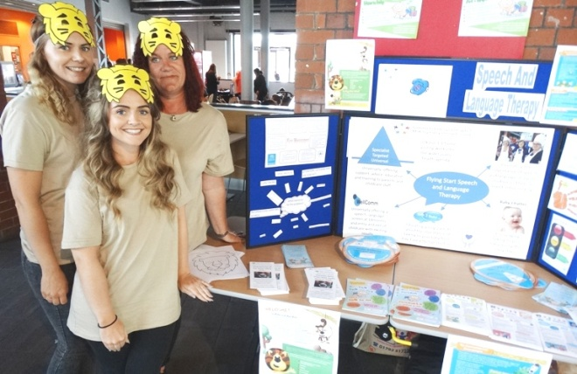
Dressed as fruit they handed out fruity snacks while passing on advice about weaning, healthy eating and portion size.
Find out more about the flu fighting campaign at www.beatflu.org

Sophie John, Bea Trigg and Dawn Hammond at the speech and language therapy stand.

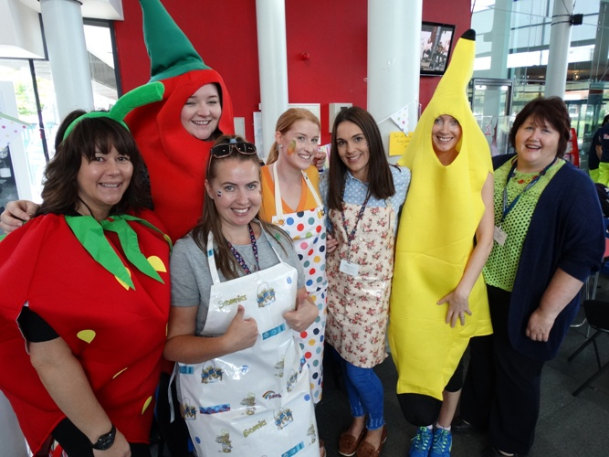
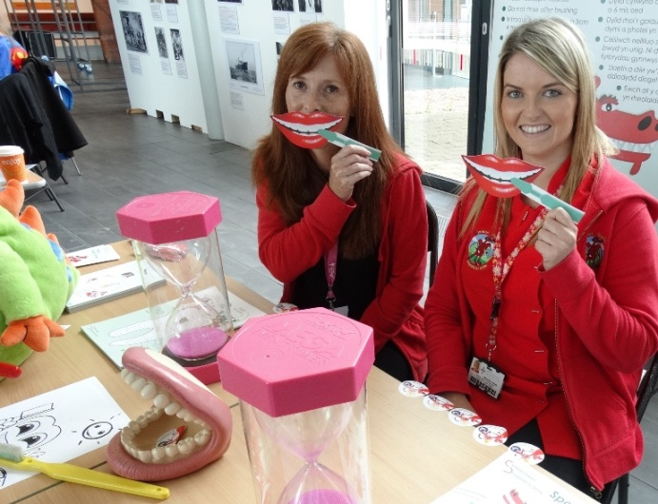

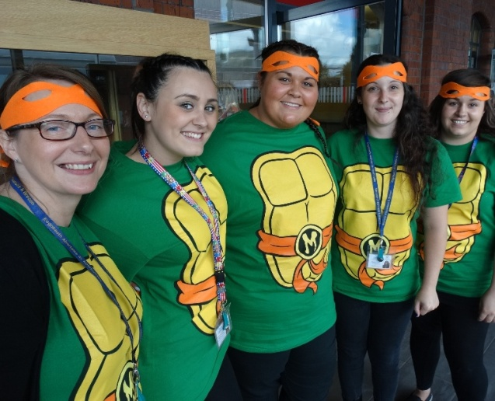

Source: Abertawe Bro Morgannwg University Health Board

