Nurse now helping patients through breast reconstruction journey
Tuesday, 4 July 2017
Patients undergoing breast reconstruction surgery at Morriston Hospital now have a familiar face to support them through their treatment.

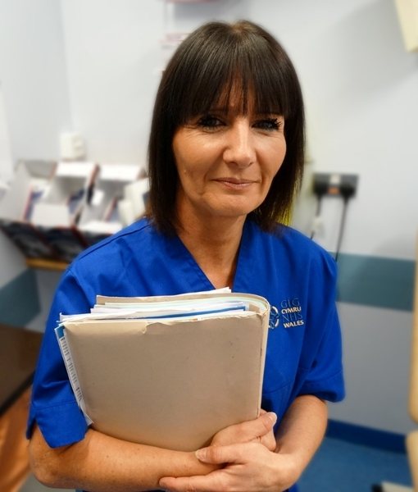
A pilot project has seen Julia Warwick (right) becoming the first breast reconstruction nurse specialist in Wales, based at the hospital’s Welsh Centre for Burns and Plastic Surgery and looking after patients before and after reconstruction surgery.

Julia now has about 200 patients in her care, and the number continues to grow.

Some of them had reconstruction surgery soon after cancer treatment, for others their operations may have been several years later or as a preventative measure following genetic testing.

She said: “All of them face the same kind of psychological and emotional implications surrounding reconstruction.

“They’ll make a number of visits to the hospital and will see me regularly in their initial post-operative period and throughout their reconstructive pathway.”

Julia is the first person new patients see when they are referred for surgery at Morriston and she has developed a Meet and Greet presentation to try to allay some of their initial fears ahead of their consultation.

“I support them from their first appointment, all the way through to discharge. Breast reconstruction is a lengthy journey, I am there to coordinate that journey and support them, to be a friendly face they can turn to.

“Often they will ask me a question that they wouldn’t ask their consultant.”

After working in plastic surgery for more than 23 years, she not only has expertise in the field but also good working relationships with the surgeons who carry out the procedures

“This really helps because you’ve got that trust so you are able to liaise more effectively with them.

“It’s also about better communication and collaboration across health boards too, working with other breast teams, making sure ladies receive primary care in a more efficient way.”

Julia sees her job as complementing the role played by breast care nurses across South and West Wales who look after patients following their initial cancer diagnosis.

“They do a fantastic job and me having this role means they can now concentrate on helping patients through their illness and treatment while I assist with the aspects surrounding reconstruction.

“I can address the more surgical issues following complex breast reconstruction such as wound management and use my knowledge to reassure patients.”

Since being in post Julia has set up a dedicated phone helpline operating five days a week from 9am to 5pm for her patients.
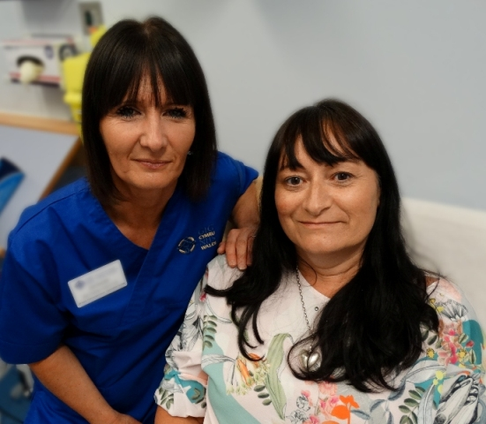
“It is being able to pick up a phone and have someone you can speak to that knows you.

“When patients are discharged I will always follow up with a phone call to see how they are feeling and how they are getting on at home.”

​Julia Warwick with patient Catherine Kirkup at Morriston Hospital.

Julia explained: “Before I took up this role the patients would all still have been cared for at their appointments but not necessarily by the same nurse each time. I have been able to offer continuity of care.“

Someone who has benefited from that care is mum-of-three Catherine Kirkup, of Llanwrda in Carmarthenshire. She had breast reconstruction surgery in April, three years after her original cancer diagnosis.

She said: “I don’t think I would have got through this without Julia if I’m honest. I have had complications and have required three separate operations.

“I have had a lot of ups and downs and every time I have come here Julia has lifted me.”

Catherine is still facing further treatment but says Julia’s guidance has been invaluable.

“Everything I have done has been through Julia; I haven’t had to deal with anyone else. It’s nice to come and see the same person, a friendly face, who knows what she’s talking about.”

“The consultants have all been really nice but you don’t feel you need bother them about anything because Julia will sort it out for you, she has all the information that I have needed.
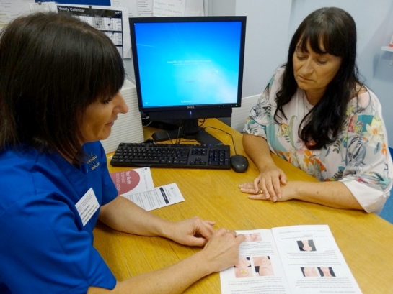
“I’ve still got a way to go but with Julia it’s like there is someone in your corner. She was there the first time I got out of bed after my operation and has been with me all the way through. I feel like I have got a new friend.”

Breast reconstruction patient Catherine Kirkup during her appointment with Julia Warwick.

Consultant plastic surgeon Dai Nguyen, who operated on Catherine, said: “This pilot post has been an invaluable addition the plastic surgery breast reconstructive services.

“Not only has it improved the clinical pathway for patients, it has enhanced the patient experience as women now have a key worker to contact.

“We are extremely lucky to have Julia who is an experienced, caring and dedicated member of the team. The hope is that this position will become a permanent post in the near future.”

Julia, who has personal experience of cancer herself, added: “I love my job. I love the autonomy it gives me, of being able to do the best that I can for these ladies under very difficult circumstances and to support them not only clinically but also emotionally and psychologically.

“It’s all about our patients’ experience and we can only improve services by listening to those patients.”

Source: Abertawe Bro Morgannwg University Health Board

