Morriston emergency team step up their sepsis campaign - with 6k run
Friday, 21 July 2017
The team behind a life-saving campaign at Morriston Hospital are taking their first big fundraising venture in their stride.
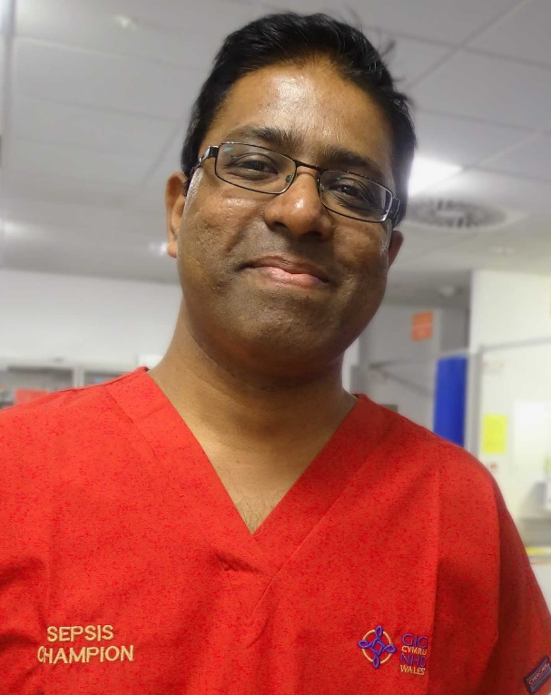
They have organised and will take part in a 6k run along Swansea seafront as part of their drive to tackle sepsis, the so-called silent killer.

Last year the hospital’s Emergency Department set up a working group called SeGMED (Sepsis Group Morriston ED), which launched an awareness campaign promoting early identification of sepsis.

Left: Dr Rangaswamy Mothukuri

Sepsis occurs when the body’s response to infection injures its own organs and can lead to shock, organ failure and death, especially if it is not recognised and treated early.

Very often it is caused by common bacteria which people come into contact with every day without any adverse effects.

Identification can be difficult because the symptoms often resemble other, less serious conditions. But early detection and treatment is the key to preventing deterioration.

As part of their campaign, the Morriston ED team have updated the existing sepsis screening tool using the latest research and data, making it more accurate and in-depth, yet easier to use.

The Sepsis 6k Run will take place along Swansea Seafront on Sunday 10th September, starting from the Blackpill Lido on Mumbles Road at 10.15am.

It was named after the half dozen interventions clinicians use. These are known collectively as the Sepsis Six and include antibiotics and fluids.

Morriston’s sepsis clinical lead Dr Rangaswamy Mothukuri said: “The run is open to everyone – staff and members of the public.

“Places are limited to 499 so we are advising people who want to take part to register in advance.

“Children are welcome to join us as we want this to be a family event but they will have to be registered.”

Dr Mothukuri will himself be running on the day, along with his family and colleagues from Morriston ED.

Other ED staff will be supporting the event in other ways, such as volunteering as stewards. It is being sponsored by Unison.
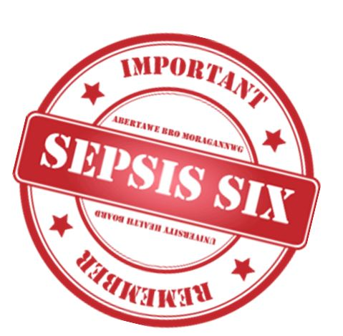
Meanwhile, a Just Giving page has been set up for people to donate to the campaign.

Dr Mothukuri said: “The money raised will go to the Morriston ED Sepsis Fund, which we have recently set up.

“It will be used for education, equipment and supporting further sepsis awareness campaigns and events in the hospital and in the community.”

You can donate to the campaign here
Register for the run here

Source: Abertawe Bro Morgannwg University Health Board

