Jamie makes a positive difference to patients with challenging behaviour
Monday, 17 July 2017
A psychiatric nurse in Bridgend is breaking new ground by offering support for patients in the community with challenging behaviour.
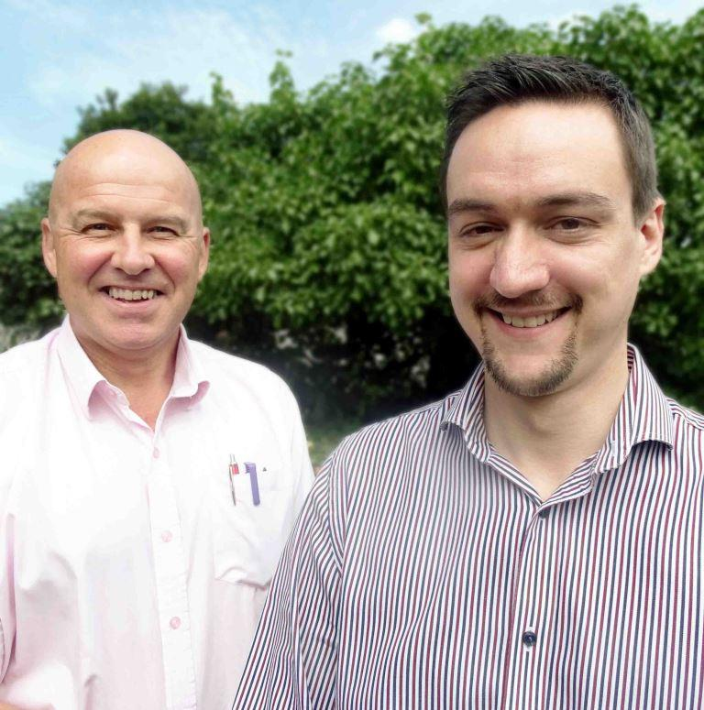
Jamie Hughes has gained a level five – the highest level – Professional Diploma in Positive Behavioural Support, or PBS.

Jamie Hughes (right) pictured with Martin Holder

He is believed to be the UK’s first community psychiatric nurse to have achieved the qualification.

PBS focuses on improving people’s quality of life by understanding why they display challenging behaviour, ranging from violence and aggression to self-harm, and finding ways of addressing it.

In the UK it’s used largely within learning disability services but over the last few years has been successfully introduced within forensic services in Bridgend’s Caswell Clinic.

Jamie began studying for the diploma while working in Caswell. When he transferred to the Bridgend South community mental health team six months ago his new manager, Martin Holder, supported him to continue.

His enhanced skills are already helping to improve the lives of people presenting challenging behaviour in addition to their mental health needs.

Jamie said: “Challenging behaviour is a broad-brush term for any behaviour that can be challenging for people around the person or for the person themselves.

“It could be socially unusual behaviour, aggression or violence, self-harm – anything that could exclude people from society because it marks them out as being different.

“Sometimes it can develop into criminal behaviour or they end up in a specialised service because they are very much isolated from society.”

Jamie is part of a multidisciplinary team including doctors, psychiatrists, nurses, and an occupational therapist, any one of whom can refer patients to him for PBS assessment.

He said: “PBS is very much based on non-aversive interventions – it is always something positive rather than any form of punishment.

“For example, if someone engages in certain behaviour to communicate their need for social interaction, we will come up with a way for them to achieve that social interaction without resorting to challenging behaviour.”

Community mental health team manager Martin said patients often did not recognise their behaviour was challenging and had an impact on others around them.

“We’re based on recovery, which means we work with the patient to enable them to live the appropriate life that they want to lead – not what we want, but what they would like.

“As well as recovery we work on what is known as the normalisation model, where it’s normal to pop out for a cup of coffee or a drink or a meal with somebody.

“If your behaviour is challenging, it’s going to be more difficult to meet up with people and go out.

“Several patients have told us they’ve got no-one, they push people away, but they don’t understand why.”

Martin said Jamie had been in the team for around six months and had made a massive impact already.

“We’ve never had this kind of support before and the behaviour of some of our patients is definitely changing.

“Ultimately it’s about patient care, about getting the best result we can for the patient. If we have the necessary skills in place then their recovery can be moved on quicker.”

ABMU’s Mental Health and Learning Disability Nurse Director Hazel Powell said: “I would like to congratulate Jamie. We believe he is the first community psychiatric nurse in the UK to have achieved the qualification.

“This demonstrates ABMU’s ability to be at the forefront of practice innovation.”
Source: Abertawe Bro Morgannwg University Health Board

