Group raise money for Tonna Hospital
Friday, 14 July 2017
Staff at Tonna Hospital are very grateful to the Cysgodfa Group for their fundraising efforts.

The group from Aberdulais chose the hospital as their chosen charity for the second year running, raising over £2,200 last year.
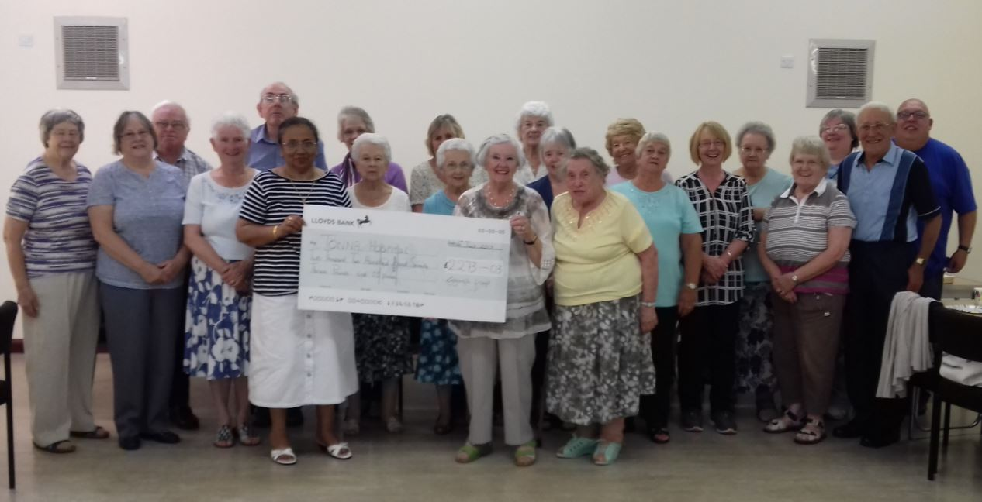
They held a collection, a charity service, a harvest and cake auction and a soup and desert evening, collecting a grand total of £2,273.

Pictured: members of the Cysgodfa Group with the cheque

In addition to the final amount, a charity concert held in January raised £609 and was match funded by Lloyds Bank for a further £500.

Mental Health Service manager, Petrina Thomas said “Cysgodfa Group are a small fellowship but group members have a big heart.

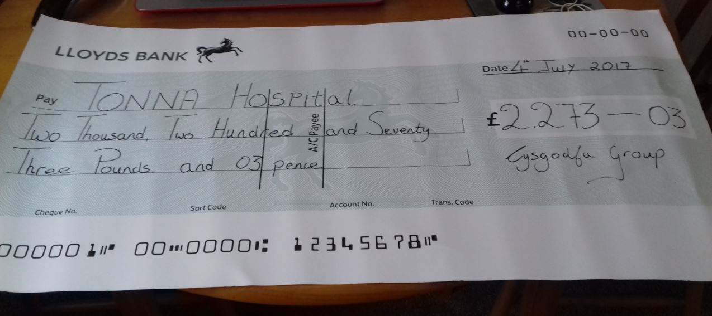
“For the past two years they have supported Tonna Hospital by organising fundraising events and also digging deep in their own pockets to help us provide those extra comforts for our patients.

“The nursing and medical staff are extremely grateful for their hard work and generosity.”

Source: Abertawe Bro Morgannwg University Health Board

