ABMU celebrates inspiring work of next generation of doctors
Monday, 24 July 2017
The top doctors of tomorrow have been honoured for the contributions they are already making to their patients at a special ceremony held at Morriston Hospital.

The ABMU Best Trainee Awards once again celebrated excellence among junior doctors, highlighting their contribution to service delivery, quality improvement and education.
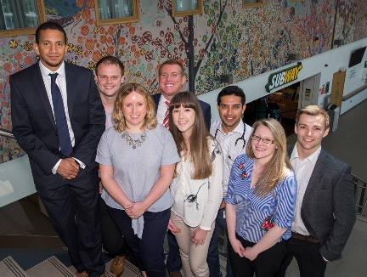
The awards, now in their seventh year, were originally launched by Dr Umakant Dave to reward the Best Morriston Hospital Trainees but over the years they have gone from strength to strength and been expanded to include entries from across the health board.

Shortlisted nominees at this year’s ABMU Best Trainee Awards held at Morriston Hospital Education Centre.

This year’s winners were:

Foundation Trainee: Dr Gney Mehta, Morriston

Junior Trainee: (joint winners) Dr Leigh Sanyaolu, Princess of Wales Hospital and Dr David Williams, Morriston

Senior Trainee: Dr Ricky Frazer, Medical Oncology

ABMU Vice-Chairman Charles Janczewski, who was a member of the judging panel and also presented the awards, paid tribute to the calibre and quality all the entrants.

“I was very impressed, they were all first class and the standard was so high it was very difficult for the panel to determine the winners.

“Congratulations to them all, particularly the winners. These awards demonstrate that the future of our health board appears to be in very capable and safe hands given the high quality of the trainees in each of the three categories,” he said.

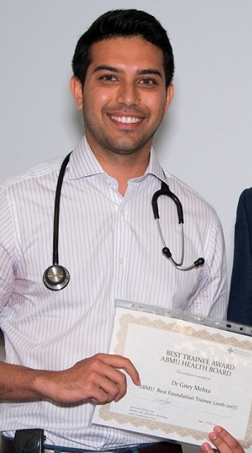 | 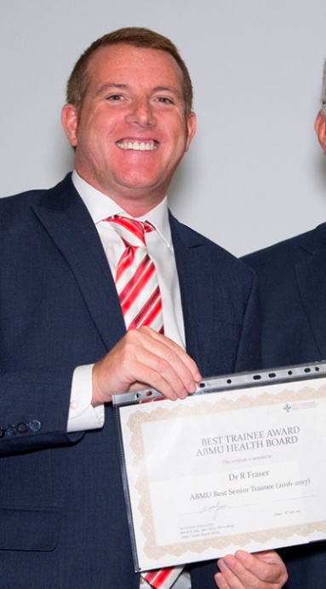
Members of staff were invited to put doctors forward for the awards. All nominated trainees then had to provide structured references from two clinical supervisors and one non-medical member of staff.

Dr Gney Mehta (far left), Dr Ricky Frazer and (below) joint winners Dr Leigh Sanyaolu and Dr David Williams with ABMU Vice-Chairman Charles Janczewski.

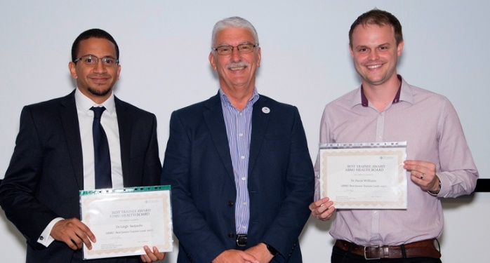
A shortlisting panel from ABMU’s education faculty reduced the nominations down to three candidates in each of the three categories who then had to present to the judges and take part in a question and answer session.

Alongside Mr Janczewski on the judging panel were Medical Director Hamish Laing, faculty lead for trainees Nick Wilson Jones, faculty lead for trainers Ingo Scholler, Swansea University Medical School’s Paul Jones, Morriston Hospital Nurse Director Nicola Williams and Donna Hole, manager of Morriston Education Centre.

Mr Wilson Jones said: “I was very pleased to be part of such an inspiring day listening to the fabulous contributions of our trainees have made to education, quality improvement and patient care.”

He also thanked Mr Janczewski and Prof Laing for their support and postgraduate education manager Marie Sheath for her hard work organising the event.

Source: Abertawe Bro Morgannwg University Health Board

