£2m funding boost helps enhance city’s reputation for burn care expertise
Wednesday, 26 July 2017
Swansea has taken major steps towards becoming an internationally acclaimed hub for burns treatment and research after winning at £2 million grant.

Morriston Hospital burns consultant Tom Potokar made the successful application for funding in his role as Professor at Swansea University’s Centre for Global Burns Injury Policy and Research.
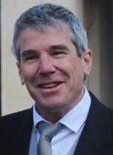
The money, from the National Institute for Health Research, will now be used to support studies into how to improve burn care in low and middle income countries.

Professor Potokar (left) said: “We are delighted that our application was successful, especially as the centre has only been running for six months.

“We are the only place in the world where they are doing this kind of research and this grant will allow us to expand the team.”

He explained that 95 per cent of burns occur in poorer countries or areas where there is conflict and the majority of those affected are women and children.

It is an issue he is particularly familiar with as co-founder and director of Swansea-based charity Interburns - the International Network for Training, Education and Research in Burns – which strives to improve burn care through education, training and research.

Every year burns staff give up their time to pass on knowledge to doctors and clinicians across the world.

Currently Interburns volunteer Danni Mehrez, who works in the burns dressing clinic, is in Palestine’s West Bank delivering burns training as part of the charity’s ongoing drive to improve education.

The experiences of volunteers in the field in countries such as Bangladesh, Ghana, Ethiopia, India and Afghanistan will provide valuable information for the research project.

“Interburns has the experience and expertise, gained by working with other agencies, of having an impact on burns injuries in these countries and this knowledge can feed into the research.
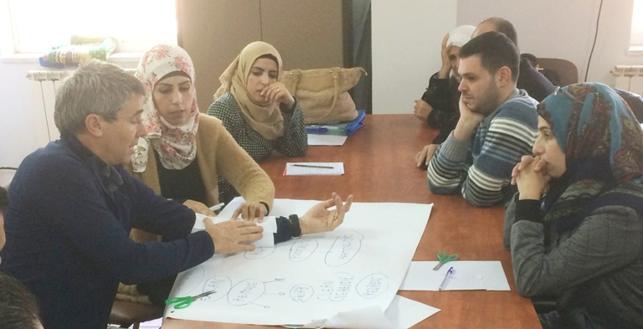
“We know what works so now with this grant we can prove that it works.

Tom Potokar delivering burn care training as part of his work with Interburns.

“The project will allow us to combine the academic work of a university centre with the clinical knowledge of the charity to help the implementation of measures to improve outcomes in these countries,” said Professor Potokar.

The Centre for Global Burns Injury Policy and Research (CGBIPR) links up with other academic centres, national and international organisations to at government level to address worldwide issues relating to burns.


Alongside the existing work of Interburns and the Welsh Centre for Burns and Plastic Surgery at Morriston, it aims to help Swansea build on its international reputation for burns treatment and research.

This has been boosted by the news that the CGBIPR will host the next World Congress of the European Club for Paediatric Burns in 2020 following Professor Potokar’s appointment as its secretary elect.

You can follow Interburns on Twitter to find out more about its work at @interburns

Source: Abertawe Bro Morgannwg University Health Board

