Swans charity supports patients recovering from brain injuries
Tuesday, 23 January 2018
The official Swans charity has teamed up with specialists at Morriston Hospital to support people recovering from brain injuries.
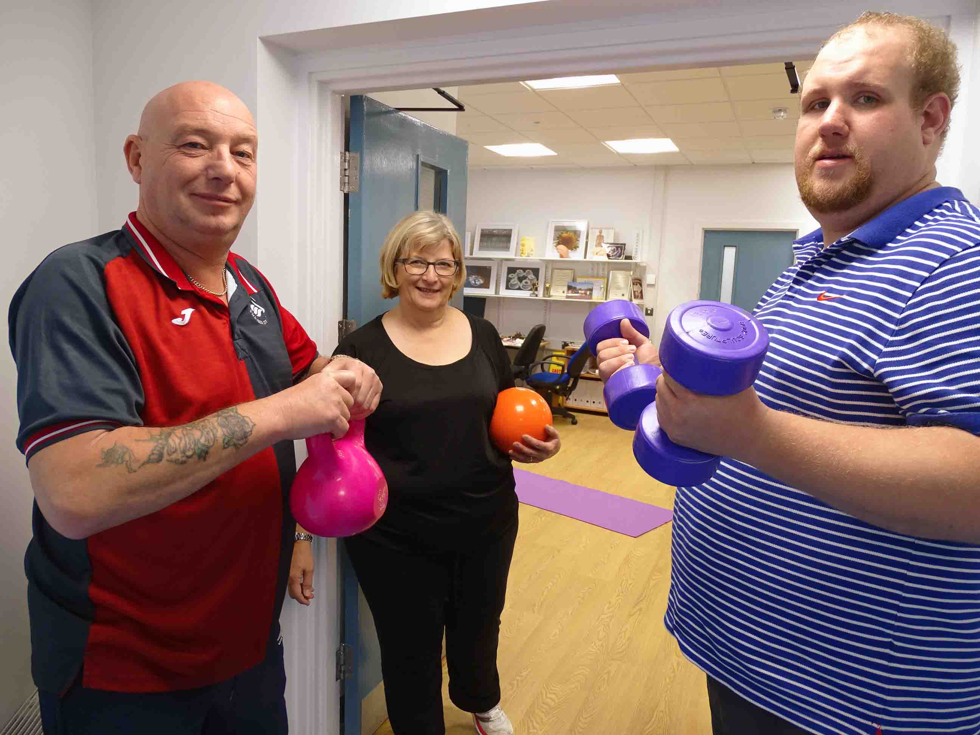
A pilot 10-week rehabilitation programme has been run by ABMU’s Traumatic Brain Injury Service (TBIS) with the support of the Swans Community Trust – Swansea City’s official charity.

Russell Williams (left) and Philip Gammond with Helen Hughes during one of the exercise sessions

It involves exercise, healthy lifestyles and vocational gardening skills training at the TBIS base in Morriston Hospital.

Comprising a multidisciplinary team of health professionals, TBIS offers tailor-made rehabilitation programmes for people with moderate to severe brain injuries caused by trauma such as assaults and car crashes.

The pilot involved 17 patients, aged from early 20s to mid-50s. Although most had suffered a traumatic brain injury, some with other brain injury conditions, such as stroke or brain haemorrhage, were also included.

TBIS occupational therapist Helen Hughes said the team, with community partners, had developed neuro-rehabilitation designed to assess and treat patients.

“This programme differs slightly in that we’re focusing on vocational rehabilitation, to help people return to employment or meaningful roles.

“After brain injury, people experience a loss of their roles due to the nature of the injury – which is known as a hidden disability.

“They can become very fatigued and have cognitive problems, such as memory and concentration, planning and other skills.

“These are skills we take for granted, but they impact on our ability to live independently and this includes returning to work.

“Often they can’t go back to their previous job. They may have been the main wage earner but they’ve had a catastrophic accident and their lives have changed dramatically.”

To help patients improve their social skills and confidence, the service decided to set up a walking football programme a year ago and contacted the Swans for advice.

TBIS was put in touch with the Swans Community Trust, which runs the successful Sign Up to Success initiative. This in turn led to the development of the pilot vocational rehabilitation programme.

Helen said: “We started in the morning with exercise led by a fitness trainer provided by the Swans Trust. It was carefully monitored and adapted to suit each individual’s goals.

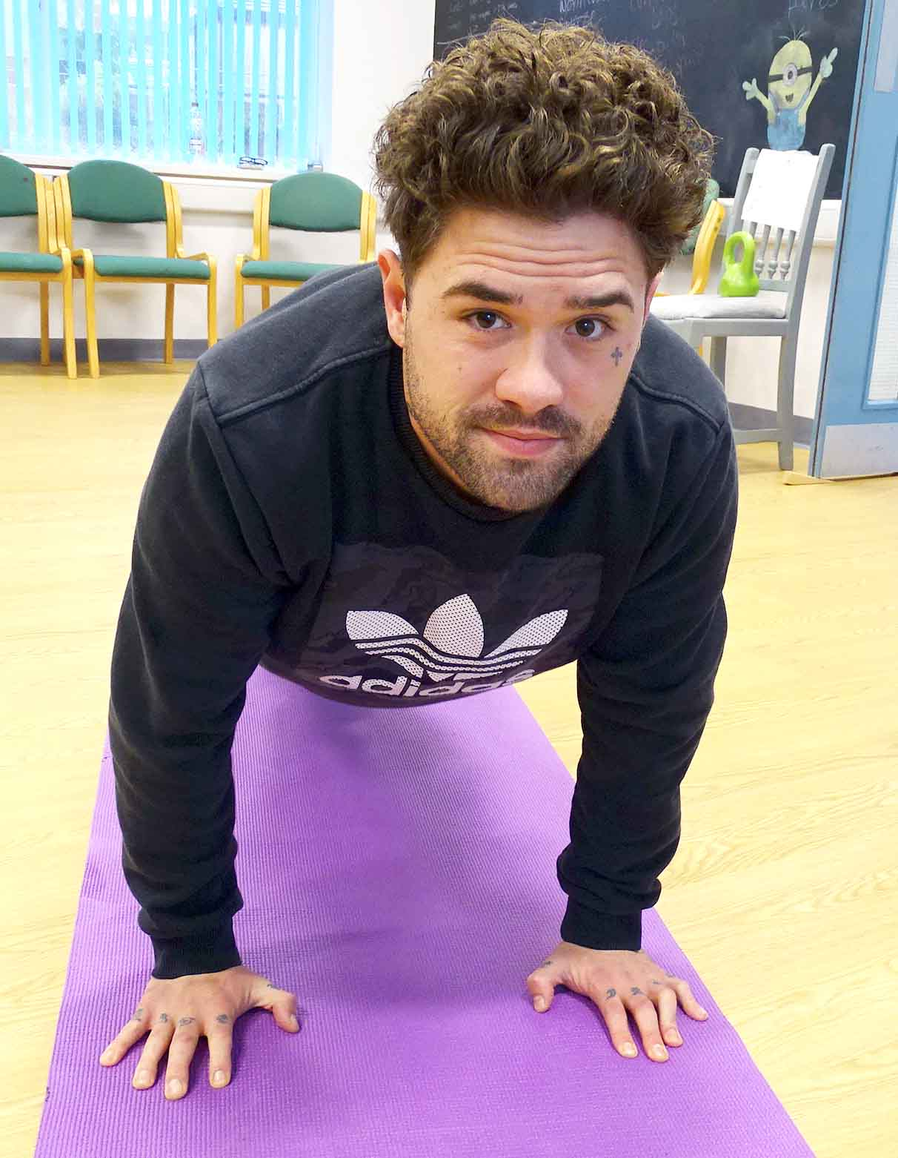
“We also looked at the importance of healthy eating, nutrition, general lifestyle and wellbeing.”

TBIS has moved from its previous home within Morriston Hospital to a new location elsewhere on the site – which has the advantage of a large garden with ornate features that had become overgrown.

Pictured right: Push-ups are on the programme for Jonny Williams while (below) Mark James gets going on the stepper

Helen said: “The renovation and development of the garden provided an excellent opportunity for vocational rehabilitation.

“Therapists were able to assess and monitor their physical, cognitive and social skills while they were in the group.

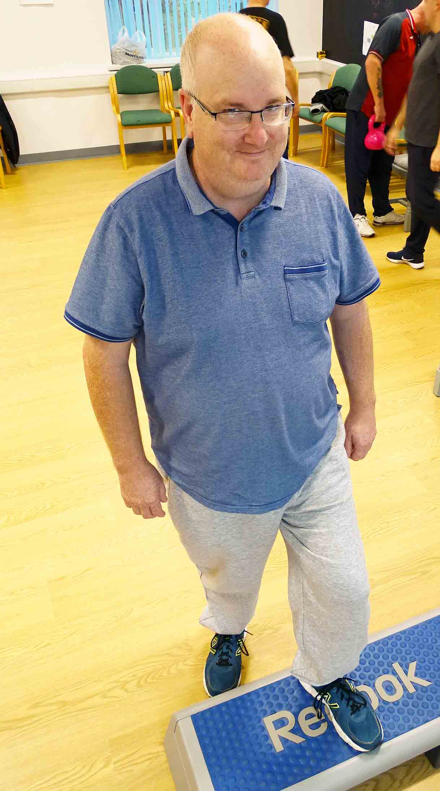
“These are skills the patients can transfer to their own homes and, hopefully, into a move into meaningful roles such as volunteering or employment.”

Russell Williams, Jonny Williams and Mark James were among the patients who attended the pilot programme.

Russell said: “I have made friends that I wouldn’t have. The course has helped me with my confidence, fitness and mixing with people.”

Jonny added: “It has definitely given me a bit boost to getting back to fitness and getting out there.”

Mark said: “All the staff were helpful and looked after us.”

The outcomes of the pilot programme are now being assessed but it’s hoped it will be followed by others.

Helen said: “We are extremely grateful to the Swans Community Trust and their sponsors BT Sport and the Premier League.

“They have been very supportive and are keen to develop this working partnership further and help us to find volunteering and employment opportunities.”

Source: Abertawe Bro Morgannwg University Health Board

