Sculpture commemorates burns centre's relationship with steelworks
Monday, 29 January 2018
A visually stunning sculpture will be unveiled at Morriston Hospital’s Welsh Centre for Burns and Plastic Surgery to commemorate its links with Port Talbot steelworks.

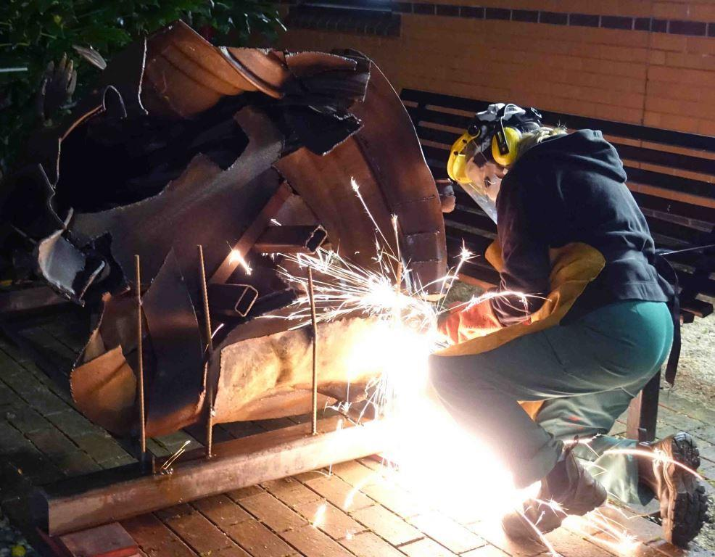
Inspired by Welsh mythology and made entirely from Welsh steel, The Lady of Llyn y Fan Fach embodies the themes of regeneration and healing.
Left: Artist Sarah Tombs works on the sculpture
Its unveiling on Monday 5th February will be ABMU’s first official event marking the 70th birthday of the NHS.

The longstanding link between healthcare provision and industry in South Wales is being highlighted by a specially-created miners’ lamp, which will be the symbol of ABMU’s celebrations throughout the anniversary year.

Although the Welsh Centre for Burns and Plastic Surgery has links with industries across the region, it has a particularly close relationship with the Port Talbot steelworks.

The sculpture commemorating that relationship was created by West Wales artist Sarah Tombs, using materials donated by Tata Steel.

Community, the principal trade union at the steelworks, paid for its production and installation in a courtyard within the Morriston centre.

According to Welsh folklore, the Lady of Llyn y Fan Fach was mother of the Physicians of Myddfai who used herbs and magical powers to heal people. The tale is recounted in The Mabinogion and The Red Book of Hergest.

Sarah spent around 18 months working on the sculpture, which is made entirely from steel. Immediately eye-catching, it’s made even more striking by the fact that it has been purposefully allowed to rust.

“I wanted the steel to come through and oxidisation is a natural process,” Sarah explained.

“It’s softer and less industrial than something that has been galvanised or painted. It will change as time passes and I like that too.”

*Former burns centre patients are welcome to attend the event. Places are limited, so please email Tracey.Rowe@wales.nhs.uk if you wish to attend.

Source: Abertawe Bro Morgannwg University Health Board

