Morriston Hospital hosts workshop for tomorrow’s physiotherapists
Wednesday, 10 January 2018
Students interested in training to become a physiotherapist will be able to get hands-on experience at an event in Swansea next month.
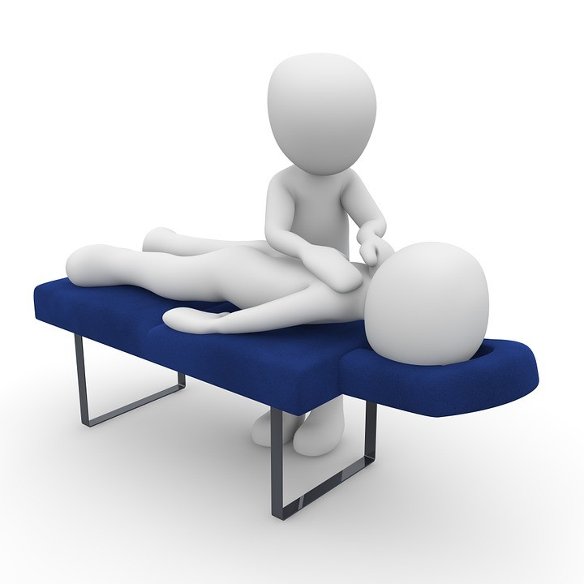
Places are now available for a workshop in Morriston Hospital highlighting what a career in physiotherapy has to offer.

The workshop, organised by ABMU physiotherapists, will be held in the hospital’s Clinical School on Monday, 19th February, from 9am-1pm.

It’s free to attend and is open to students aged 14 and over who live in the ABMU catchment area.

The event will include workshops and presentations from experienced therapists working with a range of patient groups.

Senior physiotherapist Vicki Evans said: “It will explain the training involved and scope of practice of a qualified physiotherapist.

“The day will be interactive and students will be expected to participate in discussions and practical demonstrations.

“There will also be an opportunity to meet newly-qualified therapists who can offer valuable insight into applying and studying for a career in physiotherapy.”

Places are limited and must be booked in advance – anyone turning up without having booked will not be able to attend.

Please note the workshop is for students only. Friends and relatives will be unable to accompany them.

Please e-mail Victoria.evans@wales.nhs.uk to register and to request an information pack.

For more information about Physiotherapy as a career, please visit the Chartered society of Physiotherapists (CSP) website: www.csp.org.uk

Source: Abertawe Bro Morgannwg University Health Board

