Event marks start of work on new Porthcawl primary care centre
Friday, 26 January 2018
GPs and healthcare officials have come together to mark the start of building work on the new Porthcawl primary care and community services centre.

The centre will provide local GPs and community healthcare services with extra space and modern facilities to meet the needs of residents.

A new centre is much needed because the main Portway Surgery site is too small for the 15,000 patients it cares for and doesn’t offer the accommodation required to deliver modern services.

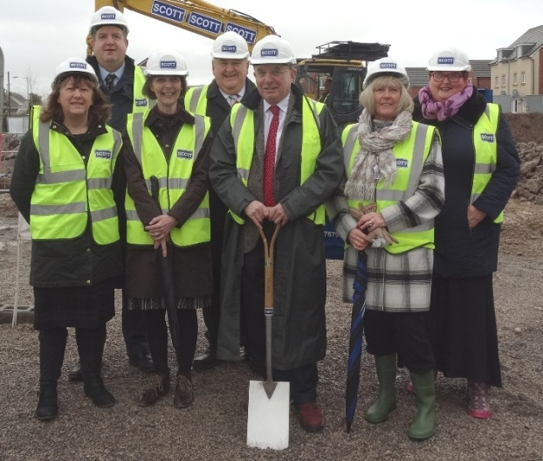
In addition, the practice has to use premises on South Road, meaning services are split between two sites.

(Pictured l – r: Dr Sharon Guest; Dr Peter Evans; Dr Romilly Rees; Lindsay Morgan; and Andrew Davies; with Karen Campbell-Ace and Nicola Willis who work for the surgery).

The accommodation at South Road, which is shared with community services, also falls far below the standard expected for modern healthcare.

None of these buildings could be modernised or expanded, so in 2015 it was agreed to move the practices and community services into a new purpose-built centre on Newton Nottage Road, next to Meadow Lake.

At the event, ABMU Chairman Professor Andrew Davies, said: “I’m very pleased that following previous difficulties finding an appropriate site, work is now starting on the new primary care centre.

“Our aim has always been to support our GP colleagues and community staff to provide the best healthcare possible to the residents of Porthcawl.

“Today we are one step closer and I’d like to thank everyone who has contributed to this project so far.

“As the number of patients continues to grow, and healthcare conditions change and develop, it’s vitally important we have the space and facilities to provided appropriate treatment and services as close to the patient’s home as possible.”

The centre, which is due to be completed in spring 2019, is on three bus routes and will have 60 parking spaces, a drop-off point and an ambulance bay making access for patients as easy as possible.

As well as GP services, the purpose-built centre will be home to a number of community health services including podiatry, speech and language therapy, maternity, screening clinics, smoking cessation support and local third sector support services.

Plus, the extra space will provide room for an onsite pharmacy and potential opportunities for additional healthcare services to move into the area and be based at the centre.

GP Dr Sharon Guest said: “We’re going from a split-site which is inadequate for providing modern healthcare services, to a purpose built centre with better facilities and room for more services under one roof. This is better not only for patients but staff as well.

“We’re very grateful to our local independent councillors and residents for their ongoing help and support with this project. We’re very much looking forward to the day we move in.”

One local resident who attend the event was Lindsay Morgan. He said: “This is going to be a modern facility in a modern world. It’ll have better treatment rooms and facilities for our fantastic physicians to work in.

“The extra space could also allow more healthcare services to be provided from the centre meaning patients, particularly elderly ones, don’t have to travel so far for treatment. Patients will also have adequate parking which is something we’ve never had before.”

Source: Abertawe Bro Morgannwg University Health Board

