ABMU statement on winter pressures
Wednesday, 3 January 2018
Like other health boards and NHS trusts, our hospitals are very busy at the moment. This media release contains key messages.

Postponed surgery

Like other health boards and NHS trusts, our hospitals are very busy at the moment.

We are having to concentrate on treating emergency cases and the sickest patients who need to come in for their planned operations. This means however that most of our routine planned surgery this week has had to be postponed (this is in line with our winter pressures management plan.)

We are very aware of the inconvenience this causes patients. We apologise, and thank them for their understanding and patience. We will reschedule their operations as soon as possible.

This is a changing situation which we are reviewing daily. We will inform patients whose routine surgery is postponed as soon as we have to take that decision. This will likely be at short notice, and again, we ask them to bear with us. Please avoid ringing to check, as we may not have that information because of the ongoing pressures of the situation.

Families can help us with hospital discharges

Families and carers are being asked to support us in helping to safely discharge their relative from hospital.

If you have a relative who is well enough for discharge, there is much you can do to ensure they go home on time. This is better for them and helps to free up beds for other patients who are very ill and urgently need the bed.

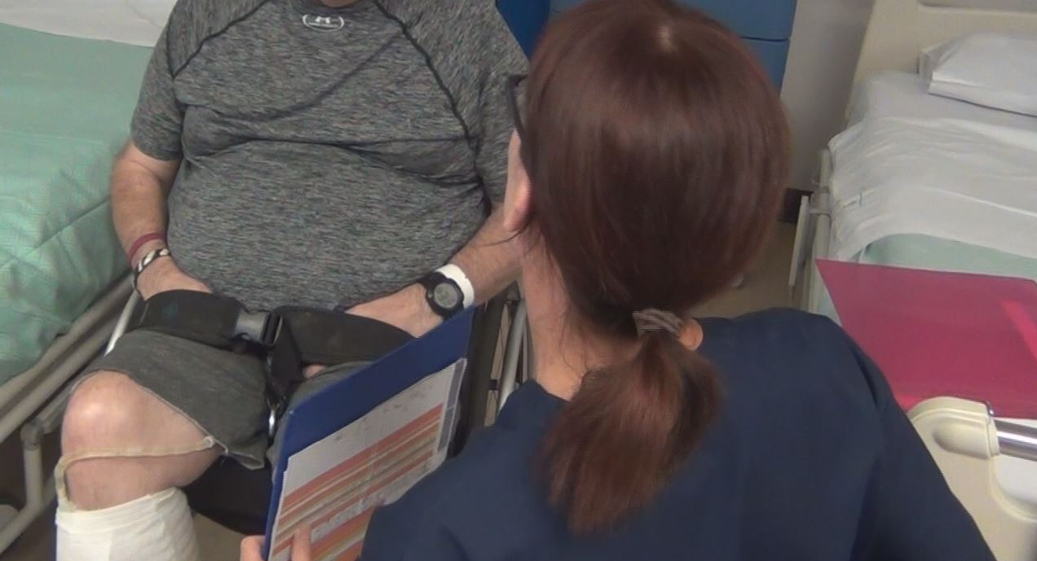
Please arrange to collect your loved one as soon as they are ready for discharge, rather than wait until later in the day. Getting them home earlier in the day, during daylight hours, helps them settle in more easily.

If your relative is awaiting a formal package of care, please work with us to agree a short term, temporary arrangement if you are able to offer some support and care. This could range from you as a family looking after them at home for a few days, to arranging for help with shopping, visits etc.

If a patient requires ongoing care in a care home setting, please work with our staff to ensure that decisions about the choice of home are made in good time, as delays can mean other very sick patients have to wait to be admitted for urgent hospital care.

Evidence shows that staying in hospital after recovery can be harmful, as hospitals receive other patients with serious infections which have a risk of spreading. Elderly patients in particular can also start to lose their mobility and independence.
So if we can work with families to get patients home as soon as they are medically fit for discharge, that would be very helpful.

111

If you live in Swansea, Neath Port Talbot, Bridgend of Carmarthenshire, you have access to the new 111 service, which is free to call from landlines and mobiles.

The service is available 24 hours a day, seven days a week, and you can use it if you need urgent care but can't wait for your GP surgery to reopen, or if you need healthcare advice.

Please be aware though, that some of the latest phones are automatically set to wireless calling. If that's your phone, you will be told the service is not available in your area, because it can't work out where you are dialling from. If that happens to you, just switch off the wireless option on your phone and use your mobile provider to call, or use a landline. Remember, 111 is FREE to call on mobiles and landlines.

You can also call the online symptom checker: https://www.nhsdirect.wales.nhs.uk/SelfAssessments/
Flu

Unfortunately, patients have been admitted to our hospitals who are seriously ill with influenza.

ABMU Director of Public Health Dr Sandra Husbands said: “Flu really is serious. If you are fit and healthy it may leave you feeling awful for a few days but for some people, especially those who have other health conditions, it can be life-threatening and require hospital treatment as we are currently seeing.

“This is why it’s so important people should have their flu vaccination. It is the best available protection against flu and could save your life. If you are in a high-risk group please contact your GP surgery or visit a participating pharmacy as soon as you can for your free NHS flu vaccination. The vaccine is very safe; there are no real side effects.”

For further information about the influenza vaccination is at www.abm.wales.nhs.uk/flu
Norovirus

We’re also seeing more cases of sickness and diarrhoea in the community. Sickness bugs are unpleasant and spread quickly but people normally get better within a few days. Sadly, for some people, especially vulnerable patients in hospital, it can be worse. We’re asking everyone to help stop these bugs spreading, especially into our hospitals.
Delyth Davies, ABMU Head Nurse for Infection Prevention and Control, explains how people can help stop sickness bugs spreading: “Regularly washing your hands with warm water and liquid soap, especially after going to the toilet, and before preparing food or eating is critical.
“If you have a sickness bug try and look after yourself at home. Although unpleasant the vast majority of people don’t need to see a doctor and antibiotics have no effect on common sickness bugs.
“I know it’s hard but the best thing to do is to try and drink fluids to keep yourself hydrated and let the virus take its course. If you are concerned, phone the urgent care helpline 111.
“Also, please stay at home; don’t go to the shops, work, have friends over or visit people in hospital until you have been free of symptoms for at least 48 hours. Even after the symptoms have stopped you are still infectious and will pass the bug to others.”

Source: Abertawe Bro Morgannwg University Health Board

