Young patients can now enjoy trip to seaside at their appointments
Thursday, 12 January 2017
Smiling sea creatures, funky fish and sandy beaches now welcome youngsters when they attend their appointments at Swansea’s Central Clinic.

The view from the window of the speech therapy department corridor used to be a dark drab flat roof but that has now been transformed, masked by a seaside landscape, complete with starfish, sand castles and bucket and spades.

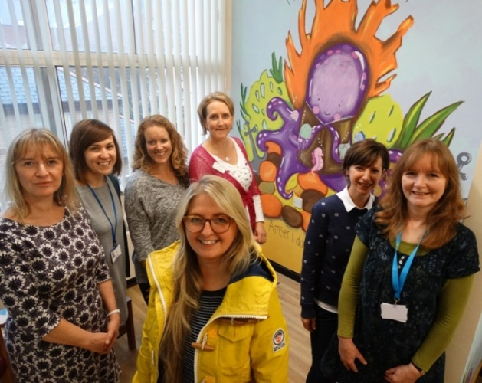
The work has helped transform the area to make it more child friendly and to provide a colourful distraction as youngsters and their families wait for their appointments.

Head of speech and language therapy Alison Clarke, Sian Matthews, Claire Pownall, Lucy Jones, Kathryn Ellis and ABMU property manager Fiona Edwards with artist Sue Evans and one of the brightly coloured scenes she created at the clinic.

Head of speech and language therapy Alison Clarke said they were eager to give their young patients brighter surroundings

“The theme of I Do Like to Be Beside the Seaside was perfect for that, especially as it matches the decor used at Hafan y Mor children’s centre at Singleton Hospital so there is continuity for any of our patients who have attended there too.”

Illustrator Sue Evans was commissioned by ABMU property manager Fiona Edwards to come up with designs for the corridor, waiting room and consultation rooms and her work was funded from the sale of artworks at other health board sites.

Sue’s art on clinic, waiting room and corridor walls was then complimented by the decorative window film supplied by Swansea graphics firm Signs Express.

“It has made a huge difference. Everyone’s reaction to the artwork has been very positive,” added Alison.

The fish that now decorate the walls of the consultation rooms have a dual purpose, explained schools speech and language therapy lead Kathryn Ellis.

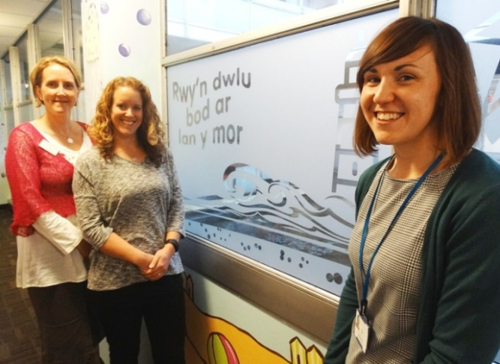
“They not only make a blank wall look more colourful but they also provide a prompt we can use to start a conversation with a child without being too distracting,” she said.

Speech therapists Lucy Jones, Claire Pownall and Sian Matthews with the new window art.

Claire Pownall, who deals with preschool children, said the paintings which also feature messages in Welsh and English help give children and their parents something to talk about when they come to the clinic for their appointments.

“A lot of our work involves seeing how children interact with adults and now they can chat about what’s going on in the pictures,” she said.

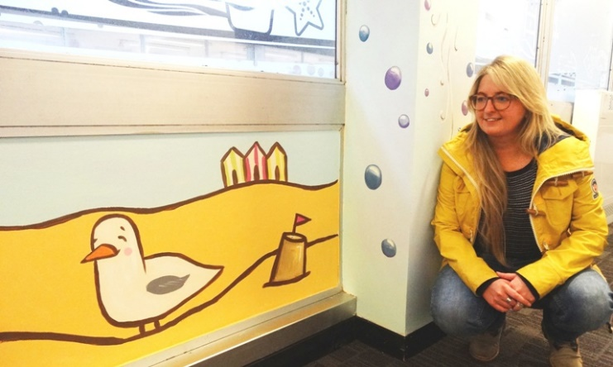
Artist Sue Evans with some of her work in the speech therapy corridor at Central Clinic.

“It’s also meant a transformation for the speech and language therapy staff who now enjoy a fresh, bright, positive environment when they come to work.

“We would like to thank Fiona and Arts in Health for supporting this work.”

Source: Abertawe Bro Morgannwg University Health Board

