Why Nev is sharing his journey from Fat Man to Ironman
Monday, 9 January 2017
ABMU’s Nev Price has a busy year ahead – he has set himself the target of battling his own health problems to complete a series of gruelling triathlons and lose a whopping seven stone along the way.
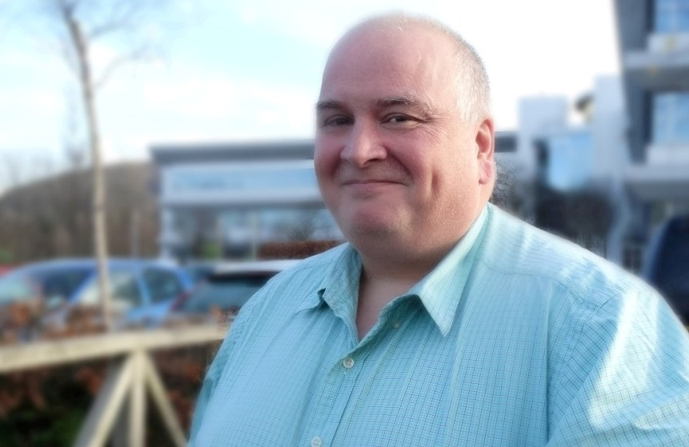
And, as he pounds the roads and saddles up for another bike ride, Nev (right) is sharing the highs and lows from every step of his fitness journey in a frank blog.

Dad-of-two Nev, who works in the IT department at the health board’s Baglan headquarters, admits he is an unlikely triathlete - his website and Facebook page dedicated to charting his progress are called Fat Man to Ironman.

When he started on his training mission in the autumn 5ft 4in Nev weighed in at 24 stone and he now hopes by revealing his own triumphs and frustrations along the way he can help others take on their own challenges.

Nev, who is 53 and from Morriston, said: “Although the weight issue is of my own doing, I started this blog as inspiration to myself, and any other overweight and middle aged budding triathlete/Ironman.

“I have battled with my weight and depression since I was a teenager.

“Over the years I have taken part in a few sports, my main passion was rugby, I was never a sportsman of any notable standard, but I learned to never give up trying.

“I used to do powerlifting and won a few titles along the way, but I think I used powerlifting to excuse the weight gain.

“Like many other overweight people out there, although very self-deprecating, over the years I have been subject to the butt of many a joke, personal comment and abuse.”

In 2015 Nev took part in a 360-mile fundraising bike ride from Paris to Swansea and then last year, after years of admiring triathletes’ achievements from a distance, he took the plunge – literally and entered his first event, a sprint triathlon in Cheltenham.

“Although finishing last, the feeling of accomplishment gave me the widely known triathlon bug,” he added.

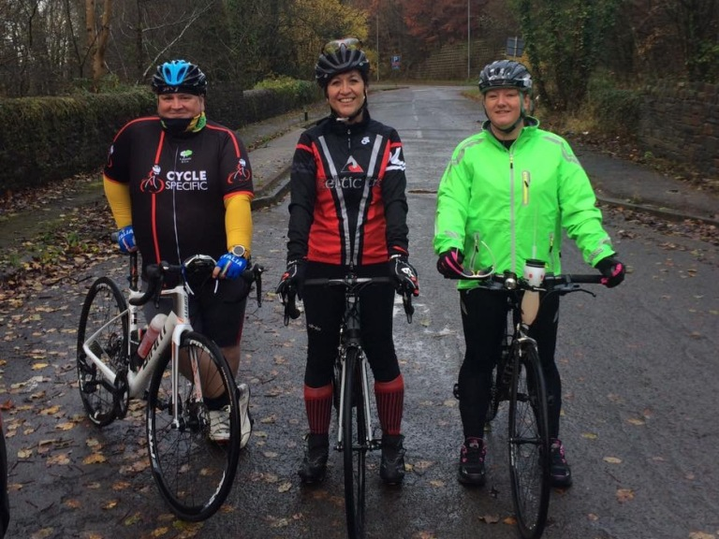
Neville says the support, advice and guidance he has had from his new friends and teammates at Celtic Tri triathlon club has been invaluable especially after he suffered his worst setback so far – a ruptured quadriceps tendon following a mugging while on holiday.

Nev with Tracey Williams and Deborah Longman at the start of the Celtic Tri Time Trial.

It saw Nev in plaster for nine weeks followed by a further three months of rehab which affected his mental and physical approach to training.

It also meant he missed out on a club triathlon event in September he had hoped to take part in.
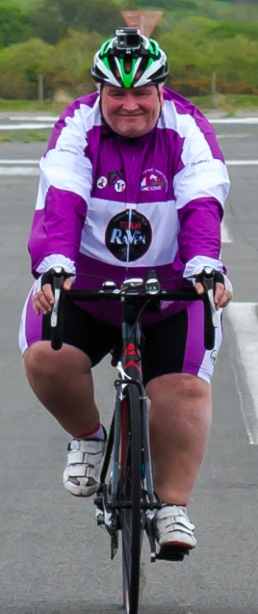
“I ended up as a marshal on the day. On one hand I was quite upset I couldn’t compete, but I had a fantastic time cheering on all the other competitors. It’ll be my turn next year to wear club colours,” he added.

He is now back in the saddle and sharing his weekly progress as he edges closer to a very full schedule of events.

And he has pledged to keep it honest: “It is pointless me not posting the bad things and only posting the good. This is a human journey with human failings.”

Nev is now planning to return to Cheltenham in April for his first triathlon of the year followed by the Carten 100 cycle ride from Cardiff to Tenby and Llanelli Sprint Triathlon in May, the Swansea City Centre Triathlon, Tenby long course weekend and the London Triathlon in July followed by the Ironman 70.3 in Weymouth in September.

He is using the events to help raise money for the Alzheimer’s Society and is hoping that by the end of the challenges he will have collected £600.

Here’s an extract from Nev’s latest weekly post. . .

Monday and the training plan has been stepped up a little after the festivities, started with a bank holiday with a spin on the mountain bike, it’s was absolutely freezing cold and icy, but managed to stay upright, followed this by a 20-minute yoga for beginners (very relaxing).
Tuesday, boom! back to work and a little normality, with an evening’s Cycle Specific for a threshold training session by Danni and Alex, very tough but thoroughly enjoyable.
Thursday 6am visit to Morriston Pool for a session, it was lovely in there, very quiet and nice and warm, and then into work for a busy day before hitting Cycle Specific for session number two of the week. Cracking session - thoroughly enjoyed it.
Friday yoga hit mainly for the stretching and the relaxation element.
Saturday was a foggy 30 odd mile Tash's Dash to Craig y Nos and back, lovely club spin with Celtic Tri, very supportive bunch, I have a lot to work on (climbing, fitness, cadence on the road), will be hitting the road as much as possible, Missed swim today, things to do.
Sunday 50m National Pool drills session 2000m. Looking forward to next week’s busy training schedule!

To read more about Nev and catch up on his latest posts go to http://dnevilleprice.wixsite.com/fatmantoironman or
https://www.facebook.com/nevschallenge/

If you would like to donate to ongoing appeal go to https://www.justgiving.com/fundraising/Neville-Price1

Source: Abertawe Bro Morgannwg University Health Board

