Survey ranks ABMU the best in Wales for training specialist doctors
Tuesday, 24 January 2017
The standard of training for specialist doctors in ABMU has been judged the best in Wales – and among the highest-ranking across the UK.
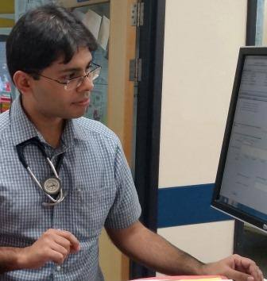
Every year the Joint Royal Colleges of Physicians Training Board carries out a survey of junior doctors who are training to become specialists in endocrinology and diabetes.
Dr Jawad Bashir: “I couldn’t recommend ABMU Health Board enough for diabetes and endocrinology training to all my colleagues.”
It covers everything from clinical and education supervision, access to educational resources, workload, and overall satisfaction.

The JRCPTB summarises the scores for each category using a series of colour-coded flags.

Red flags, for example, denote a score that is well below the national average while green flags are significantly above it. The other flags indicate scores either on or above average.

None of the Welsh health boards had red flags. And ABMU’s five green flags was not only the highest proportion in Wales but tied with two NHS trusts in England for second best in the UK.

Only Oxford University Hospitals NHS Foundation Trust did better.

Professor Jeffrey Stephens is a consultant physician in diabetes, endocrinology and general internal medicine at Morriston Hospital.

He is also an education and clinical supervisor for medical trainees at Morriston, and a clinical professor in diabetes at Swansea University Medical School.

Professor Stephens said: “The aim of the survey is to highlight weaknesses and strengths. ABMU comes out very well, in joint second place behind Oxford for the provision of quality training.

“As well as being good for trainees in diabetes and endocrinology training, it provides reassurance and confidence for other trainees in the health board’s ability to deliver specialist training.”

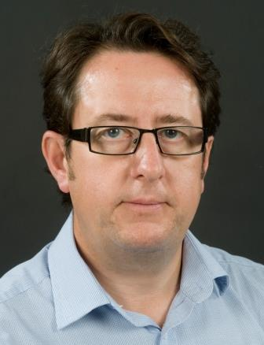
ABMU had green flag in overall satisfaction, clinical supervision, adequate experience, supportive environment and access to educational resources. Its performance has steadily improved over the last three years.

Professor Stephens (right) said: “I think it is down to the fact that we’ve got good quality educational clinical advisors in diabetes and endocrinology across the health board.

“We offer a strong research base and clinical exposure within diabetes and endocrinology.”

Dr Jawad Bashir, a specialty trainee registrar in diabetes and endocrinology, rotated through Singleton, Morriston and Princess of Wales as part of his training.

He said: “I had ample opportunity to interact with the diabetes and endocrine teams in all three hospitals.

“I feel privileged to work in such a diverse setting where the training in my speciality, and in general medicine, has been marvellous.”

Dr Bashir said there was an amazing diversity of cases for diabetes and endocrine training.

He said the teams of consultants, specialist nurses and secretarial staff had been phenomenal.

“This has been an all-round experience that any trainee would want before picking up a consultant post.

“I couldn’t recommend ABMU Health board enough for diabetes and endocrinology training to all my colleagues.

“It wouldn’t be unfair to say that this is one of the best centres for diabetes and endocrinology training in the UK.”

ABMU also scored highly in a General Medical Council survey of doctors in training, published last September. You can read about that here
Source: Abertawe Bro Morgannwg University Health Board

