Staff buy new weighing scales after piling on the pounds
Tuesday, 10 January 2017
Staff at Princess of Wales Hospital have been piling on the pounds to improve the service they offer to patients.
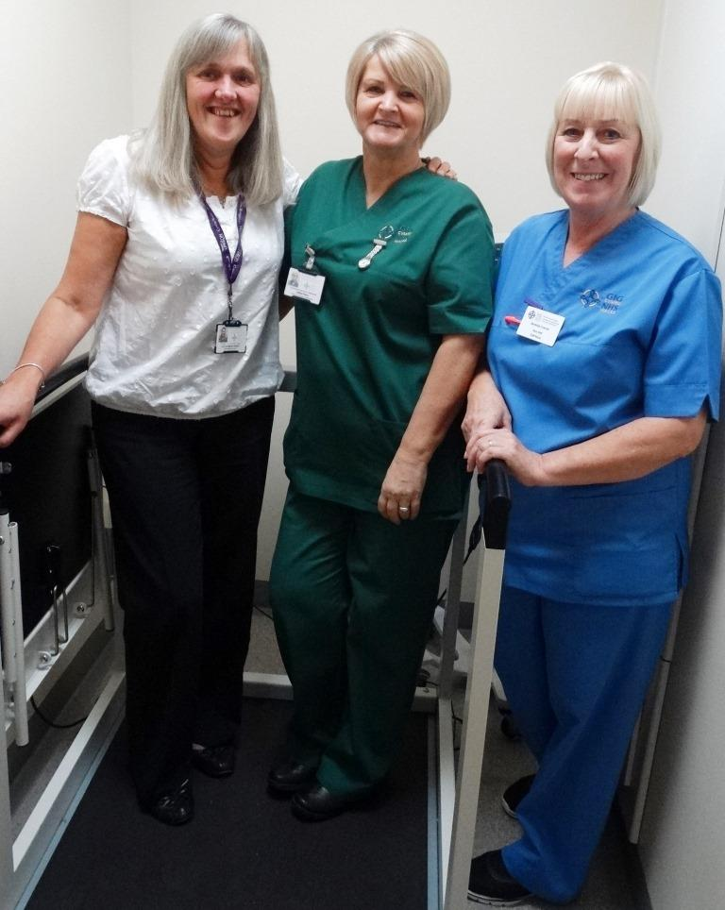
The outpatients department now has wheelchair-friendly weighing scales after a three-year fundraising effort by staff and some of their patients.

L-r: Outpatients receptionist Wendy Cook, healthcare support worker Gillian Parry and staff nurse Bev Francis

Raffles held three times a year, together with the support of patients and a few businesses, meant the £1,200 target has finally been reached and the weighing scales are now in place.

Outpatients department sister Donna-Marie Holder said staff had raised money for various things in the past, including baby-changing facilities and toys in the children’s area.

“We have three raffles a year – Easter, summer and Christmas, but the Christmas raffle is the biggest and always raises the most money.

“Tesco have given us a prize every year and we buy other prizes out of some of the money we raise from previous raffles.

“All the profits, along with donations we receive from individual patients, go towards whatever we are fundraising for at the time.”

Donna-Marie said the decision to buy wheelchair-accessible weighing scales led to the biggest fundraising effort to date – taking around three years from start to finish.

“We had support from the manufacturer, SECA, who found out we were fundraising and secured us an ex-display model in perfect condition with full guarantee and servicing. That saved us £400.

“The boys from our estates department were marvellous, putting it together straight away for us. It’s working great.

“And it’s such a good thing for us to have. We are getting more people, particularly elderly people, who are not mobile and are unable to get out of their wheelchair.

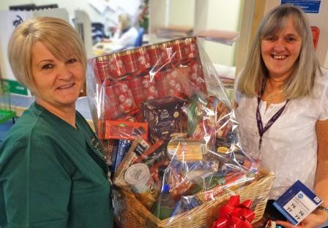
Right: Gillian and Wendy are now helping with the next fundraising effort

“They can roll straight on to these weighing scales and we are compiling a log of wheelchair weights so we know how much to deduct.

“We all know the importance of nutrition and making sure people are at the correct weight.”

Donna-Marie said she wanted to thank everyone who had supported them so far.

She added: “It’s a real team effort. But particular mention must go to healthcare assistant Gillian Parry who produces the trollies displaying the raffle prizes, and our receptionist Wendy Cook, who is marvellous selling the tickets.

“We will be deciding soon what to raise money for next. We ask the patients what they want – we like to keep them at the centre of everything we do.”

Source: Abertawe Bro Morgannwg University Health Board

