Seasonal cough? Your GP doesn’t need to see you
Thursday, 5 January 2017
Coughs and colds are at a seasonal high, but GPs are giving assurances that unless you have other, more serious symptoms, they really don’t need to see you.
Nothing doctors can prescribe will make a common respiratory infection go away any quicker. Plenty of rest and fluids, keeping warm - and time - are the only cures.

Antibiotics are not effective against common chest infections, so unless your symptoms have worsened (indicating a possible bacterial infection) a trip to the GP surgery is pointless, and takes up an appointment slot which a really sick patient might need.

Coughs in particular are causing people to contact their local surgeries in droves, when in reality they don’t need to.

Swansea GP Steve Bassett, who is also the lead GP for the new 111 service, said:

“If you have a cough - even if you are producing green phlegm - if you are eating and drinking normally and are otherwise pretty well; then we don’t need to see you.

“It’s only if you have other symptoms, such as a fever as well as a cough, or have problems breathing, or are vomiting, that we may need to investigate further.

“Coughs and colds simply have to run their course. There isn’t any prescribed medication which can shorten or cure them, and that includes antibiotics which are not effective on viruses, and are more likely to cause you problematic side effects.”

He added that in the past doctors may have listened to patients’ chests if they had a cough, but that made little difference to treatment, unless the patient also presented with additional, more serious symptoms.

“Having a cough, but otherwise feeling more or less pretty well, means you simply don’t need to see a doctor.”

Skewen GP Heather Potter said GP surgeries across the area were extremely busy with patients attending with coughs and colds. This was causing problems in many surgeries because of the effect on appointments.

“People who really do need to see a GP are getting frustrated because they are finding it harder to get an appointment,” she said.

“In some cases these patients end up in the hospital emergency departments because they can’t get to see us quickly enough.

“There’s absolutely nothing a GP can do for a general cough or cold. My best advice, if you have caught a common infection, is to take paracetamol to deal with some of the symptoms and drink plenty of plain tap water.

“People don’t drink enough water generally anyway, and when your body is fighting a virus it needs plenty of water. So drink at least two litres a day.”

Dr Potter advised that if you have had a cough for a week and symptoms get worse – including a higher temperature, much darker phlegm or violent shivering – then go and see your local pharmacist as a first port of call.

“Pharmacists are professionally qualified people who can give advice on whether you may need to go to a GP. If you are asthmatic, for example, they may advise you get an appointment at your surgery. If you are otherwise well, they may suggest you wait for the infection to go away by itself.”

For children under five, she said that a baby or toddler with a cough or cold who was otherwise active and eating normally did not need a visit to the doctor.

“But if they are refusing to feed, vomiting or have dry nappies, then we would want to check them over,” she said.

Below is a list of common seasonal respiratory illness, with advice on how to deal with them:
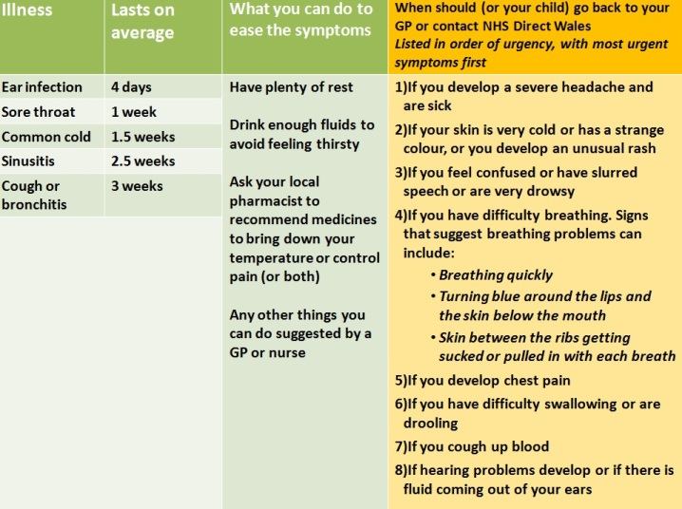

Source: Abertawe Bro Morgannwg University Health Board

