Orthoptists share their eye care expertise during visit by Health Secretary
Thursday, 26 January 2017
Health Secretary Vaughan Gething has been given a close-up look at how eye health care is developing for Welsh patients.

On a visit to the orthoptic clinic at Princess of Wales Hospital in Bridgend he met staff who explained the range of services and treatments they can offer to help patients living in ABMU Health Board area.

Orthoptists are health professionals who work alongside other eye specialists to diagnose and treat patients with eye problems such as squints or double vision.

Mr Gething was greeted by Karen Phillips, head of ABMU’s orthoptic services, which currently account for a third of the orthoptic workforce in Wales including the only five advanced orthoptic practitioners in the principality.

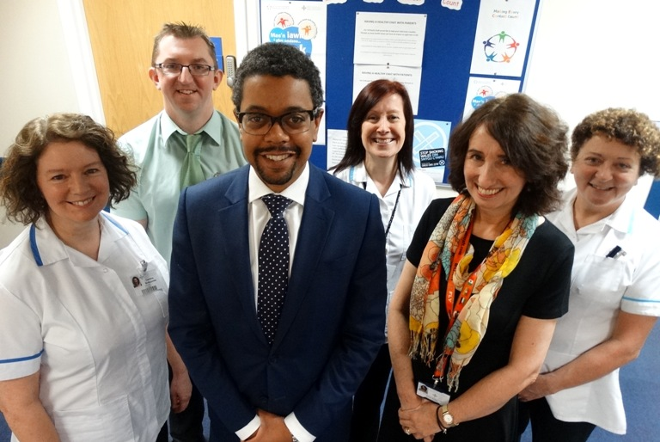
​Health Secretary Vaughan Gething with (from left) Caroline Bodycombe, Alan Ashcroft, Suzanne Martin, Karen Phillips and Judith Downs during his visit to the Princess of Wales Hospital.

She explained how staff across the profession are now developing their skills to expand the role of orthoptists and what treatments they can deliver to patients.

Karen said: “We were pleased to welcome Mr Gething to Bridgend Eye Unit to showcase orthoptic services on behalf of our colleagues across Wales.

“As a small profession, we are relatively unknown and it’s been a great opportunity for us to demonstrate our input into Welsh eye care.”

During his tour Mr Gething talked to Suzanne Martin, the first orthoptist in Wales qualified to give injections directly into the eye to treat conditions such as wet age-related macular degeneration and diabetic macular oedema.

He also met staff who specialise in dealing with conditions such as glaucoma, patients who have had strokes or have learning difficulties and children with visual problems affecting their reading.

The team members, who see patients at Princess of Wales, Singleton and Neath Port Talbot hospitals, shared their vision for how their diagnostic techniques and clinical interpretation skills can be put to wider use in the future.

After meeting the staff Mr Gething said: “I have been very impressed by what I have seen here today and learned about orthoptics.
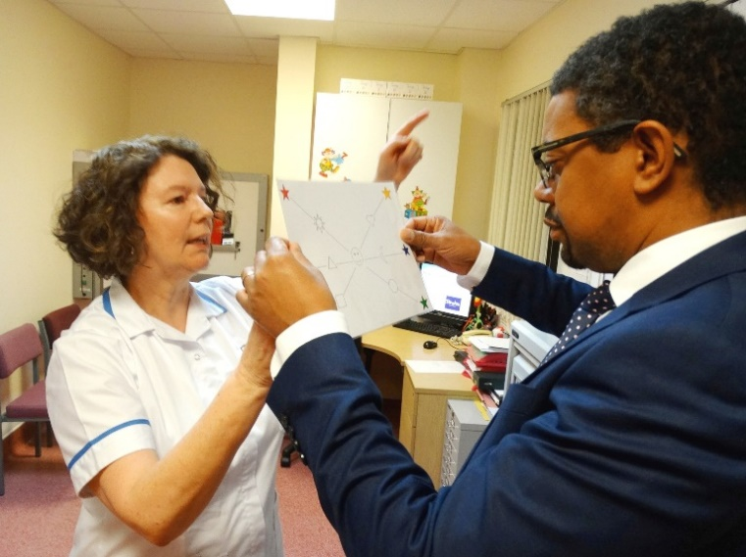
“This is a good example of how different staff can do different things and how we are taking advantage of that variety of skills to help our patients.”

Orthoptist Caroline Bodycombe, who leads the service at Neath Port Talbot Hospital, explains an eye test she uses with stroke patients to Vaughan Gething.

Source: Abertawe Bro Morgannwg University Health Board

