Now a national call to end visits by cola truck
Wednesday, 11 January 2017
ABMU’s Director of Public Health Sara Hayes has welcomed calls to end the nationwide annual Christmas tour by the Coca-Cola truck.

Writing in the latest British Medical Journal, public health experts have united to condemn the marketing tour – which visited 44 towns and cities across the UK during the festive season, handing out free samples – for promoting unhealthy sugary drinks, especially to children.


Their fears about the influence the tour has on youngsters and their demand for it to be banned hit the headlines today.

It was an issue highlighted by ABMU health visitors and dental nurses back in November when they raised their concerns about the brightly coloured truck coming to Cardiff, encouraging youngsters to drink unhealthy sugary drinks.

Dr Hayes (left) said: “I am delighted to see that other health experts share our concerns about this and that those concerns are now getting national coverage.

“This is something that we feel very strongly about and our health visitors and dental nurses actively campaigned to raise awareness about the harm such a marketing ploy can cause.

“It is very satisfying to see that message is being picked up on by other parts of the health community.”

In the BMJ editorial Robin Ireland, director of the group Food Active, set up by public health directors to tackle obesity, and public health consultant John Ashton accused Coca-Cola of “hijacking Christmas by bringing false gifts of bad teeth and weight problems to our children”.

It claimed warnings from public health leaders about the health implications of such marketing were given little coverage compared to the attention the truck’s visits received.

Ahead of the truck’s trip to Cardiff at Christmas, ABMU’s lead public health visitor Jane O’Kane had said: “We know that the acids in fizzy drinks erode tooth enamel and the sugar in the drinks can lead to tooth decay.
“But as NHS staff we just can’t compete with multi-million pound marketing campaigns by fizzy drinks companies, and our message is getting drowned out.
“However, we see the effects of tooth decay in children every day. It’s heart-breaking, and we feel duty bound to speak out about it.”

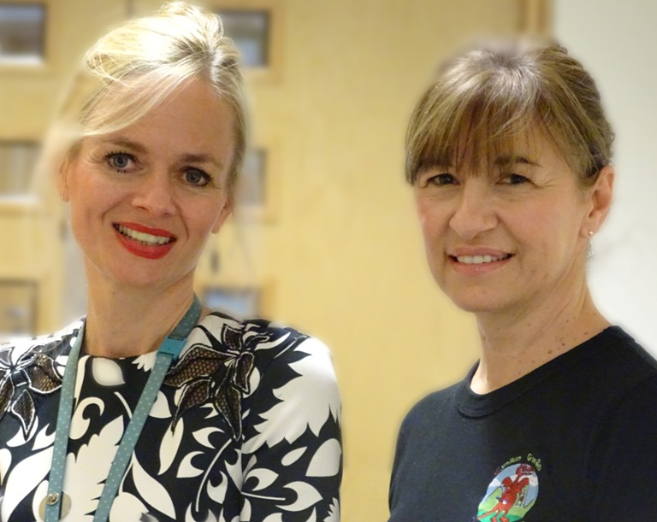
Qualified dental nurse and ABMU lead for the Designed to Smile children’s dental programme, Mandy Silva, said: “The Coca Cola truck is fast becoming a Christmas icon as our towns and cities give the go-ahead for it to tour around, handing out free samples.
“We don’t want to spoil anyone’s fun, but it’s not fun to have decayed teeth either. We want children and young people to enjoy Christmas with healthy smiles.”

Jane O’Kane and Mandy Silva highlighted their concerns about the Coca-Cola truck’s tour in November.

Source: Abertawe Bro Morgannwg University Health Board

