New primary care hub gives more patients the care they need
Monday, 30 January 2017
A new way of working by GPs in Neath is helping thousands of patients get faster and more direct access to treatment.

The Neath Primary Care Hub is an innovative project which has earned Welsh Government ‘Pacesetter’ status, for inventive ways of delivering care in future.
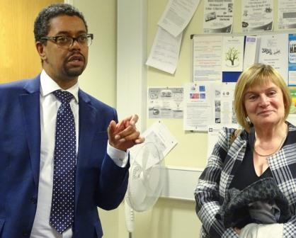
Right: Health Secretary Vaughan Gething with Dr Heather Potter during a visit to the Neath hub

It has improved access for unwell patients who really need to see a doctor; motivated clinicians, and helped to meet future demand, for example demographic changes.

All eight GP practices* in the Neath GP Cluster work together, using special software which links their appointment systems, and cuts paperwork. The Hub also has a prescribing pharmacist, two part-time physiotherapists, and a mental health support worker who care directly for patients.

Patients are triaged (assessed) by a doctor to determine if they need to see a GP face-to-face or can instead get the care they need from another member of the team.
A snapshot assessment of the new service revealed that:

- In one year the Hub’s pharmacist saw over 1,400 patients face-to-face in a variety of settings and managed the needs of another 6,000
- Over three months 574 patients were sent directly to the physiotherapists
- Over four months 112 appointments were made to see the mental health worker, resulting in 64 wellbeing assessments

This has freed up time for GPs to concentrate on patients who specifically need to see a doctor. The service started just over a year ago, but has only been fully up and running for about nine months.

GP Heather Potter, of Skewen Medical Centre, explained:
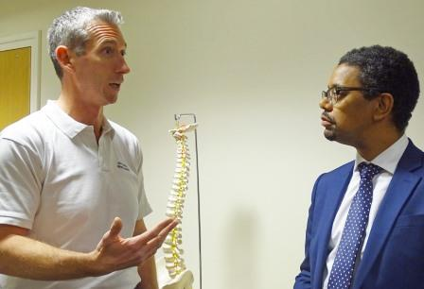
“The Hub was born out of collaboration between the members of the Neath cluster. Two practices had experience in telephone triage. One of the practices had experience in triaging directly to a physiotherapist.

Left: Physiotherapist Scott Hurford in discussion with Mr Gething

“It was conceived that the two models could be brought together and serve all eight of the central Neath practices, with a population of 56,000 patients.”

Dr Potter said that all patients requesting appointments are called back by a GP from their surgery. During the telephone consultation it is decided if the patient needs a face-to-face appointment. In many cases, one of the alternative health professionals in the Hub can provide the care instead.

The system works because the computer software links appointment systems, enabling direct appointment booking while the patient is on the phone to the GP. This electronic communication also allows the clinician to write clinical entries onto the journal, back in the patient’s surgery. This means no time is lost sending paper-based appointments and clinical outcomes.

Health Secretary Vaughan Gething said: “It is fantastic to see the great work at the Neath Primary Care Hub, which has received funding through the National Primary Care Fund.

“New, innovative ways of working such as using a range of healthcare professionals to free up GPs’ time for the most in need, clearly benefits patients. This approach also fits in with our principles of prudent healthcare and our Primary Care Plan. I want to thank everyone here who is working together to improve care for people in Neath.”

Dr Potter said:

“The advantages to this system have been very satisfying. Many musculoskeletal problems are better served by a physiotherapist who has the rights of investigation and onward referral to hospital musculoskeletal services.

“Many mental health problems in primary care don’t require drug therapy, and respond much better to counselling and mental health support groups. These are better accessed by our mental health support worker.

“As well as seeing patients, our pharmacist has relieved many backroom medicine management tasks which used to add to the burden of a heavy working day for a busy GP. This has freed GPs to see unwell patients.”

She added:

“We believe the Hub has great potential for the future. There are many projects in healthcare and social care which would work better at scale. In the future we are looking to place other clinicians in the Hub to further aid the busy GPs and in many cases provide an even better service for patients.”

One patient who has benefited from the Hub is 47-year-old Amanda Barlow, from Skewen, who had been experiencing increasing back pain for a number of years.

She was sent by her GP to see physiotherapist Alex Tincombe.

“Alex was really good. He listened to my symptoms and spoke about the different causes of back pain and the types of treatment that may be offered. He asked a lot of questions and looked at my previous x-rays. He wasn’t happy with the x-rays I had done. He said that they were the wrong view, and asked for different x-rays.

“Even before I knew my special problem [which was a rare condition] he made me feel good as I left. I felt more hopeful and looked after.

“I have seen doctors in the past and it did take a physiotherapist to find my problem. The doctors were okay but they can’t be experts at everything.

“It was great to be referred by the GP to the physiotherapist. I am now waiting to see a spinal specialist.

“I think this is a service which should be extended.”

Another patient who was supported by the Hub service was a 46-year-old woman (who prefers to remain anonymous) who was put in touch with mental health support worker Carl Dunning.

The patient was experiencing the onset of depression following life events, and needed extra support during her recovery as she had become withdrawn and isolated. She said:

‘’I think the scheme is a great idea. I wasn’t clear about what I wanted. I started with a telephone call to Carl and I could tell from his voice that he would be reassuring. I met Carl and he was a great guy. He sold the idea of attending a local arts and crafts centre.

“He went with me on a prearranged meeting. I was able to chat with the arts centre manager and his wife and they really understood the need for physical activity to help recovery from mental health problems.

“I met Carl for a third time at the Alfred Street Hub. There were some delays at this appointment and this was a problem. However, once I met Carl this more than made up for it. He explained my situation and mental health problems. He helped me realise the need to reconstruct my life and restore it.

“He was concerned when I mentioned I had stopped my medication. He told me he thought I should see my GP regarding this.

‘’Carl is a good listener and a genuinely nice guy. My illness has made me a sensitive person and he was very easy to be around. He was also honest and passionate about his work and that was great.

‘’My experience of the Neath Hub has been good because of Carl’s help.”

Ends

*The eight surgeries are: Alfred Street; Victoria Gardens; Skewen; Tabernacle; Briton Ferry (two practices); Dyfed Road and Castle Surgery.

Source: Abertawe Bro Morgannwg University Health Board

