Neath Port Talbot Hospital leading the way in UK with super-microsurgery
Tuesday, 31 January 2017
Transforming the lives of people with a previously incurable condition has established Neath Port Talbot Hospital as a UK surgical leader.

The hospital is the only place in the UK where super-microsurgery on people with lymphoedema is carried out on the NHS.

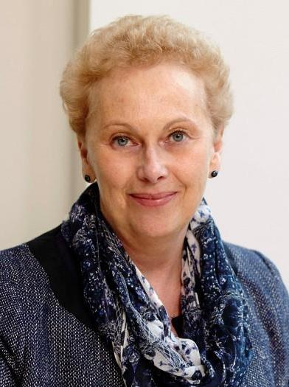
A two-year evaluation of the benefits proved so successful after just 12 months it has already been extended by a further year.

The service is provided by Lymphoedema Network Wales in partnership with ABMU.

Its pioneering work has attracted interest from hospitals in England – and has won a prestigious award.

One of the people whose life the service has changed is Jan Williams (pictured), who was diagnosed with breast cancer and had a double mastectomy in 2002-3.

Jan was devastated when she went on to develop lymphoedema. It severely affected her for 12 years – until super-microsurgery gave her a whole new outlook.

Lymphoedema is caused by the accumulation of lymph fluid. It can lead to swollen limbs that leak fluid, decreased mobility, pain, anxiety and depression and frequent admission to hospital with cellulitis.

It is caused by damaged or removed lymph nodes following cancer treatment or surgery, as well as non-cancer conditions.

Many people have to wear compression garments for the rest of their lives. Others need medication to control infection.

In 2015, Wales became the only UK nation to offer lymphatic venous anastomosis (LVA) on the NHS. It uses super-microsurgery to bypass damaged lymph vessels.

The Welsh Government invested £773,000 for up to 42 patients to be treated annually as part of a two-year evaluation of the benefits.

Because the results of the first year, completed in September, were so encouraging, that evaluation has been extended to three years.

Originally, all the procedures were to be carried out by ABMU consultant plastic surgeon Amar Ghattaura, who at the time was the only trained super-microsurgeon in Wales.

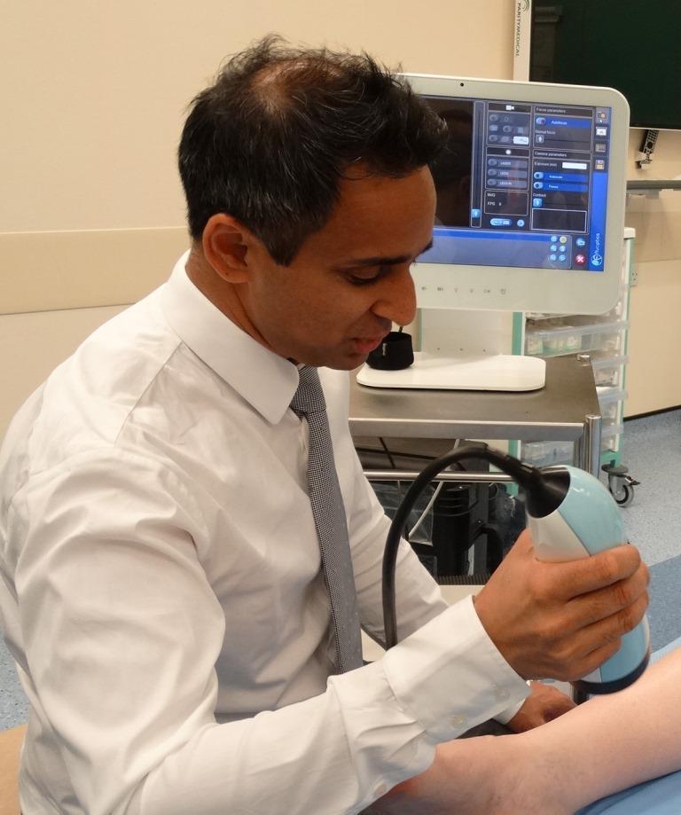
However, Mr Ghattaura (pictured right) has since been joined by microsurgeon Tom Bragg, who is also a sarcoma cancer surgeon.

Mr Ghattaura said: “We’ve done around 48 procedures with good results so far. There is, however, a demand to increase the numbers in the long term to better serve the lymphoedema population of Wales.

“Tom has really enhanced the service in making sure we complete procedures in a timely fashion and improving the number we can perform.”

The full benefits may not occur until up to three years after surgery. But no patient who underwent LVA at Neath Port Talbot has since developed cellulitis, freeing hospital beds and reducing antibiotics.

Six have already stopped wearing compression garments and have been discharged from the lymphedema service.

Melanie Thomas, National Clinical Lead for Lymphoedema in Wales, said: “People with lymphoedema have to make considerable alternations to their day-to-day life due to wearing a compression garment.

“Simple tasks such as washing the dishes and moving their limbs can be affected. Many patients complain of pain and heaviness in their limbs.

“Since having LVA surgery, 100 per cent of patients reported the heaviness had disappeared and pain had significantly reduced.”

Jan Williams was devastated after being diagnosed with lymphoedema in her left arm in 2003.

“Family and friends found it hard to understand the impact, given what I'd been through, but for me it was a daily physical reminder.

“People kept asking what had happened to my arm and, of course, it was debilitating.”

Although Jan, who lives near Swansea, worked hard to manage her lymphoedema she felt self-conscious, hated warm weather and found the summers really stressful.

“I would have given anything to wear a sleeveless dress without my lymphoedema sleeve.”

She praised the lymphoedema team, including Melanie Thomas and Macmillan specialist physiotherapist Cheryl Pike, for helping her through many down times.

“When Melanie mentioned the possibility of LVA, I sent up more than one prayer that I would be suitable for surgery.

“The assessment clinic was such an emotional experience and I cried when I was told I was suitable.

“I am now nearly 18 months post-LVA and my life has been transformed.

“I look forward to the sun, enjoy shopping for summer clothes and relish not having to explain what's happened to my arm.

“LVA has changed my life and I will be forever indebted to Mr Ghattaura, Melanie, Cheryl and the team.”

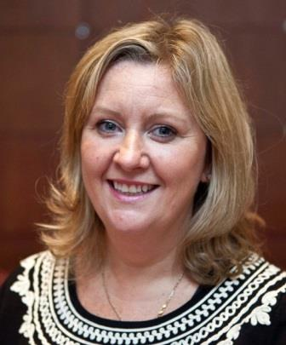
Last month, Lymphoedema Network Wales, based in Cimla Hospital, received the Efficiency through Technology Award at the 2016 MediWales Innovation Awards.

Mrs Thomas (left) said: “Winning this award recognises the importance of collaboration between different services in developing innovation to positively change patients’ lives.

“The LVA service has only been made possible by the Welsh Government Health Technology and Innovation Funding.

“We are so grateful to them for supporting our vision to reduce cellulitis infections and enable patients to stop wearing their garments.”

Meanwhile, the success of the service has led to inquiries from the Royal Marsden Hospital, which has just commenced an LVA trial, and Liverpool’s plastic surgery service.

Mr Ghattaura said: “We’re seeing more and more patients and as we are getting better known, we are getting more and more referrals – not just from Wales but from England too.

“That is good because it means added income, which can fund our research physiotherapist.

“Research is very important part of this work. The data we are collecting goes way beyond current literature published from European and Japanese units working in LVA.”

Source: Abertawe Bro Morgannwg University Health Board

