Mum puts life-saving skills into practice the day after lesson
Tuesday, 17 January 2017
When mum Rebecca Davies was taught what to do when a child starts choking she had no idea she would need those skills to save her own son just 24 hours later.

She sprang into action after four-year-old Kaiden accidentally swallowed a bubble gum ball and used the techniques passed on by nursery nurse Laura Crocker during a routine visit the day before.

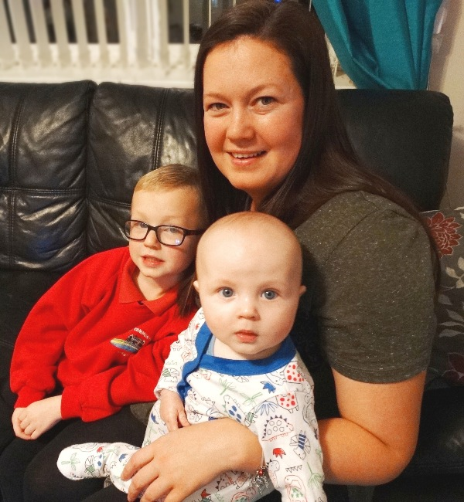
Now a grateful Rebecca, of Eigen Crescent, Mayhill, is sharing her experience so other new parents will realise just how vital those skills are.

“It took less than 15 minutes for Laura to demonstrate what to do but it literally saved a life,” said Rebecca who is also mum to six-month old Oliver.

​Rebecca Davies with her sons Kaiden, now aged five, and baby Oliver.

“I had been taught what to do when I used to work as a nursery nurse but as things change so much when Laura came round for her routine visit with Oliver I wanted her to show me again for my own peace of mind.

“And now I am so glad that she did!”

Little Kaiden had been playing with his cousin when he accidentally swallowed the gum at the bottom of a Screwball ice cream. His mum realised straightaway that it was stuck and he was beginning to choke.

“Because the demonstration was so fresh in mind I knew just what to do, I grabbed him so quickly he didn’t even have a chance to drop the toys he was holding in his hands.”

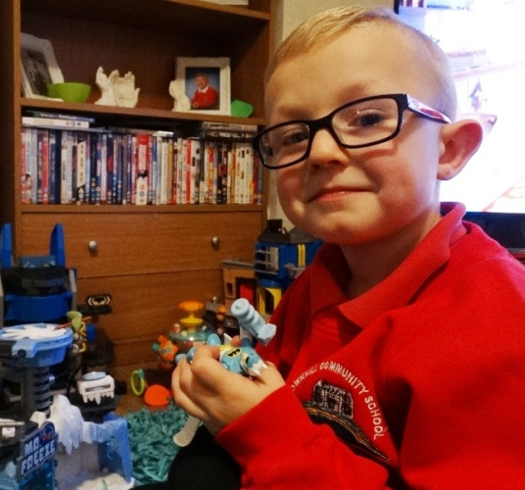
Rebecca delivered five back blows between his shoulder blades, just as she’d been shown, and dislodged the gum which shot out of Kaiden’s mouth.

Though shocked and a bit tearful straight afterwards, Kaiden (right), a pupil at Townhill Community School, was soon back playing as normal.

Laura, who is part of the Flying Start health visiting team covering Townhill and Mayhill, said she was delighted the technique had been put to such good use.

“This is the first time I have actually heard of someone using the technique but I think it is so important that families know what they need to do in an emergency.”

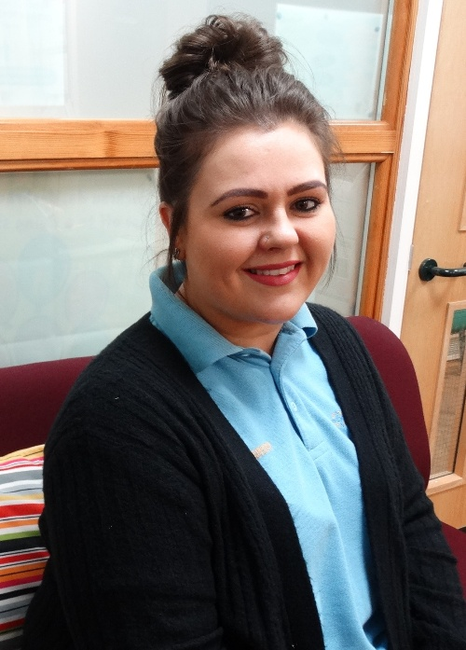
Laura and her colleagues in Flying Start teams across ABMU routinely pass on basic life support to new mums during home visits within four to six weeks of a baby’s birth.

She leaves laminated cards containing the instructions - to deliver five back blows and five chest thrusts – as a reminder and so families can share the information with others.

“If my demonstrations have helped just one family then I am happy - it definitely makes my job worthwhile,” she added.

Community nursery nurse Laura Crocker at Townhill Flying Start.

Health visitor Nicola Baker (right), with Flying Start based at St Helen’s School in Swansea, needed to practise what she preaches when a 10-month-old baby began choking while she was talking to the little girl’s mum.

“I could see the baby was coughing and becoming distressed. It all happened so quickly I’m not sure the mum realised what was happening.

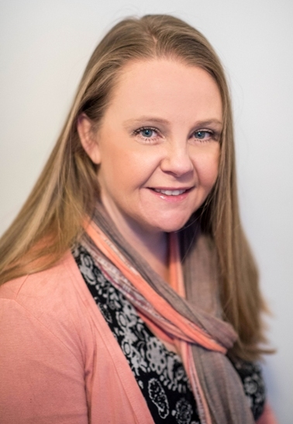
“The baby hadn’t changed colour but it was obviously distressed. I asked to take the baby and gave it back slaps and the baby brought up a gold star, the kind used in handicrafts, which it must have put in its mouth.”

Nicola, who has been a health visitor for three years, added: “This is the first time I have had to use it in a real situation and it was good to be able to put the skills I teach into practice. It shows how important they are.”

ABMU’s lead health visitor for public health Jane O’Kane said it was possibly one of the only health boards in the country to provide life support skills to all its new mums and dads.

“Health visiting in ABMU has been offering this service to families with new infants for many years. All our health visitors have baby resuscitation dolls and can show families the techniques in their own homes.

“These two incidents really go to show how vital it is that parents and carers know what to do if a child they are looking after begins to choke.

“They really are simple techniques but they can mean the difference between life or death.”

The health visiting team hand out a leaflet detailing the key points of basic life support after they have provided the demonstration using a dummy baby.

For choking:
- Safety – check the area is safe
- Encourage the child to cough
- Shout for help
- Give up to five back blow
(If still choking)
- Give up to five chest thrusts
(If still choking)
- Repeat steps 4-5 and ensure an ambulance is called

CPR:
- Safety – check the area is safe
- Stimulate – try to wake the baby
- Shout for help
- Airway – check mouth, tilt head and lift chin (eyes facing towards the ceiling)
- Look, listen & feel for breathing for up to 10 seconds
(If not breathing)
- Give five breaths
- Circulation – Look for any response/normal breathing for up to 10 seconds
- If no response – give 30 chest compressions
- Continue to give two breaths to 30 chest compressions for one minute
(After one minute)
- Call 999 – continue with two breaths to 30 compressions until help arrives

Source: Abertawe Bro Morgannwg University Health Board

