Hospitals’ Wi-Fi improvements given warm welcome by patients
Friday, 6 January 2017
News that ABMU will be expanding its free Wi-Fi network across its hospitals has been warmly welcomed by patients who know what a difference it can make.

Morriston Hospital is among the sites where patients, visitors and staff can already take advantage of the service.
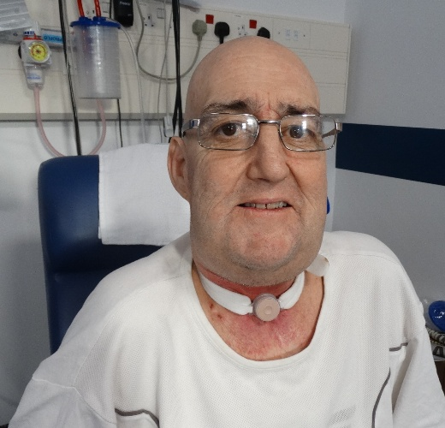
John Thomas, (left) a patient on Ward T, is unable to speak after undergoing a laryngectomy and says he depends on using his telephone and tablet to be able to communicate with loved ones.

“Having free Wi-Fi has been a real lifeline for me. I use my phone constantly to message my friends and family – it is the only way that I can speak to them,” he said.

Mr Thomas, of Swansea, says because he has been in hospital for a while his family can’t always come to see him every day but, thanks to the Wi-Fi, he can email and message them whenever he wants – as well as access information, news and entertainment.

“I am so pleased that it’s been available, it has made the world of difference for me while I am in hospital.”

Thanks to the health board securing a £3.5 million investment, it will now be able to extend its wireless infrastructure to give full coverage to Singleton Hospital as well as bringing Wi-Fi to community hospitals at Tonna, Cimla, Gorseinon, Maesteg and Glanrhyd.

Since ABMU became the first Welsh health board to provide free Wi-Fi, the popularity of the service has grown enormously and now more than 55,000 individual devices connect to the service every month.

It has also been able to extend its system which allows staff to access, the intranet, email, calendars and other digital resources.

The investment is from Welsh Government as part of its digital health and social care strategy for Wales. Improved wireless technology is a crucial tool in the health board’s long-term strategy of modernising the way in which it works and engages with patients.

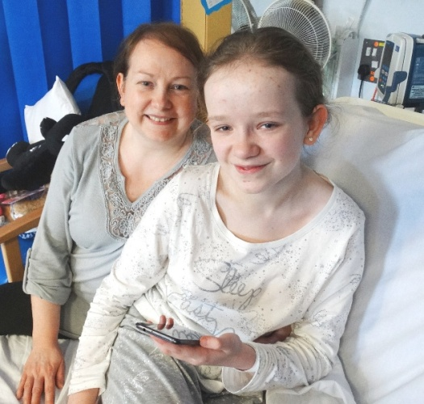
The investment will also help improve patient care by giving clinicians the technology to access and update information on a portable device at a patient’s bedside.

However, as far as 12-year-old Abby Turner, of Neath, is concerned its benefit is simple. She had to spend time away from her friends when a bout of laryngitis led her to Oakwood Ward at Morriston Hospital.

Dawn Turner with her daughter Abby during her stay at Morriston Hospital

“But because there is Wi-Fi I have been able to get on Facebook and Snapchat and keep in touch with everyone and what’s been going on.

“I’ve been glad to have it while I have been here. I would have been really bored without it,” she said.

Her mum Dawn added: “It has been wonderful for us. It has meant I’ve been able to send out group messages and keep family and friends updated about how Abby has been doing so much more easily.”

ABMU’s head of ICT operations Carl Mustad said: “This investment is great news, not only for our patients but also for the staff looking after them.

“We pride ourselves on the fact we are constantly looking at ways we can use informatics to help staff and patients - our wireless business case is one of a number the health board will be submitting to Welsh Government as part of our Informatics Strategic Outline Programme to deliver state-of-the art digital services to support the provision of high quality care.”

Source: Abertawe Bro Morgannwg University Health Board

