Health board to take over volunteer services at Singleton Hospital
Monday, 30 January 2017
Managers at Singleton Hospital are set to take over services currently provided for visitors and patients by the British Red Cross.

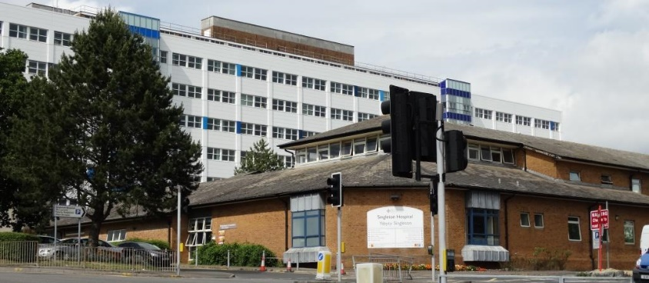
The charity’s decision to withdraw from the hospital follows a review of its services and the role it plays in the community.

The Red Cross has provided a front desk information and advice service, and operated a tuck shop as well as offering refreshments and emotional support for patients and families using the chemotherapy and radiotherapy units at Singleton for the past 20 years.

Hospital chiefs have reassured the public these services will continue and are now involved in talks with the charity about making the transition as smooth as possible.

More than 60 volunteers who currently give up their time to help at the hospital will be able to join ABMU’s own team of volunteers or continue to work with the British Red Cross as it strengthens its role supporting vulnerable patients in the community.

Hospital Director Jan Worthing said: “We are very grateful for the support the British Red Cross and its dedicated volunteers have provided for us, our patients and visitors over the years.

“We value their role and will be happy to welcome those who wish to stay on at Singleton to our team.

“Our priority remains making sure the public receive the help and support they need when they come to use our services and those volunteers help us do that.”

Annie Fazackarley, the British Red Cross’ Independent Living Operations Manager for Swansea Morgannwg, Mid and West Wales, said: “We are reviewing our future role at Singleton Hospital because of changes to our organisational strategy and service focus.

“We want our volunteers to remain involved in the work the British Red Cross carries out in the Swansea area and we will support them however we can to enable them to do that.

“Our volunteers have been at the heart of our services at Singleton, supporting patients and their families for two decades, and it is essential that we do everything we can to retain that experience and passion for voluntary service as we continue to support people in our communities during their times of crisis.”

Everyone affected by the changes was invited to attend a meeting today to discuss the transition which is expected to be complete by May.

One permanent member of British Red Cross staff based at the hospital is currently in discussion with ABMU under TUPE regulations.

Ms Fazackarley said the service the Red Cross provides at Morriston Hospital’s Accident & Emergency department, offering refreshments and support as well as a home transport and resettlement service, would not be affected by the changes.

And she said, subject to funding, the organisation hoped in future to be able to introduce a similar emergency department support service at Singleton Hospital.

“We hope to maintain what remains a valued, long-standing and fruitful relationship with Singleton Hospital and look forward to working alongside health professionals there well into the future,” she added.

For more information contact British Red Cross’ Independent Living Operations Manager Annie Fazackarley on 01554 745480 or if you are interested in becoming an ABMU volunteer call 01656 753781 or email volunteer.centre@wales.nhs.uk

Note: This is a joint release on behalf of ABMU Health Board & British Red Cross

Source: Abertawe Bro Morgannwg University Health Board

