Grateful golfers’ boost for hospital ward
Monday, 23 January 2017
Golfers teamed up and teed off to raise money for the Morriston Hospital ward that had helped them.
Jeff Cox chose good causes to support during his year as captain of Cwmrhydneuadd Golf Club, near Llandysul, Ceredigion, - and one of those was the hospital's Cyril Evans Ward which looks after cardiac patients.

As a result Jeff, of New Quay and fellow club member John Williams, from Pentregat, visited the ward to hand over £1,250 to sister Louise Jenvey.

The money was raised at a special Captain's Day held at the club which saw teams take on the nine-hole course.

Both John and Jeff, as well as several other club members, had received treatment on the ward in the past.

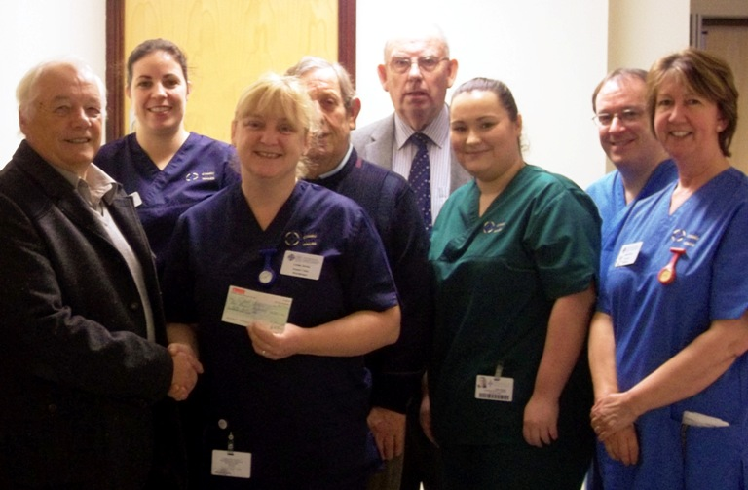
"We wanted to do something to say thank you for the wonderful care we received at Morriston. We are all doing well now, thanks to the staff there," said John.

Louise said: "We are very grateful for this wonderful donation. A big thank-you from all the staff and future patients."

Sister Louise Jenvey and staff at Cyril Evans Ward with Jeff Cox and John Williams.

Source: Abertawe Bro Morgannwg University Health Board

