Get your year off to a healthy start by exercising safely
Friday, 6 January 2017
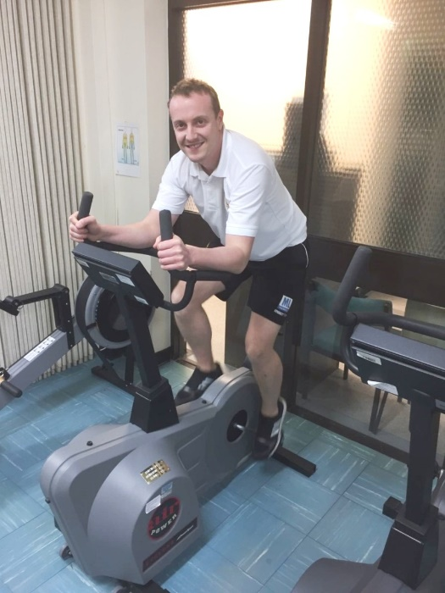
As we begin the new year there is no better time to make a few lifestyle changes to get 2017 off to a healthy start.

But it’s important to go about it the right way. Over-indulgence and good intentions will see hundreds of us rushing back to the gym but don’t forget to take care so you avoid injury if you are starting a new exercise regime.

Luke Hathaway, of ABMU’s Physiotherapy Health Promotion Group, said: “We want to get the message out about how people can prevent injuries as they start back exercising or take up fitness as part of their new year’s resolution.”

Physiotherapist Mathew Lewis takes to the exercise bike

While the group encourages people’s passion to work off those extra calories, Luke said they always need to remember that getting fit is a marathon, not a sprint.

The team wants to make sure people exercise carefully and to help spread the message the physiotherapists have now put together guidance about injury prevention.

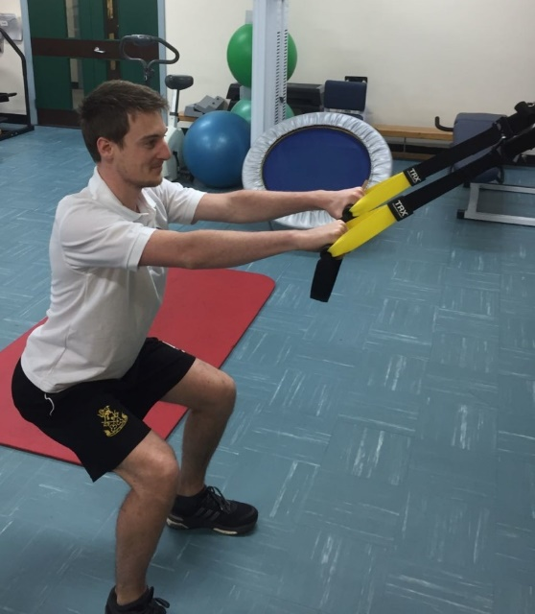
Physiotherapist Gareth James demonstrates the safe way to exercise

Their advice includes making sure you get the right nutrition and hydration to help the body repair itself after exercise, it also emphasises the importance of taking rest days to allow your body to recover and getting enough sleep.

They say simple tips like having the right footwear to prevent twists and sprains and warming up and cooling down correctly can make a real difference.

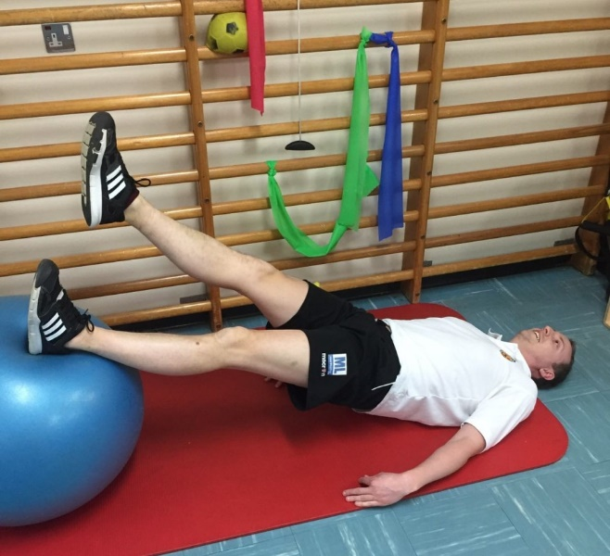
Luke added: “From a staff wellbeing perspective we want our colleagues to avoid injury so they are able to work at what is always a very demanding time of year for health care.

“But this advice applies to everybody and hopefully if we can keep people fit and well this will help ease pressures on services such as physiotherapy.

“Getting and staying fit are great goals to set yourself for 2017 but you have to remember to do it sensibly and take care of your body.”

For more information go to www.nhs.uk/livewell

Source: Abertawe Bro Morgannwg University Health Board

