Friends’ donation helps keep patients sitting comfortably
Wednesday, 25 January 2017
Maesteg Hospital League of Friends have generously donated more specialist equipment to enhance the care provided to patients on Llynfi Ward.
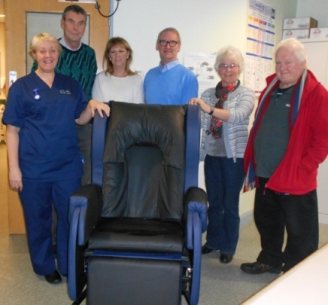
Representatives from the group visited the hospital to hand over two Auto Logic pressure relieving systems and a HydroTilt chair to ward manager sister Helen Bridgman.

Sister Helen Bridgman, John Thomas, Dianne Thomas, Michael Ball, Lynda Williams and Steve Jones with the new HydroTilt chair.

Helen said: “This equipment is vital to patient pressure-relieving care and comfort, they are invaluable and in daily use.

“The ward staff cannot thank the league enough for their support in providing additional equipment to the ward.”

League chairman John Thomas said: “These donations would not be possible without the generosity of the local community and we would like to thank everyone for supporting the League of Friends throughout the year particularly at our annual fete.”
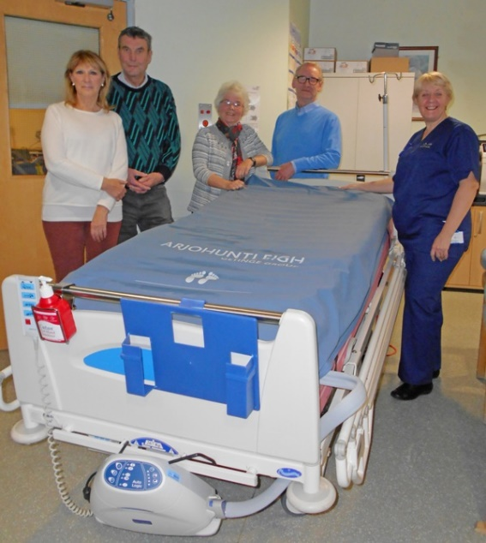
He said the group was always on the look-out for more members to help continue its fundraising efforts.

“If you would like to join our small committed group you can contact us via Maesteg Hospital,” he added.

Pictured with the Auto Logic mattress on a bed are Dianne Thomas, John Thomas, Lynda Williams, Michael Banks and sister Helen Bridgman

Source: Abertawe Bro Morgannwg University Health Board

