Bridgend North residents get hearty with new programme
Wednesday, 25 January 2017
Health secretary Vaughan Gething has been finding out more about a programme aimed at reducing the number of people dying prematurely from cardiovascular disease (CVD) in the Bridgend North area.

Eight Bridgend North GP surgeries, in partnership with ABMU health board and local organisations, have launched the latest stage of a Wales-wide pilot programme to help residents in their area live a healthier life for longer.

Evidence shows that people living in deprived areas such as the North of Bridgend, are likely to have shorter healthy lives by up to 21.5 years and, are at greater risk of CVD, when compared to people living in affluent areas.

There are a number of types of CVD. The main ones are Coronary heart disease – angina, heart attacks and heart failure; strokes and mini strokes.

The CVD programme will see people aged 40 – 64 years living in the North of Bridgend, who don’t often go to their GP, being invited to a lifestyle assessment with a qualified and specially trained health care support worker (HCSW).

The HCSW explains what CVD is and how it can impact on your life. By using information people provide about themselves, the HCSW is then able to assess the likelihood of the individual suffering from CVD. If risks are found, the HCSW then supports the individual to decide on and make positive changes helping them to feel better and live a longer healthier life.
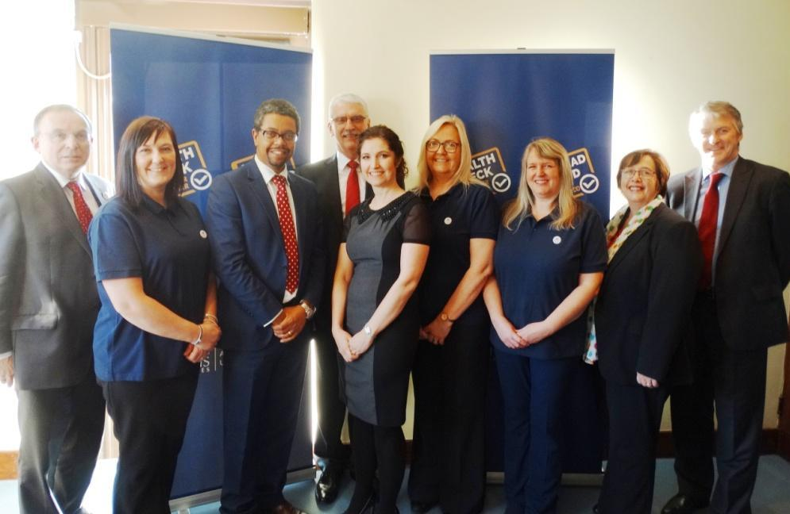
Pictured at the launch: Andrew Davies (ABMU Chairman); Louise Kenny (HCSW); Vaughn Gething AM; Charles Janczewski (ABMU Vice Chairman); Dr Sara Jones; Heather Dawes (HCSW); Anne Williams (HCSW); Elaine Tanner (ABMU Support Officer) and Huw Irranca-Davies AM.

Lead clinician for the programme, Tynycoed GP Dr Sara Jones, said: “Everyone should be able to live a long healthy life and see their family grow-up no matter where they live. We want to help the residents in our area to do just that. We have the resources available to help and support them to make simple changes to their lifestyle, reducing the chances of them becoming ill and dying prematurely.”

In order to give residents the best chance possible, the Bridgend North GP surgeries are working in partnership with organisations such as Bridgend County Council, the National Exercise Referral Scheme, Education Programmes for Patients, Drug and Alcohol Services and the Bridgend Association of Voluntary Organisations.

The GP surgeries have also recruited a lifestyle coach, working with HALO leisure, to provide much needed support to those wishing to lose weight by increasing physical activity and learning about nutrition.

Dr Jones added: “Working closely with other organisations to ensure individuals can access all they need to make changes is key to their personal success and the health of the community as a whole.

“The benefits of this programme are endless. As well as giving the individual a better quality of life and helping them to live longer, it will reduce the number of people needing medical treatment in the future and therefore reduce admissions to hospital.”

On speaking with members of staff, Health Secretary, Vaughan Gething said: “I am pleased to launch this programme, which will positively affect many lives in the Bridgend North area.

“This prudent and sustainable programme will not only help prevent people from developing cardiovascular disease but will also ensure that those who are already affected by it have access to high quality high quality cardiac services regardless of where they live.”

Bridgend North has one of the highest rates of residents living in deprived areas in Wales.

The project will begin in Tynycoed and Aberkenfig surgeries in the next month, with staggered launches for the following surgeries:

Nantymoel Surgery
Pontycwmmer Surgery
Woodlands Surgery
Bron-Y-Garn Surgery
Llynfi Surgery
Ogmore Vale Surgery

Residents will be invited by letter for an assessment over the next 18 months.
Source: Abertawe Bro Morgannwg University Health Board

