Be careful in icy conditions
Wednesday, 11 January 2017
Snow may or may not fall this week but emergency doctors are warning that ice could pose even more of a danger this winter.

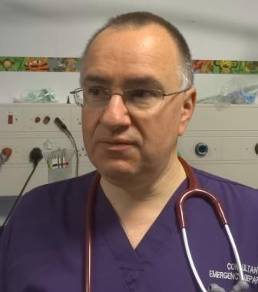
Elderly residents are particularly at risk of slipping and falling while going about everyday tasks like taking the bins out or even feeding the birds.

Morriston Hospital emergency consultant Andy Macnab

That can lead to serious injuries such as broken limbs or hips, requiring surgery and a stay in hospital.

Instead, when it gets icy, they are advised to stay indoors; and if possible get a fit and healthy friend or relative to run any errands for them. Or, wait until later in the day when ice has thawed.

Newspaper headlines this week are filled with speculation about snow. But forecasts are changing almost hourly, and it is unclear how much snow may fall in this part of South Wales.

However, ice is always a more likely prospect throughout the winter, and can catch elderly people unawares as they go about routine chores in the familiar surroundings of their own homes and gardens.

Morriston Hospital A&E consultant Mike McCabe said: “The majority of fractures and slip injuries happen within five to 10 metres of people’s homes.

“Their own paths, driveways and gardens are the most dangerous areas.

“My advice is to stay indoors unless you really have to go outside. Don’t worry about putting the bins out or feeding the birds – they can wait. What’s important is that you stay safe.”

Morriston Hospital emergency consultant Andy Macnab said elderly people often wanted to clear ice from their path or steps in case someone fell.

“But their sense of balance isn’t as good as a younger person’s and they can end up falling themselves, ending up in A&E with a broken bone.

“The clear message for elderly people is to stay indoors. Get a fit and healthy relative or friend to run any errands for you.”
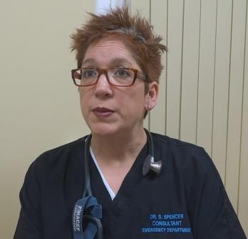
Princess of Wales Hospital emergency consultant Sarah Spencer (right) added: “Every year we see an increase in patients arriving at our EDs with broken bones and other injuries from falling in snow and ice.

“For some people this means having a wrist, arm or leg in a plaster cast for a few weeks.

“But for others it can be much more serious and very painful, requiring an operation and a stay in hospital.”

Anyone who does have go out is strongly advised to take extra care and wear warm clothes and non-slip shoes. Wherever possible they should wait until midmorning when the worst of the ice will have thawed.

Meanwhile, doctors are advising residents to take steps to help keep their families safe and well should the weather take a turn for the worse.

Very cold weather can lead to an increase in conditions such as flu, hypothermia and heart attacks.

The very young, old and those with existing chronic health conditions are particularly vulnerable to the effects of very cold weather.

They should not go out unless they have to. Instead they should remain indoors but keep moving about as much as possible.

Very minor illnesses such as a cough or cold can be treated at home with basic over-the-counter medicines such as sore throat and cough remedies, pain relief and a first-aid kit.

Pharmacists can provide further help and advice, as can the 111 urgent care service now available in the Bridgend, Neath Port Talbot and Swansea areas.

Source: Abertawe Bro Morgannwg University Health Board

