ABMU up for three UK awards for putting patients at the heart of healthcare
Monday, 16 January 2017
Putting patients at the heart of healthcare has led to a trio of ABMU projects making the final of a UK-wide awards scheme.
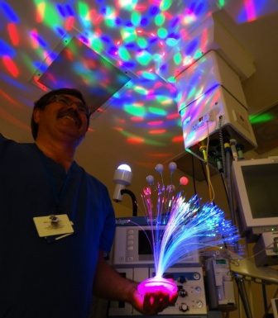
Health board staff have made the shortlist three times in the Patient Experience Network National Awards.

A self-management group, a unique “spa” experience and an arts in health programme are all in the running.

Paul Harris of Princess of Wales Hospital where the unique Soothing Patient Anxiety initiative has been shortlisted for a PEN award

The Patient Experience Network (PEN) is a not for profit independent organisation that strives to improve the experience not just of patients but their family and friends too.

Each year the PEN National Awards recognise best practice in the experience of care across all facets of health and social care throughout the UK.

The 2016 winners will be announced at the PEN conference and awards ceremony in Birmingham Repertory Theatre on Tuesday 21st March.

ABMU has been shortlisted twice in the Strengthening the Foundation category.
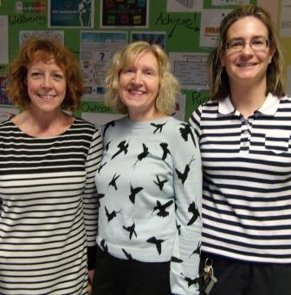
Caswell Clinic, a medium secure forensic mental health unit at Glanrhyd Hospital in Bridgend, is in the final for its patient self-management group.

Set up and run by occupational therapy staff with nursing support, this is an innovative project to give patients a greater involvement in their own care and treatment.

The Caswell Clinic team that runs the self-management group: forensic community mental health nurse Leah Evans, OT team manager Janet Day and OT technician Jo Poupon

They take part in workshops where staff provide them with the necessary skills to become more involved with their care and treatment plans.
The patients are encouraged to explore different aspects of their lives, identify potential problems and find possible solutions to help them move on.
Occupational therapist team manager Janet Day said the feedback had been very positive and a research project was under way to examine its overall effectiveness.
She added: “I’m very pleasantly surprised that we have been shortlisted.
“The patients have been very positive about the group and I am delighted the work we are doing has been recognised.”
ABMU is also in the Strengthening the Foundation category for the way it has developed the arts to support excellent care.
This began with a part-time arts coordinator for an 18-month pilot five years ago and has grown into a part-time team of five.

Thousands of patients have benefited from a wide-ranging programme of music, storytelling, poetry, dance and visual arts.

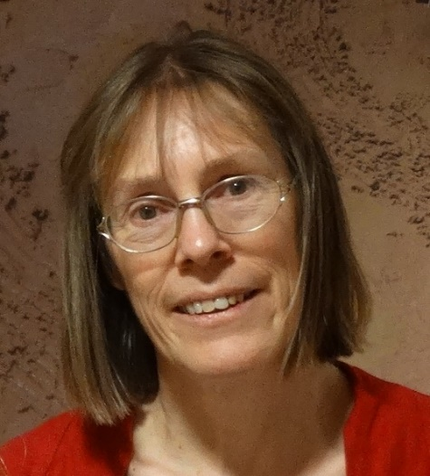
In addition to ABMU charitable funds, £200,000 of external grants has been secure to help pay for these activities.

Arts in health coordinator Prue Thimbleby (pictured) said: “Five years ago a small group of staff plus the charitable funds committee took a risk and appointed an ABMU arts coordinator.

“Being a finalist in the PEN Awards shows that it has paid off.

“Arts in health is growing across the world with evidence of real benefit. Our aim is for ABMU to help lead and support this emerging field.”

Meanwhile, Soothing Patient Anxiety (SPA), a unique initiative at Princess of Wales Hospital for patients with learning disabilities, has been shortlisted in the Personalisation of Care category.

The project, which has already won an NHS Wales Award, sees the theatre team including specialist trainer Paul Harris going to extraordinary lengths to make sure patients feel at ease ahead of surgical treatment.

This could mean playing a favourite film or music to a patient as they go to sleep or using an array of props ranging from disco lights to remote controlled toys to help relax them.

Paul said: “The team feel very honoured to have their work recognised at such a prestigious event.

“Clinical environments can often appear frightening to many.

“It’s a pleasure to make the essential, reasonable adjustments necessary to deliver a highly personalised care experience for unique people that is memorable for the right reasons.”

Source: Abertawe Bro Morgannwg University Health Board

