Minister gets first-hand experience of apprentices’ success stories
Wednesday, 28 February 2018
Welsh Government Minister Eluned Morgan has been finding out for herself the career-changing difference ABMU apprenticeships can make.
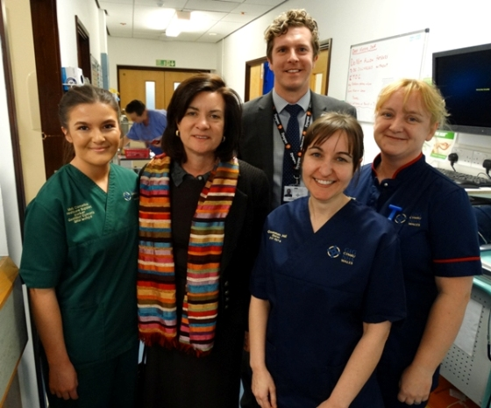
She dropped in to attend one of the regular workshops held at Morriston Hospital by the Health Board’s Apprentice Academy, which bring its new recruits together for training and support.

Molly Cornelius (left) with Eluned Morgan, Prof Tom Crick, Ward Manager Gwennan Hall and Matron Louise Jenvey at Cyril Evans Ward.

The Minister for Lifelong Learning and the Welsh Language heard from both current apprentices and their line managers about what they have gained from taking up the training opportunities.

She also visited Cyril Evans Ward to meet Molly Cornelius who swapped scissors for scrubs when she gave up hairdressing to become a healthcare support worker apprentice.

She has now become one of the successful apprentices to secure full-time employment with ABMU at the end of her initial training and now works on the cardiac ward.

Molly said: “I started as an apprentice about a year ago and I have been lucky enough to be kept on. My role now is as a healthcare support worker. I am about to go onto a Level 3 qualification and the plan is hopefully to go into nurse training.”

Cardio-thoracic surgery matron Louise Jenvey said: “Molly has gone from strength to strength. The apprenticeship has been a really good way of getting her into nursing.”

Paul Davies, Head of Nursing for surgery, added that finding innovative ways of developing future nurses was very important.

He said: “We aim to be very flexible; we can offer contracts that enable an individual to remain in employment but still be able to complete all their university opportunities.

“And even if a university-based degree course isn’t the answer, Molly and her colleagues will still have opportunities to progress. We have a vested interest in their success.”

ABMU launched its apprenticeships in 2016 to provide a stepping-stone to a career in the health service and since then they have become increasing popular with jobseekers of all ages, including existing members of staff who want to add to their skills.

Academy manager Ruth Gates said: “Currently we have apprentices working as administrators, HCSWs on our wards and in our theatres, assistants in our laboratories and in areas such as learning and development, outpatient booking offices, estates and facilities and our therapies department.”
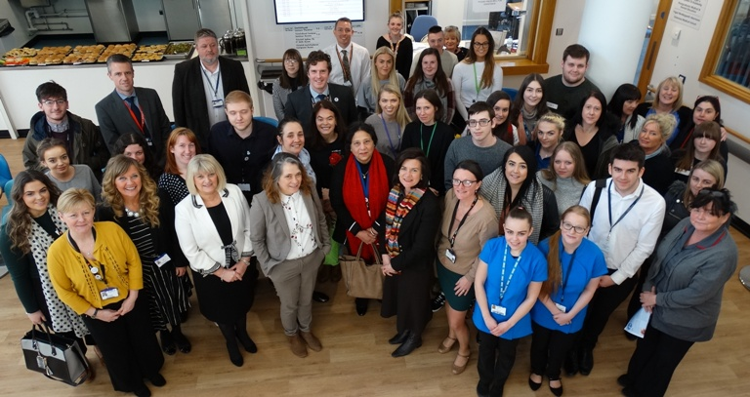
Minister for Lifelong Learning Eluned Morgan with apprentices, ABMU staff and representatives from NPTC Group.

She said the majority are undertaking apprenticeships in business administration and clinical health care support but there are plans to expand the qualifications on offer to pharmacy, hospitality and ICT.

Successful applicants secure a fixed-term 12-month contract and work towards a nationally recognised qualification while being paid an apprentice rate.
Theatres apprentice Sharon Hunt said though this rate might put some applicants off it does prove the apprentices’ commitment to their training and the long-term advantages additional qualifications can bring.

“It shows I am here because I want to be here and that shows I do mean business,” she said.

Neurophysiology manager Helena Morgan said her positive experience since having Robyn Hopke as part of her team had encouraged her to take on further apprentices. Robyn is now a Higher Level apprentice in neurophysiology and has progressed to a Level 3 qualification.

Helena said: “Apprenticeships provide a unique opportunity. If they don’t like what they are doing they haven’t given up too much of their life, but if they do they get a good idea of a future career path and what it involves.”

HCSW apprentice Bethan Turner said she became an apprentice because she felt it would be more beneficial than staying on in college.

Now based at Morriston’s Ward D, she said: “I have no regrets; every day brings a new challenge.”

The Minister was welcomed to the event by Professor Tom Crick on behalf of ABMU’s board, along with Nicola Thornton-Scott and Alec Thomas, from NPTC Group of Colleges.

Their organisation works in partnership with the academy to identify suitable candidates for apprenticeships and to support them throughout their training.

During the session, she also heard from Shannon Rees, who has gone from apprentice to a role as senior IT support officer.

She said: “My apprenticeship was an unbelievable experience I was able to gain qualifications as well as learning on the job.

“From there I applied for a vacancy that was on offer and because of my past experience and on-the-job training I successfully got the job. It wasn’t for my apprenticeship I don’t think I would have been able to proceed further into IT.
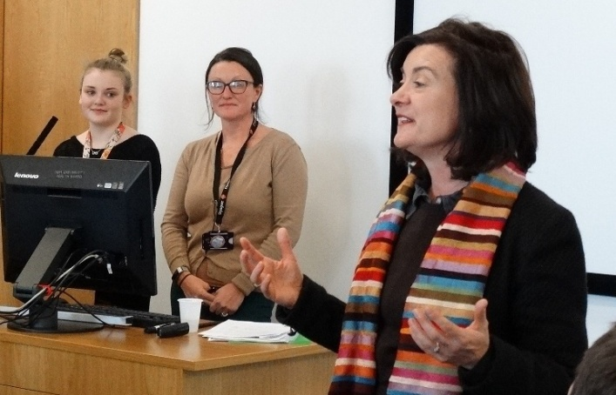
“I am very grateful for that opportunity. I would love to go into a management position eventually.”

Minister for Lifelong Learning Eluned Morgan with learning and development apprentice Giorgia Towns and ABMU Apprentice Academy manager Ruth Gates.

The Minister urged the apprentices – whatever their roles – to continue their commitment to lifelong learning, especially as developments such as tele medicine and technological advancements bring new challenges.

“We all have to continue learning - every day there is something new to learn and we have to keep learning to keep up.”

She told the apprentices: “The future of the NHS in Wales is in your hands – please continue to learn and continue to care.”

Source: Abertawe Bro Morgannwg University Health Board

