Lisa’s clocking up the miles on latest charity challenge
Wednesday, 14 February 2018
Fundraising ABMU nurse Lisa Phillips has laced up her running shoes for another gruelling charity challenge – and it is going to take all year to complete.
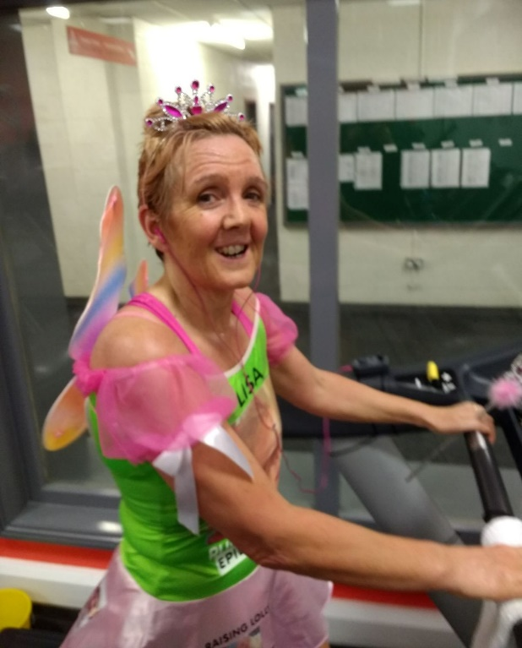
Lisa, a children’s epilepsy nurse specialist, is planning to run 11 half marathons and a marathon this year to raise money for Ty Olwen hospice at Morriston Hospital and Epilepsy Action Cymru.

She has already clocked up one half marathon on a treadmill but is now looking forward to her second run of the month on Saturday 17th February.

Lisa (left) during her first half marathon on the treadmill..

Lisa said: “I will be dressed as a fairy while I run from Alltwen to Neath golf course and back.

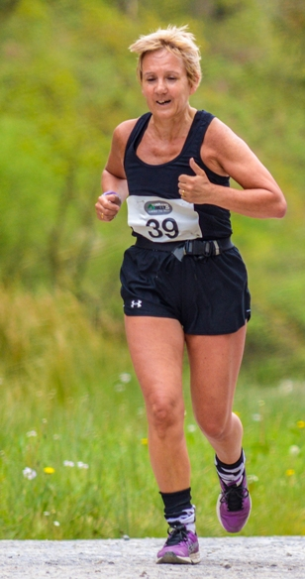
“The reason I’m dressed up is because one of my little patients, Rosie, loved pink and everything to do with fairies.

“Sadly Rosie is no longer with us but she comes on all my runs as I have her photo on my fairy costume.

“I also have a photo of my friend’s husband and my wonderful dad who were both looked after so well by staff at Ty Olwen.”

Lisa says anyone is welcome to join her on her route this week or on any of her other runs.

“Unfortunately illness meant I had to miss January so I have two planned for this month to catch up.

“I will be running Merthyr Half next month, Newport Marathon in April, Swansea Half in June, Port Talbot Half in August and Cardiff Half in October. I plan to fill in the gaps in my calendar I go along.”

Running to raise money is nothing new to Lisa. Back in 2015 she won the Chair’s Challenge at ABMU’s Chairman’s Awards for her mission to mark her 50th birthday year by taking part in five major road run events while supporting good causes.

She also organised a 24-mile fundraising group run from Princess of Wales to Singleton hospital in 2016.

If you would like to support her latest campaign please click here to support Ty Olwen or here to donate to Epilepsy Action Cymru.

Source: Abertawe Bro Morgannwg University Health Board

