Denise praises 111 after cough leads to four-night stay in hospital
Tuesday, 20 February 2018
A Swansea woman has praised the 111 Wales service after a cough developed into something far more serious.
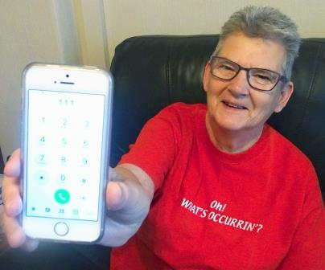
Denise Betsworth didn’t think too much about the cough at first.

But it got gradually worse, culminating in Denise being woken in the early hours with stabbing pains in her back.

The next day, Denise called 111 – the NHS Wales number people can use for advice and to access urgent care after their GP surgery has closed – thinking she had damaged a rib or a muscle by coughing.

Instead she was sent directly to Morriston’s Emergency Department and was admitted with pneumonia and flu, as well as a chest infection.

Denise, of Plasmarl, only ever sees her GP as a last resort, preferring to self-medicate and get advice from a pharmacist, which is what she did when she first started coughing.

“Eventually it got really bad. My chest felt tight. I started sneezing, had a runny nose, felt hot and cold, was aching all over. I couldn’t keep any food down, or water.

“I was awake all night, coughing constantly, so much so that I couldn’t catch my breath. I couldn’t breathe.

“During the early hours of the morning, I woke up with a stabbing pain, as if someone had stabbed me in the lower left of my back.

“I thought I’d broken a rib or strained a muscle coughing. So in the morning I phoned 111.”

People should call 999 in the event of a life-threatening emergency. For everything else they can use 111, the free-to-call number which brings together NHS Direct Wales and the GP out-of-hours service.

It is available to people registered with a GP practice in Bridgend, Neath Port Talbot, Swansea and Carmarthenshire.

Having a single, memorable number to call makes it easier for them to access health information and advice if they are ill and unsure of what to do, and access urgent care if their GP surgery is closed.

When they dial 111 they first speak to a call taker who asks them a series of questions.

The appropriate healthcare professional – which could be a doctor, nurse or pharmacist – will take more detailed information. They will then decide the best course of action.

Denise spoke to one of the 111 nurses. “She asked me questions about the aching, and about how I was feeling.

“She was concerned it might be a cardiac problem because I was having pains in the back of my neck and arm.

“She told me I needed to go to the Emergency Department, and made sure I had transport or she would have sent an ambulance.

“I went up to the hospital thinking they’d sort me out and send me home.

“But it turned out I had severe chest infection with a high level of infection, pneumonia, and then flu on top of that.

“I had two lots of antibiotics in a drip, then in pill form. I was in until the Monday afternoon but even after I was discharged I needed more antibiotics because my chest still hadn’t cleared.”

In fact it took several weeks for the cough to go and for Denise to feel well enough to leave the house.

She described the service she received from 111 as wonderful.

“They went through everything thoroughly and the advice was spot-on.

“I wouldn’t have gone to A&E because I know how busy they are and I would have felt like I was wasting their time.

“But when I was told I really needed to go, it made me feel more confident about it – and I’m glad I did now.”

For health information and advice, including online symptom checkers, visit the NHS Direct Wales website.

Source: Abertawe Bro Morgannwg University Health Board

