Read all about library friends' fundraising boost for patients
Friday, 10 February 2017
The members of a friendship group who meet every week for coffee and a chat have helped support care for renal patients at Morriston Hospital.

The Ladies of the Library get together every Tuesday at Llangennech Library but besides enjoying a catch-up over a cuppa, they also hold regular fundraising event to support various charities.

Two of its members have personal experience of the care provided by the Renal Unit at Morriston Hospital and wanted to do something to help the hundreds of dialysis patients it looks after from all over South and West Wales.

Brenda Payne and Susan Hill returned to the unit to hand over a cheque for £325 on behalf of group members to senior sister Melanie Jones.
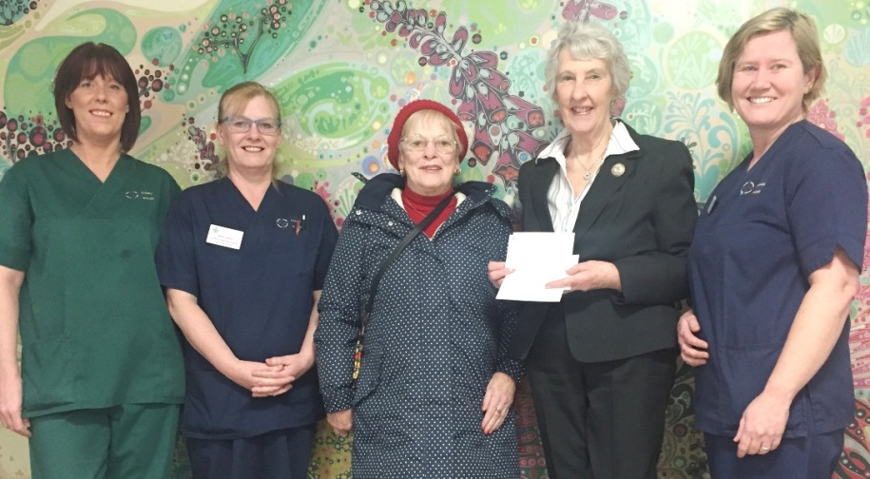
Pictured at the presentation are (from left) are healthcare support worker Kelly Jones, sister Debbie Hopkins, Brenda Payne, Susan Hill and senior sister Melanie Jones.

Renal clinical lead Dr Clare Parker said: “We are so grateful for this donation, it is a wonderful gift that will go towards enhancing our patients’ experience during their treatment here.

“Sadly renal disease affects so many lives and we do see a large number of people needing our service but we are very fortunate that so many of them, as well as their family and friends, are willing to give something back.”

Source: Abertawe Bro Morgannwg University Health Board

