Patients and families telling tales ready for Swansea conference
Tuesday, 21 February 2017
A celebration of storytelling in health that will take place in Swansea this year is attracting worldwide interest.
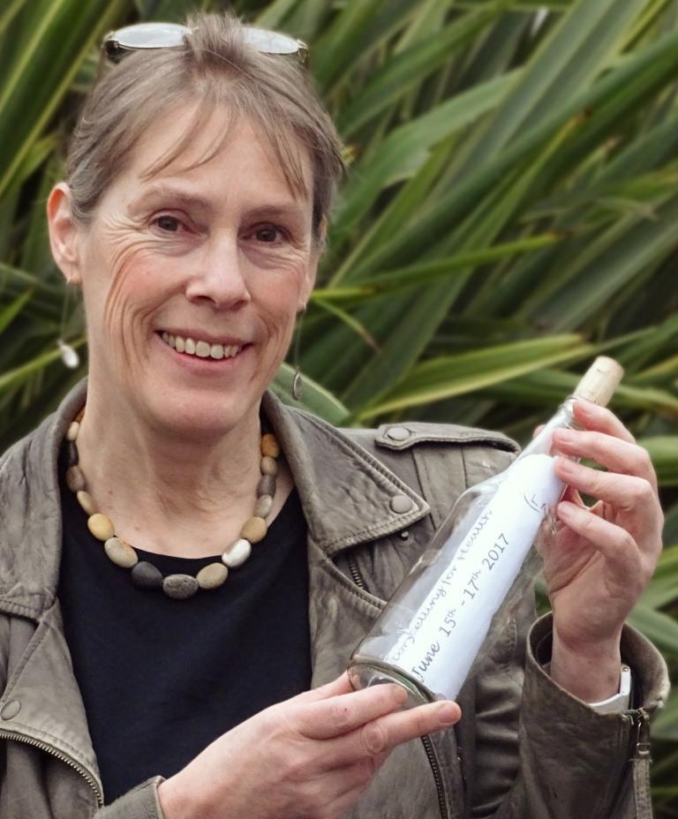
It will be staged across several venues over three days in June and will be the culmination of a series of projects now under way in the city.

Storytelling for Health began as an idea put forward by ABMU arts in health coordinator Prue Thimbleby (left) while Swansea was bidding to become 2017 City of Culture.

Prue said: “Although we didn’t get City of Culture, some of the ideas had built up so much momentum they carried on. This was one of them.

“That’s where the seed of the idea started and it has grown from there.”

Prue is leading the conference along with Emily Underwood-Lee, research fellow at the George Ewart Evans Centre for Storytelling at the University of South Wales in Cardiff.

The university is a major partner in the event, as are the University of South Wales Trinity St David’s, Swansea University, Glynn Vivian Art Gallery, the National Waterfront Museum and Volcano Theatre.

It will take place on Thursday, Friday and Saturday, June 15-17, and is being supported by an Arts Council of Wales grant and by various sponsors. The event is open to the public and tickets are on sale now.

Speakers include:

• Award-winning, Toronto-based storyteller Dan Yashinsky;
• Mike Wilson, professor of drama at Loughborough University who is a leading authority on storytelling and performance; and
• Jac Soarsa, an artist based in Cardiff who will exhibit work from her residency in a Singleton Hospital oncology ward.

Also speaking will be leading Welsh storyteller Daniel Morden, who will present a major new work, Stolen.

It was inspired by his experiences following treatment for cancer of the jaw, and people he met during his residency in ABMU’s cancer services.

He has collaborated on Stolen with musicians Oliver Wilson-Dickson and Sarah Moody.

Meanwhile, three more artist in residency projects are taking place now, in advance of the conference.

Prue, who has an MA in community storytelling, is working with community mental health in Swansea to teach people to become storytellers themselves.

Jessica Wilson, a storyteller and experienced forensic mental health nurse, is working with patients and staff on ABMU’s forensic mental health wards so they can set up story groups.

Finally, Steve Killick and Nicola Grove are working with foster care families in the Swansea area.

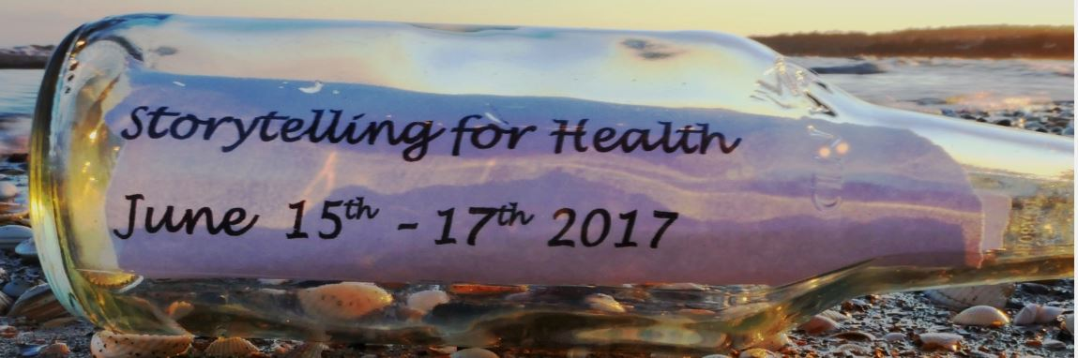
These projects will be showcased during the conference, which will be opened by Baroness Eluned Morgan and Arts Council of Wales Chairman Phil George.

Each morning will start at the National Waterfront Museum with keynote speakers and live music.

From 11am-1pm and 2.30pm-4.30pm there will be themed sessions at Volcano Theatre in High Street, the Glynn Vivian Art Gallery, and in the Reading Room and the Dynevor lecture theatre at UWTSD.

Sessions will include storytelling in mental health, maternity, end of life, clinical training and much more.

There will be a range of performances, workshops and interactive presentations.

On Saturday there will also be a designated workshop for children of conference delegates, where they will get to create their own health and wellbeing stories.

Prue said: “I’m passionate about the power of storytelling.

“Our aim is to acknowledge and celebrate the importance and growth of storytelling for health and to understand and promote good practice and new research.

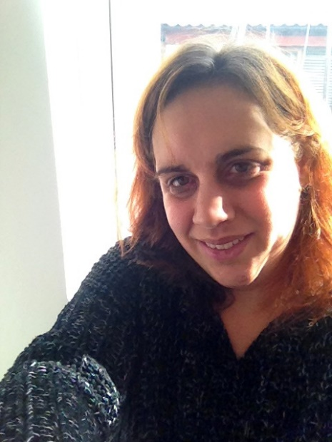
“We sent out the call for contributions, and then suddenly I started getting emails from all over the world.

“People are coming from Europe, South Africa, Australia, the States and Canada. It has created a real buzz. It’s very exciting.”

Dr Underwood-Lee (right) said she was delighted to be able to work with ABMU on the conference.

She added: “It’s great to be able to share work that cuts across disciplines in such exciting ways.

“The George Ewart Evans Centre for Storytelling has an established track record of working on innovative storytelling and health projects.

“My own research within the centre has focused on how women tell stories of both cancer and motherhood.”

You can find out more about the conference, including ticket booking details, here

Source: Abertawe Bro Morgannwg University Health Board

