Hospital now offering expert guidance for carers
Monday, 6 February 2017
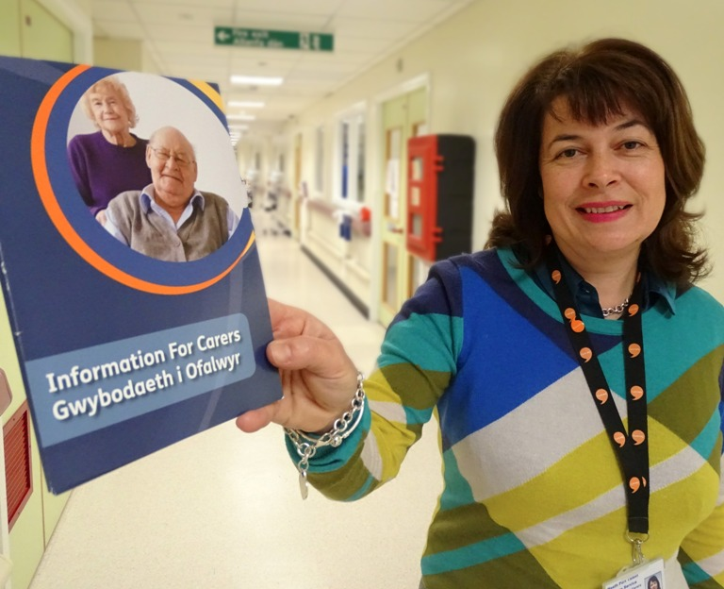
A new service to help support and guide carers has just been launched at Neath Port Talbot Hospital.
Carers health liaison officer with Neath Port Talbot Carers’ Service Jan Thomas (right) will now be touring the wards every week to explain what help is available to anyone looking after someone else.

Jan’s role has already seen her promote services available to carers in the Neath Port Talbot area at local GP surgeries, clinics and health bases.

Now she is hoping her visits to the hospital will give her the chance to meet carers face to face when they bring people in as well as build up relationships with ward staff to help identify those who might need support.

A carer is someone of any age who provides unpaid support to family or friends who could not manage without this help. This could be caring for a relative, partner or friend who is ill, frail, disabled or has mental health or substance misuse problems.

In Neath Port Talbot 20,365 people are unpaid carers, according to latest figures. Many people may not regard themselves as carers or realise that they need advice and support, let alone where to get it from.

Jan said: “The main aim of working closely with the hospital is so we can engage with carers and to let them know what we’re able to offer in Neath Port Talbot Carers’ Service.

“Hopefully being in the place where carers come to visit those who need support, they will have the right information at the right time – in a place where they are able to contact somebody at first point.

“Sometimes it’s easier to speak to somebody and explain things face-to-face. Obviously there are other routes available but by being able to engage with somebody in conversation, I think they become more relaxed and able to ask more questions. It’s the personal touch.”

Jan can provide information to those individuals and is also dedicated to ensuring health staff know about her role and how they too can signpost those individuals to the carers service.

Since she took up her post with the service Jan has visited all 21 GP practices in Neath Port Talbot where she has carried out awareness sessions to build up relationships with staff and patients.

“Our partnerships have worked very well, especially during Carers Week and flu clinics,” she added.

Jan will be available to talk to staff and carers at various wards every Thursday from 1pm to 4pm but information is also available on the Patient Experience and Advice Service stand (PEAS) in the hospital’s Atrium.

To contact Jan call 01639 642277 or email JanT@nptcarers.org.uk. You can also write to her at Neath Port Talbot Carers Service, Health and Social Care Centre, Cimla Neath SA11 3SU

Source: Abertawe Bro Morgannwg University Health Board

