Choir members sing the praises of Renal Unit as they hand over donation
Friday, 3 February 2017
The care provided by Morriston Hospital’s Renal Unit certainly struck a chord with the members of Swansea Excelsior Ladies Choir who raised more than £2,000 to support its work.

The choir teamed up with children from Sketty Primary School for its annual charity concert at All Souls Church in Tycoch and have now handed over the proceeds of the event – a bumper £2,200 - to staff at the unit.

The 48-strong choir has supported a wide variety of charities and organisations in the area but this year wanted to help the Renal Unit in recognition of the care Ieuan Jones is receiving there.

His wife Linda is secretary of the choir and she was joined by fellow committee members to hand over the cheque to renal clinical lead Dr Clare Parker and senior sister Melanie Jones.

The unit at Morriston provides care for patients from all over South and West Wales and currently around 400 of them are on haemodialysis.
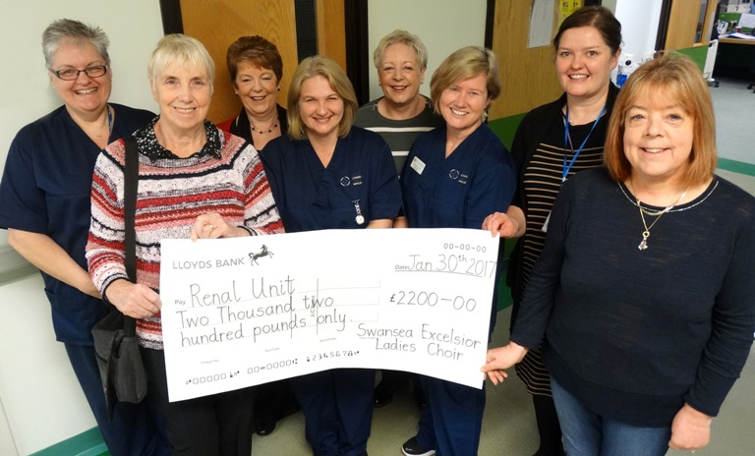
(From left) Tina Christensen, choir chairperson Julie Truran, Vanessa Kelly, Nicky Lloyd, choir secretary Linda Jones, senior sister Melanie Jones, Dr Clare Parker and choir musical director Lynda Richards with the cheque at the Renal Unit, Morriston Hospital.

Dr Parker said: “Sadly renal disease affects so many lives and we therefore see a large number of people needing our service.

“Those requiring regular treatment often form close bonds with staff and other patients and so the ‘family feel’ inspires many people to give generously of their time and money to support the unit.

“This donation will be used to enhance the patient experience during the long hours they spend here undergoing treatment. We are most grateful for this gift, thank you, Swansea Excelsior Ladies Choir.”

Mrs Jones added: “The staff at the unit are very dedicated and we wanted to do something to helps support them. We were delighted to say that some of the nurses were able to come along to the concert to hear us in action.”

The choir are now preparing for their next fundraising concert alongside Cwmrhydyceirw School’s junior and senior choirs on Thursday, 9th March at St David’s Church, Morriston.

Source: Abertawe Bro Morgannwg University Health Board

