Welsh babies prone to higher rates of certain birth defects
Tuesday, 18 December 2018
Babies in Wales are prone to higher rates of certain birth defects than other parts of the world. That has been the finding of a Swansea team, which is urging women trying for a baby to ensure they take folic acid first.

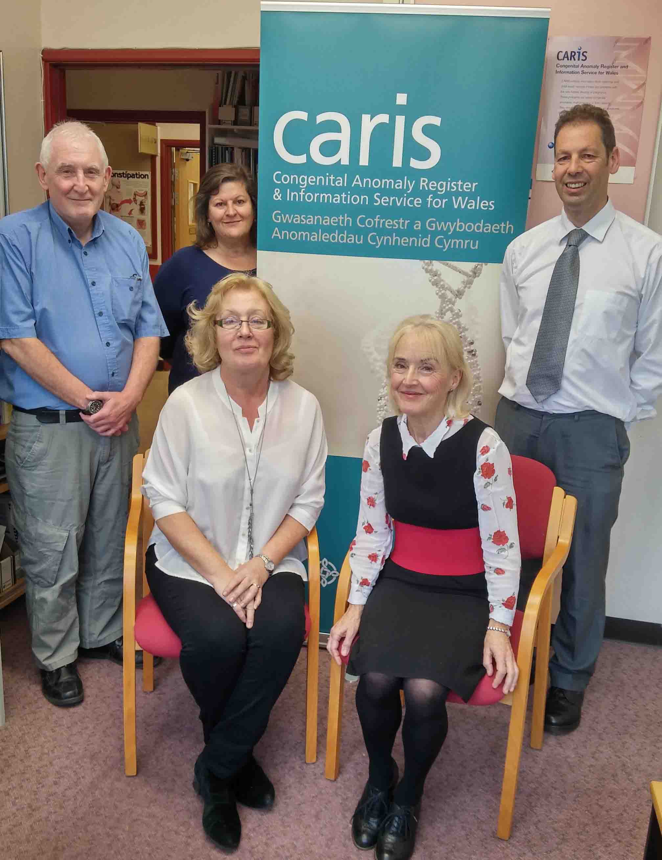
The B vitamin can help reduce the risk of disabling and sometimes fatal neural tube defects (NTDs). These include spina bifida and anencephaly, where the bones of the baby’s skull do not form properly.

Data collected from across Wales by Singleton Hospital-based CARIS (Congenital Anomaly Register and Information Service) – which has just celebrated its 20th anniversary - shows these defects currently occur, on average, in 12.0 foetuses/babies in every 10,000 total births in Wales. England has a similar rate of 12.9, but the European average is 9, with 11.5 per 10,000 total births in America.

Pictured left - right: The CARIS team – Vivian Morgan, Linda Bailey, Helen Jenkins, Margery Morgan and David Tucker

The benefits of folic acid supplements have being known since 1991, when a study published in the Lancet medical journal showed that taking it before conception reduced the risk of a NTD pregnancy by an estimated 72%.

The defects occur early in pregnancy when the neural tube, which later becomes the brain and spinal cord, fails to close properly.

But CARIS co-founder and Consultant Obstetrician and Ggynaecologist Margery Morgan said that, 27 years on, very few women follow pre-conception advice about folic acid.

She said: “When I last looked at it in Swansea, only about 20% of women were taking folic acid before becoming pregnant, which is the correct way to take it.

“You need to start it early and increase the folate levels in your blood to give you that extra protection.”


Dr Morgan said: “South Wales was well known in the ‘60s and ‘70s for high spina bifida rates because of local research at the time. And we still have high NTD rates. These have improved but are still high compared to the rest of the world.”

In 1957 a south Wales study reported a prevalence rate of 115 NTDs per 10,000 births.

Rates have fallen since then but data collected by CARIS since its inception in 1998 shows that the numbers have remained relatively high, going from 18.7 in 1999 to 2002, to the current rate of 12.0 in 2017.

CARIS data also shows that rates of neural tube defects are higher in the most deprived fifth of areas in Wales, compared to the least deprived (most affluent) fifth. The reasons for this are not clear, but one factor may be variation in diet and a second factor may be higher use of maternal folate supplements before and during early pregnancy in less deprived areas.

Over the years CARIS, along with other experts, has pushed for successive UK governments to fortify flour with folic acid, following the lead of 78 other countries including the USA, Canada and Australia, which has led to a dramatic drop in the rate of NTD births.

The UK Government is due to launch a consultation on the mandatory fortification of flour with folic acid in early 2019. One of the issues it will look at is whether the benefits to the population outweigh any medical concerns.

For the time being women who are trying to become pregnant are advised to take a daily supplement of 400 micrograms of folic acid before they conceive and during the first 12 weeks of pregnancy. Women at increased risk like those with diabetes, epilepsy or who are obese need to take the 5mg dose, which is prescribed by their GP.

However, as many pregnancies in the UK are unplanned, it’s hoped the fortification of flour will ensure all women get the required nutrient.

CARIS Manager David Tucker said: “It would mean that once you’ve had your slice of toast in the morning with your cup of tea you’ve had your folic acid.

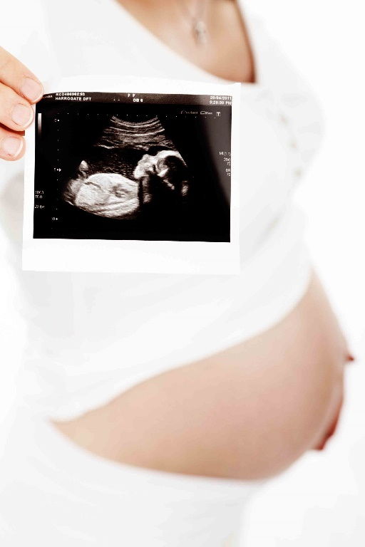
“The English regional registers and Wales published a paper two years ago to coincide with the 20th anniversary of the USA fortifying their flour and the paper asks the question, ‘If we had done this at the same time, how many lives would we have saved? How many children could we have expected to be live born and be healthy?’

“The answer was somewhere over 1,000.”

Picture right posed by model

The cost of adding folic acid to a bag of flour is about 1p.

The meticulous compilation of data is a powerful tool for CARIS and the wider NHS in Wales in identifying trends, tackling issues and planning for the future of services.

Prior to 1998 data had been collected via an old paper-based service brought in following the Thalidomide scandal of the 1950s and ‘60s.

Mr Tucker said: “It worked well in the initial years, but by the mid ‘80s it was failing because details of pregnancies were not being recorded well. Many health professionals did not know about the scheme so valuable data was lost.”

Funded by the Welsh Office, Dr Morgan and her colleague Dr Judith Greenacre started CARIS in 1998, receiving data from hospitals across Wales.

This was 17 years ahead of England, which only started its national equivalent in 2015. There were good registers in several regions of England, but these covered only 30% of the population.

Over the past two decades CARIS has collected data on around 35,000 cases of congenital anomaly and has contributed to many studies in Europe and worldwide. The data has been included in around 100 medical papers, making pregnancy safer for women and their babies.

Stronger warnings about sodium valproate were issued this year following a European study that CARIS contributed data to. This drug used for epilepsy can cause problems in foetal development and the study highlighted the need for the drug manufacturer to make women and doctors aware of these problems.

And more money was pumped into the training of sonographers after CARIS data revealed in the early 2000s that ultrasound scans were not efficient enough at picking up certain heart anomalies.

Mr Tucker said: “Cases of a congenital heart defect known as Fallot’s tetralogy were rarely picked up antenatally and these days we pick up three quarters of them. This enables the mum to prepare for delivery and the extra services necessary.

“Having a well-established congenital anomaly register in Wales puts us in a strong position. We can look back at trends and be aware if rates of a particular anomaly is rising. This may sign post further investigation.

“We hope we can continue for another 20 years safeguarding the development of babies by monitoring trends and rates.”

Source: Abertawe Bro Morgannwg University Health Board

