Staff host Christmas day lunch to combat loneliness
Friday, 14 December 2018
Staff at Neath Port Talbot Hospital are once again giving up their time to organise a Christmas Day lunch for those in the community who are most vulnerable.

It is the 16th year they have come together to combat loneliness.

Community psychiatric nurses Jane Briggs and Sue Shannon Jones, who has retired, began the tradition along with social worker Sian Davies.

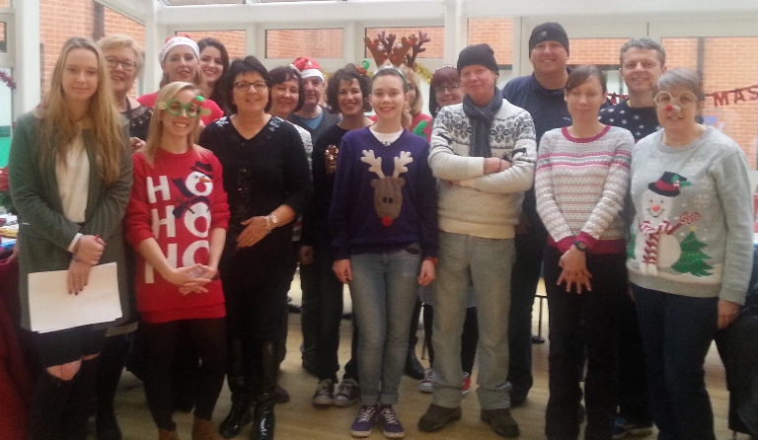
They were visiting patients in their homes after the festive period who told them that they had not seen anyone over Christmas.

Pictured left: Staff and Volunteers helping at one of their previous Christmas days

Jane said: “They told us they were desperate for company.

“It really got us thinking. The truth is that for some people Christmas Day is lonely time and often spent alone without a hot meal and without family or friends around them.

“Hearing that the patients felt this way gave us the original idea of hosting a Christmas lunch.”

Staff and an army of volunteers at Neath Port Talbot Hospital have joined together every year to help prepare for the festive day. This year is no different.

The lunch will be held at the hospital, where the hospital’s catering department will prepare the three-course Christmas lunch with all the trimmings.

After lunch, they will enjoy entertainment from Christmas songs to karaoke.
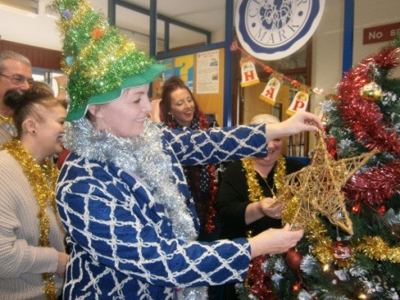
Pictured right: The team preparing for Christmas day

The first Christmas lunch held fifteen years ago had 16 guests.

Jane said they are very fortunate to have support from the local community, with local businesses including Tata Steel contributing to the costs.

Jane said: “Every year more and more people have come to the lunch. Last year we catered for 35 people.

“We are so pleased that we are able to do this for our patients and can’t thank our local community and businesses enough who contribute to help make this happen.

“It’s amazing to see the smiles on everyone’s faces year after year as they enjoy Christmas Day surrounded by people who then become friends.”

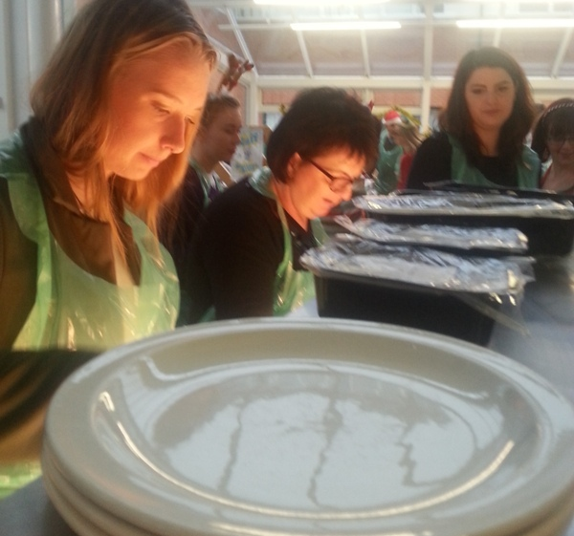
Pictured left: The team serving dinner at one the previous Christmas days

Guests are also given gifts and a take-home supper – before being picked up by taxis, which are organised by staff.

Jane added: “Some people will find themselves with no-one to say Merry Christmas to or be able to tuck into Christmas lunch with so doing this is so important for us.

“I’d like to say a big thank you to everyone who makes this happen.”

If you would like to volunteer on the day, please contact Jane Briggs on Jane.Briggs@wales.nhs.uk

Source: Abertawe Bro Morgannwg University Health Board

