Morriston opens specialist unit for patients with breathing failure
Tuesday, 4 December 2018
Specialist staff at Morriston Hospital are leading the way with the launch of a dedicated new unit for people suffering from breathing failure.
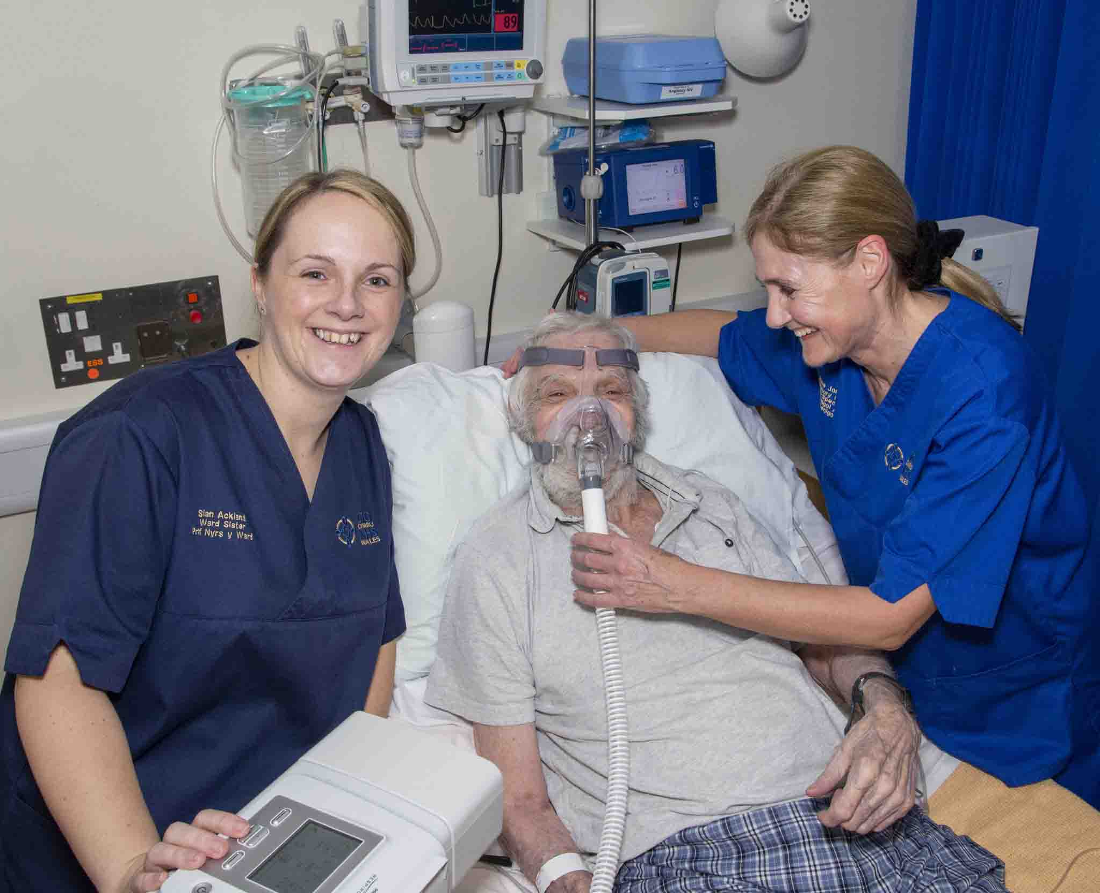
Part of Anglesey Ward, which cares for respiratory patients, has been converted into a Non-Invasive Ventilation (NIV) Unit.
Left: Dennis Webber receives NIV treatment in the new unit. Mr Webber is pictured with the unit’s clinical lead Sian Ackland (left) and respiratory clinical nurse specialist Kate Jones
Before the introduction of NIV, people with an acute flare-up of chest conditions such as Chronic Obstructive Pulmonary Disease were helped with their breathing by having a tube inserted into their airways and then put on a ventilator.
This is not without risks and NIV, which helps them breathe through a face mask, is a safe, effective alternative for those who meet the criteria.
Morriston has been able to provide NIV but only in intensive care – taking up beds that could otherwise be available to other very unwell patients.
But this week saw the opening of a four-bed NIV Unit on Anglesey Ward after not just months but years of planning.
Respiratory medicine consultant Dr Favas Thaivalappil said: “We try to avoid intubation as much as possible, especially in people with underlying lung disease.
“The main advantage of providing non-invasive breathing support is that it reduces complication rates, shortening the hospital stay for patients compared to intubation.”
Dr Thaivalappil said NIV had previously only been carried out in intensive care in Morriston. But there was good evidence it could be safely done on the ward, releasing intensive care beds for other critically ill patients.
“We’ve been trying to set it up for many years. It never materialised for various reasons, but now it is happening.
“Guidelines are for one staff nurse to two patients, which is what you get in high dependency unit, so we’re transferring that environment to the ward.
“We have an excellent team of experienced nurses and respiratory and on-call medical teams.
“Also, because it is in the respiratory ward, the respiratory team can quickly provide additional expert advice for these patients.”
Evidence shows NIV reduces mortality by 50 per cent during an episode of lung disease flare-up, and can considerably extend life expectancy.
But the benefits are not limited to hospital, as ABMU has invested in a home ventilation service and dedicated home ventilation clinic for patients with breathing failure.
That means appropriate patients who have been treated with NIV on the ward can continue the non-invasive treatment at home.
Dr Thaivalappil said: “The new NIV Unit in Anglesey will perfectly compliment the home ventilation service to provide high quality care for very vulnerable patients.”
Acute medicine sister Linda Rees said recruitment had taken place to ensure the nurse-patient ratio could be achieved.
She added: “Being able to establish the NIV Unit as part of Anglesey Ward will provide a great opportunity for our experienced respiratory nurses to use their skills.
“Many of our new nurses are also keen to rotate into the unit as part of their development.”
Respiratory clinical nurse specialist Kate Jones said staff had looked at similar services elsewhere but could not find one with the same set-up as Morriston – making it something of a trailblazer.
“When a patient comes in, an alert will be put out which we will respond to. The patient will be brought to the ward quite quickly and therapy will be established in a timely manner.
“Hopefully the new unit will prevent patients that meet the criteria for ward-based NIV being admitted to intensive care.
“But there are lots of other benefits, like lower mortality and cost savings. It’s more comfortable for the patient too.
“Staff have been very enthusiastic during training sessions and we are confident this service will improve patient care.”
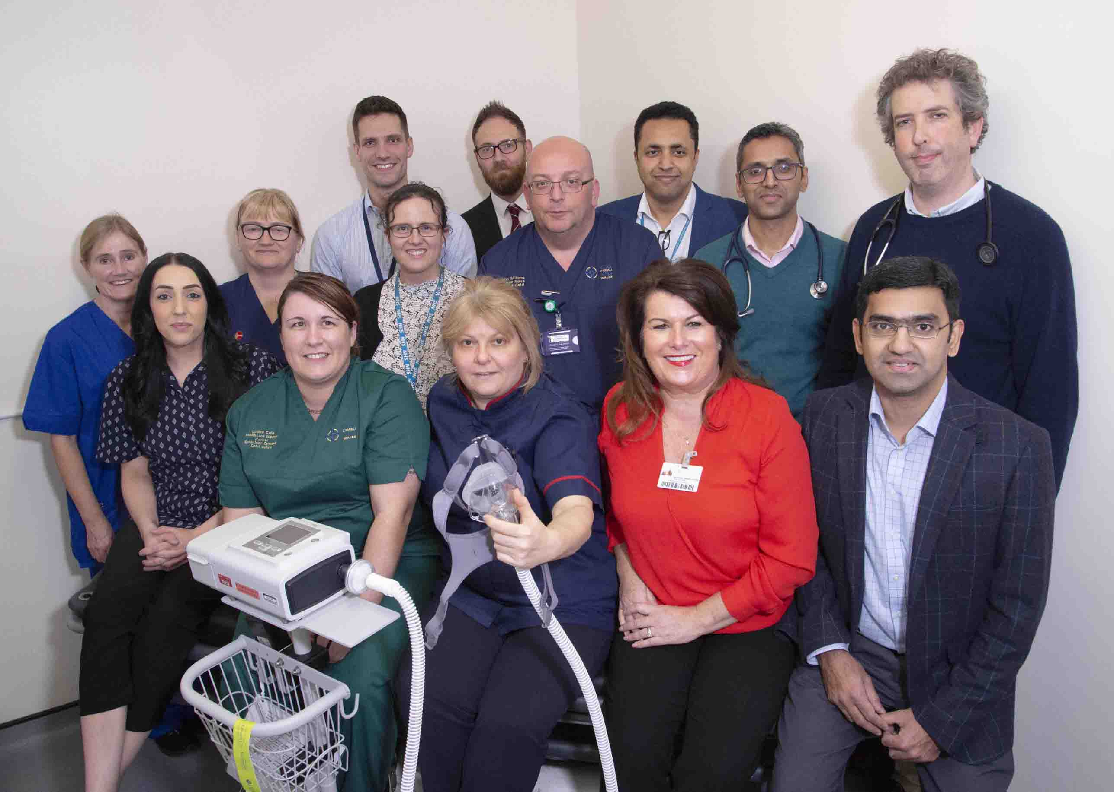
Right: Some of the respiratory and management team involved with developing and running the NIV Unit
Consultant chest physician Dr Emrys Evans said the senior management team had been very supportive, and had made a considerable investment in the new unit.

He added: “The nursing team have spent a lot of time on staff training while still caring for their patients.
“All this hard work has required a lot of effort by everyone, including our fellow consultants. It has been a real team effort.”
Medicine Service Group Assistant Manager Gareth Barbour said: “Implementation of the acute NIV service on Anglesey Ward represents a significant milestone in the provision of critical care to respiratory patients at Morriston Hospital.”
Morriston Hospital Service Director Rebecca Carlton added: “We are delighted we are now in a position to open an acute NIV Unit.
“This is a fantastic development for our patients and is an essential service for a major hospital like Morriston.”
Source: Abertawe Bro Morgannwg University Health Board

