Jimi marks milestone birthday with donation to unit that saved his life
Thursday, 27 December 2018
A schoolboy has donated more than £1,300 to a unit which cares for very sick babies.

Jimi Jones wanted to give back to the neonatal intensive care unit at Swansea’s Singleton Hospital as staff there saved his life when he was born.

He also smashed his original fundraising goal of £100 thanks to the success of a sponsored walk up Pen y Fan, which was supported by his entire school.

His mum Jo Griffiths, 30, said Jimi had come up with the idea himself to celebrate his 10th birthday.

She said: “He told me, ‘It’s been 10 years so shall we raise some money to give back?’

“When he was little he didn’t realise what he had been through, but as he’s got older we have shown him pictures. It’s more real now, so I think this was the right time to do this.”
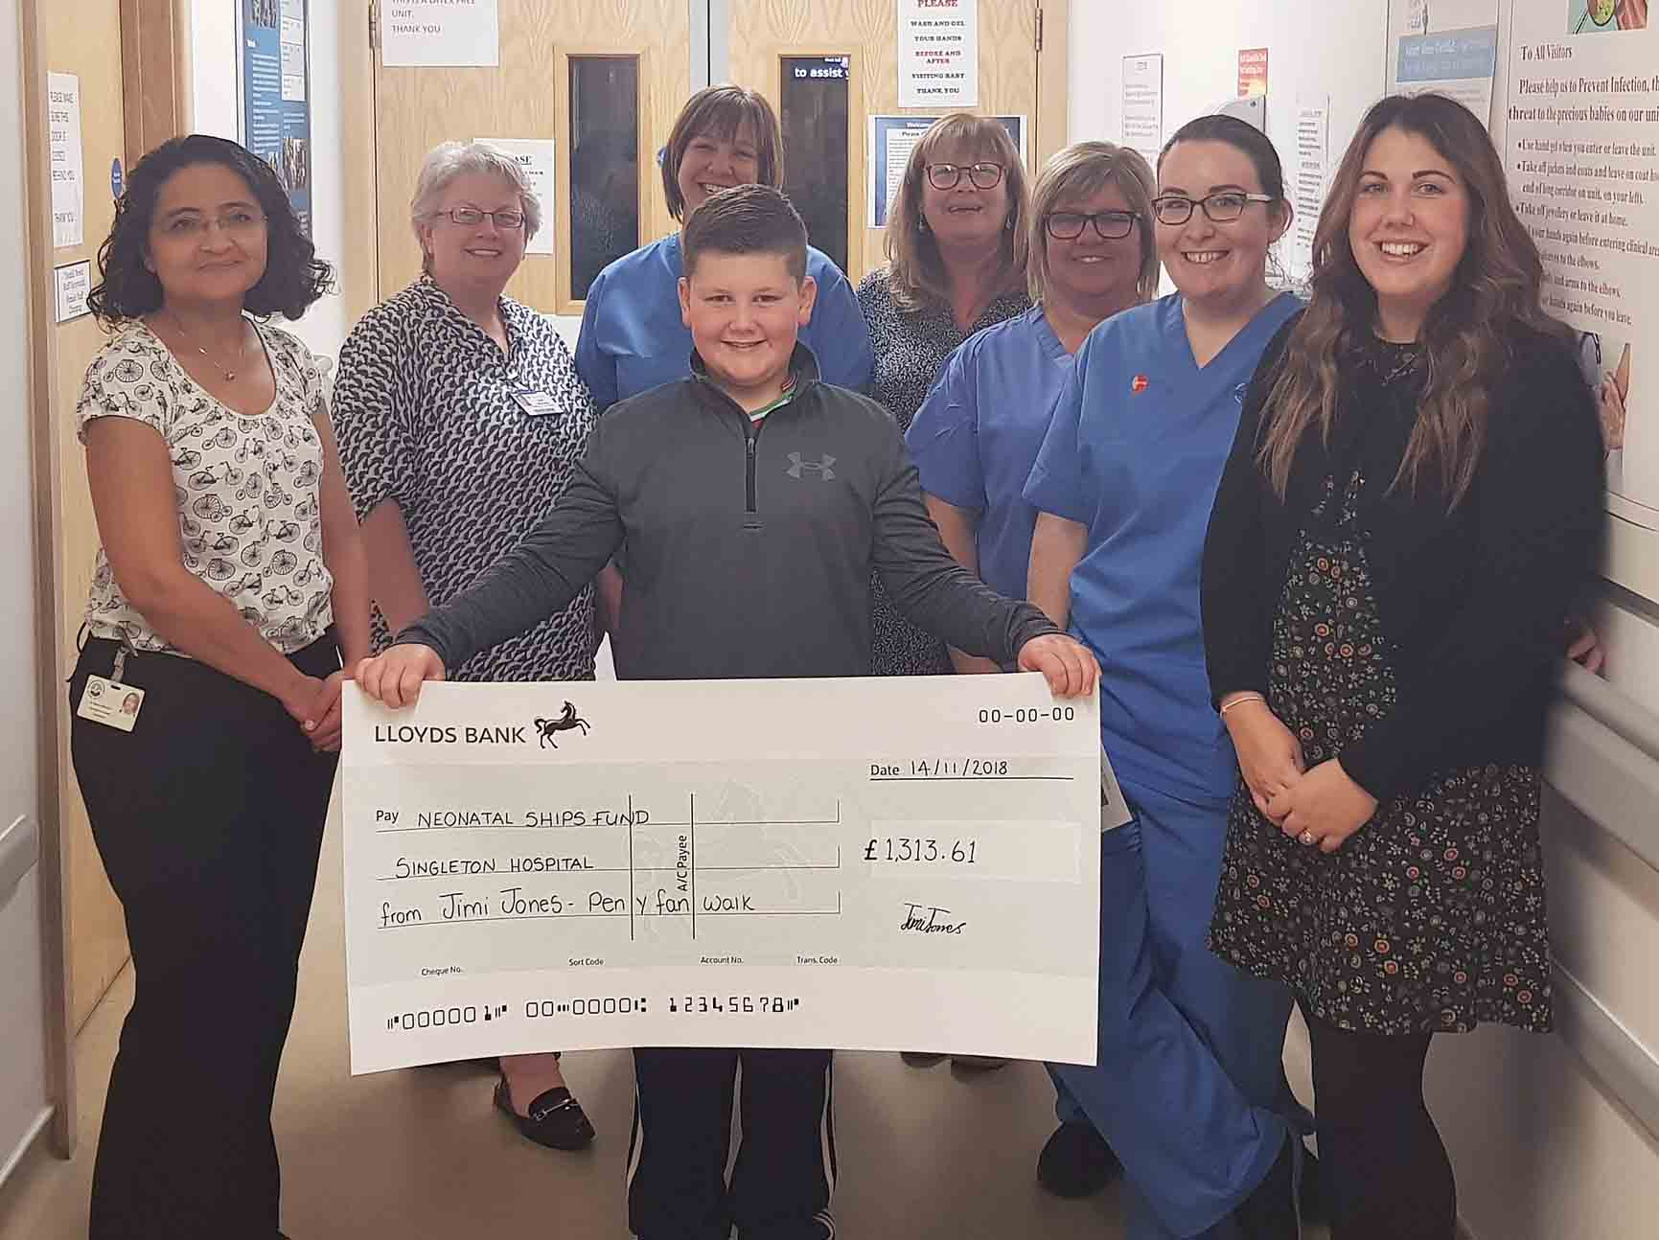
Jimi, from Gorslas near Cross Hands, was born via emergency Caesarean section on November 7, 2008. The group B strep bacteria had made him so sick he was unable to breathe for himself and had to be intubated.

He also suffered from a collapsed lung, pneumonia and extremely high lung blood pressure.

Jo – who was struck down with sepsis after the birth - said: “We were advised to have him christened because the doctors didn't expect him to get better.

“By the Saturday when he was eight days old, his lung blood pressure was really high and he was on so many drugs to keep him alive and to keep him sedated, that his heart began getting weaker and it struggled to compensate for the lung that was filled with infection.

Above from left: Consultant Maha Mansour, Advanced Neonatal Nurse Practitioner Kate Richards, Staff Nurse Jo Thomas, Jimi’s nan Kim Hillier, Support Worker Janet Rees, Staff Nurse Rhiannon Jago and Jo Griffiths.

“It was decided that he needed a treatment called ECMO - basically a heart and lung bypass.”

Jimi, pictured below right in the NICU, was flown to the ECMO centre at Glenfield Hospital in Leicester in an RAF Sea King helicopter.

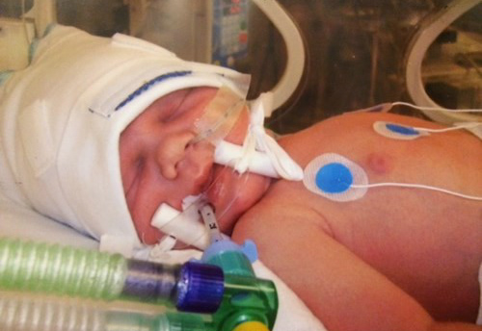
Jo said: “Jimi was part of a trial and was cooled to 35 degrees to try and prevent any damage to the developmental part of his brain during treatment.

“Following 60 hours of ECMO Jimi was transferred back to Swansea by road ambulance.”

He was 15 days old before he received his first cuddle from Jo and at that point he was alert and responding.

The following day Jo began breast feeding and she and Jimi have never looked back.

Follow-up appointments have revealed no problems with his development.

Jo said: “Jimi is a loving little boy who loves his friends, art and playing the piano. He is the best big brother and we are so very lucky to have him.”

In October Jimi, his brothers Osian, six, and Oli, seven, Jo, staff, pupils and parents from Ysgol Gorlas climbed Pen y Fan.

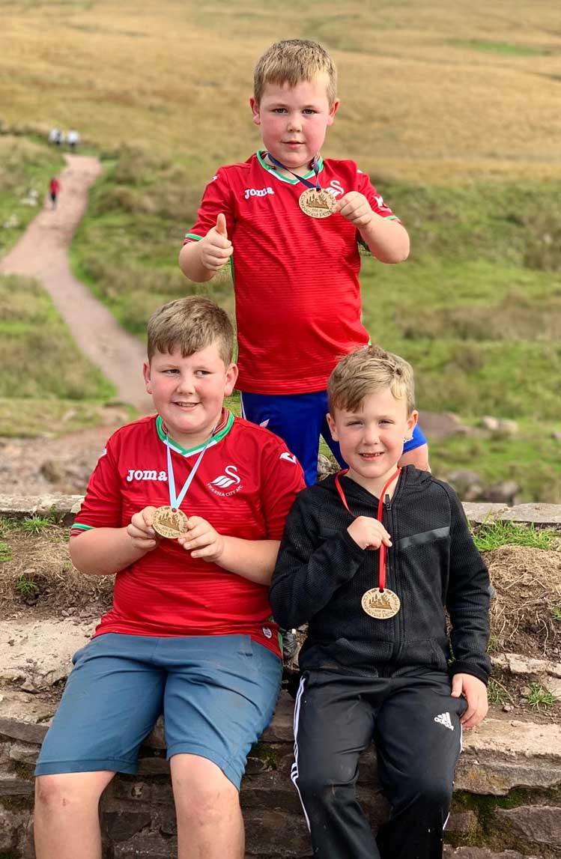
Jimi Jones, left, with brothers Osian, centre, and Oli after climbing up Pen y Fan

Jimi has since returned to the NICU to present the cheque to staff, who were thrilled to see him.

Consultant Neonatologist Dr Maha Mansour said: “As Jo mentioned, Jimi was very critically ill as a newborn baby, and he went on to require prolonged intensive care. So it was really encouraging to see how well he was doing after he was discharged from NICU, as I saw him in follow-up clinic.

“And it was an absolute treat to see him just after his 10th birthday and to hear of how he managed to get so many people to climb up Pen Y Fan to support him.

“He is a delightful young man and we were very honoured that he thought of us. We wish Jimi and his family all the very best.”

Source: Abertawe Bro Morgannwg University Health Board

