Children and young people encouraged to share their health experiences
Monday, 10 December 2018
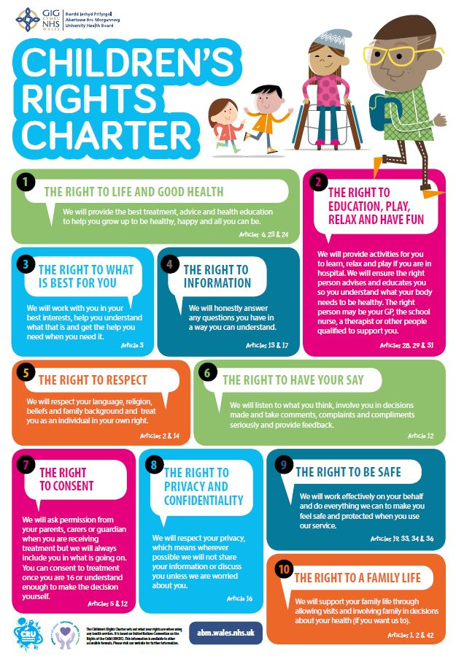
Children and young people are being encouraged to share their views and experiences of health services.
ABMU Health Board is keen to find out how it’s doing after becoming the first health board in the UK to adopt a charter committing to the human rights of children.

Launched in 2017, it lists 10 promises to children and young people, respecting their rights when visiting a health professional – including the right to consent, to be safe and to have their say.

The health board is now working in partnership with Observatory on the Human Rights of Children and Neath Port Talbot Children’s Rights Unit to assess its progress.

It has created a survey to enable young people to give their feedback on their experience of visiting health professionals.

Head of Nursing and Children’s services Eirlys Thomas said: “We are determined to learn what we can do to make sure we are respecting the human rights of all the children we work with.

“We want to hear from as many young people in our area to make their visits to see a health professional even better.”

The survey is the first step to assess how well they are doing, and coincides with International Human Rights Day on 10th December 2018.

The health board will also gain feedback and suggestions from strategic managers and health professionals.

Eirlys added: “The care of children and young people is part of the work of almost every department in our hospitals.

“We are aiming to repeat the process every two years to give us scope to always improve.”

If you are a child (7-12 years) who would like to share your views and experiences on health services in Bridgend, Neath Port-Talbot or Swansea, you can participate in the survey clicking on this link:
https://www.surveymonkey.co.uk/r/chcr2018

If you are a young person (13-17 years) who would like to share your views and experiences on health services in Bridgend, Neath Port-Talbot or Swansea, you can participate in the survey clicking on this link:
https://www.surveymonkey.co.uk/r/ypcr2018

To read ABMU’S Children’s Rights Charter please click ABMU Children’s Rights Charter

Source: Abertawe Bro Morgannwg University Health Board

