Three top prizes for ABMU-linked projects at 2017 MediWales Awards
Tuesday, 19 December 2017
ABM University Health Board flew the flag for Welsh health boards at this year’s MediWales Innovation Awards, scooping three prizes for trail-blazing projects which all involved ABMU.

The Research in Excellence in the NHS award was given to ABMU and Swansea University Medical School for their clinical trial that explored the use of the AliveCor Kardia mobile device to detect atrial fibrillation – an abnormal heart rhythm – which is a common cause of stroke.

The NHS Wales Collaboration award went to ABMU’s Department of Diabetes and Swansea University Diabetes Research Group for their collaborative clinical trials with companies of all sizes.

The Cimla Hospital based Lymphoedema Network Wales received the Innovation within NHS Wales award thanks to their on-the-ground education project enabling community nurses to gain knowledge and learn skills around lymphoedema and chronic oedema.

Hundreds gathered at this year’s MediWales Innovation Awards, held at the National Museum of Wales in Cardiff, to celebrate the achievements of the Welsh life science sector in 2017.

Founded in 1992, MediWales is the life science network and representative body for Wales. MediWales provides advice, support and business opportunities for members, whilst promoting collaboration within the life science and health technology community in Wales.

Andrew Davies, ABMU Chairman, said: “I am delighted that the talented teams behind these innovative projects have been recognised with these prestigious awards.

“Their achievements also demonstrates the power of working collaboratively.”

More details about the winning projects:
Research in Excellence in the NHS

The research project was a single-centre controlled trial which involved screening 1,000 patients for atrial fibrillation (AF) for the prevention of stroke. The trial was based at the ABMU/Swansea University Joint Clinical Research facility.

The team investigated whether regular ECG monitoring by patients in the community, using a new hand-held electronic device, would result in better detection of AF than routine care. It resulted in a fourfold increase is the diagnosis of the condition, and has the potential to reduce the important AF complication of stroke.

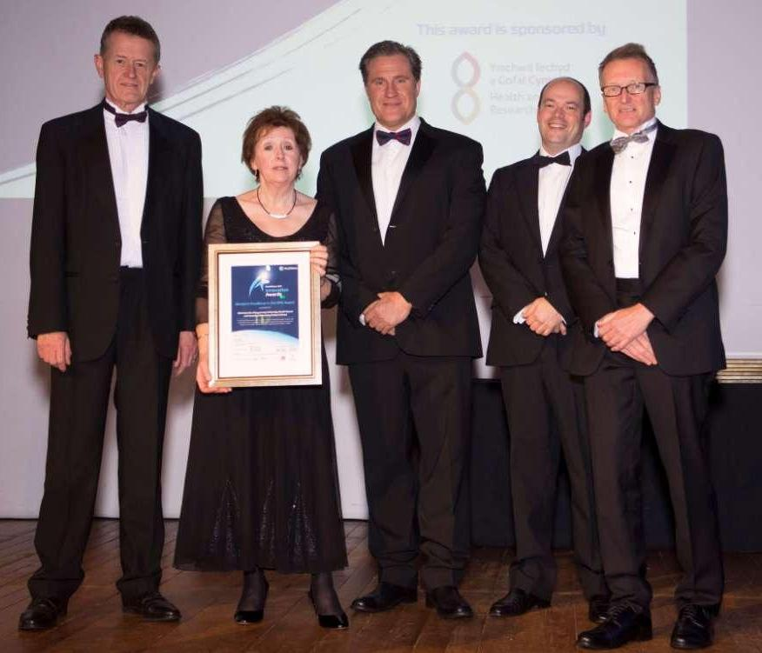
Pictured from L-R, Ceri Phillips, ABMU non-executive Board member and Head of the College of Human and Health Sciences at Swansea University; Kathie Wareham, Director of the Joint Clinical Research Facility, shared by ABMU and Swansea University; Julian Halcox, Consultant Cardiologist and lead for the study, Mike Gravenor, Professor of Statistics at Swansea Medical School and Frank Atherton, Chief Medical Officer for Wales.

People with AF can form blood clots because blood tends to pool in their heart as a result of their abnormal heart rhythm. This can lead to strokes if a clot then travels to the brain, and unfortunately these types of strokes can be more severe than others.
If doctors know a patient has AF, strokes are largely preventable by using anticoagulation drugs like warfarin to thin the blood. However more than one in four AF strokes happen when AF has not been diagnosed. AF affects one in 200 people and gets increasingly common with age. AF is responsible for about 20% of all strokes.

The project was awarded a £772,000 Health Technology and Telehealth grant co funded by Welsh Government (£650,000) and AliveCor Inc (£120,000). It recruited volunteer patients over the age of 65 from GP surgeries across the Swansea area.

Half were given a handheld heart monitor called AliveCor and the other 500 were managed through normal routine care and health checks.

At the end of the trial, 19 people had been diagnosed with AF from the Alivecor group, and five via routine health care.

Professor Julian Halcox, who led the study, said: “Understanding the full clinical impact on stroke prevention and the cost effectiveness of this approach will require a much larger study involving tens of thousands of people over a longer period of time.

“We are investigating the use of the device to screen for AF in other clinical settings such as community pharmacies, GP surgeries and after a stroke.”

NHS Collaboration with Industry

The award recognised how a decade of collaboration between ABMU diabetes specialists and Swansea University had led to the Diabetes Research Group becoming a leading centre for collaborative clinical trials with industry. Strong partnerships have evolved with a wide range of major diabetes-related pharmaceutical companies.

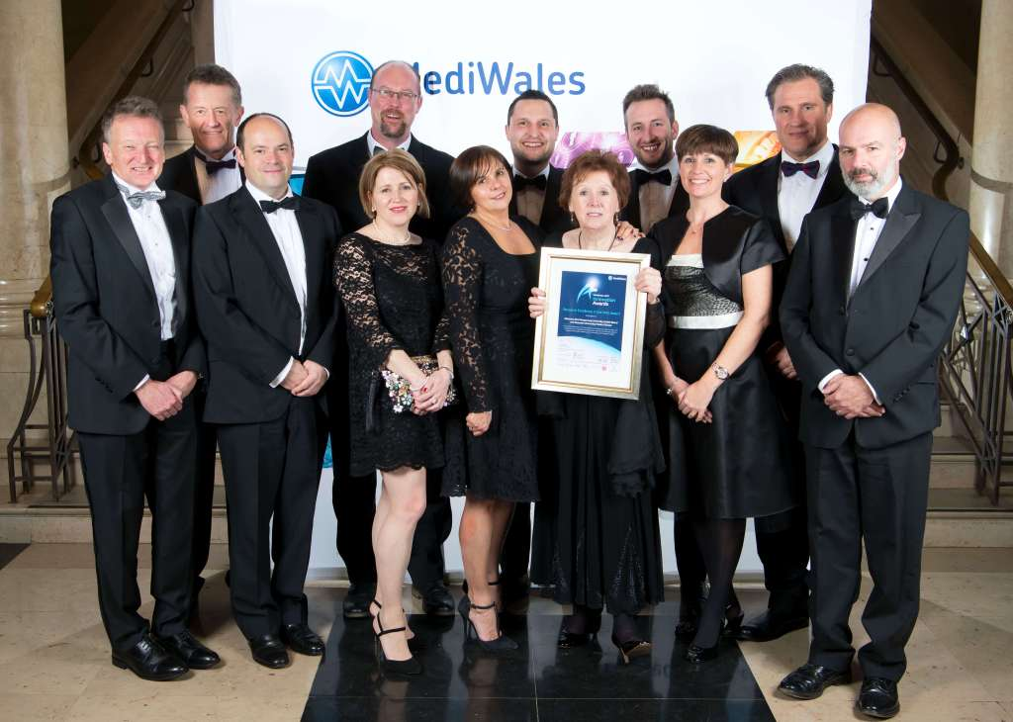
The Diabetes Research Group is now recognised as a centre of excellence, and is regularly approached by companies looking for advice and expertise in the design and conduct of proof-of-concept trials.

Pictured L-R: Frank Atherton, Chief Medical Officer for Wales with Ceri Phillips, Kathie Wareham, Mike Gravenor, Bev Luchmun, from the National Institute for Social Care and Health Research, Julian Halcox and members of the winning team including Claire Fagan, Lucy Barlow, Matthew Hanney, and Scott Davies.

Diabetes and related metabolic conditions are a leading cause of ill-health and premature deaths, exerting huge financial pressures on health services.

Diabetes affects seven in every 100 people in Wales, and accounts for more than 10p in every pound spent by the Welsh NHS.

Research to prevent and manage the diabetes epidemic is a priority, with considerable focus on clinical trials relating to diabetes therapies, in collaboration with pharmaceutical companies and small and medium-sized businesses.

These therapies have been turned into routine clinical use within the UK and worldwide, and are now part of the standard treatment guidelines for diabetes, for example, under NICE. Work from the Swansea team has been published in the highest ranking medical journals and has improved patient care and diabetes therapy options for patients.
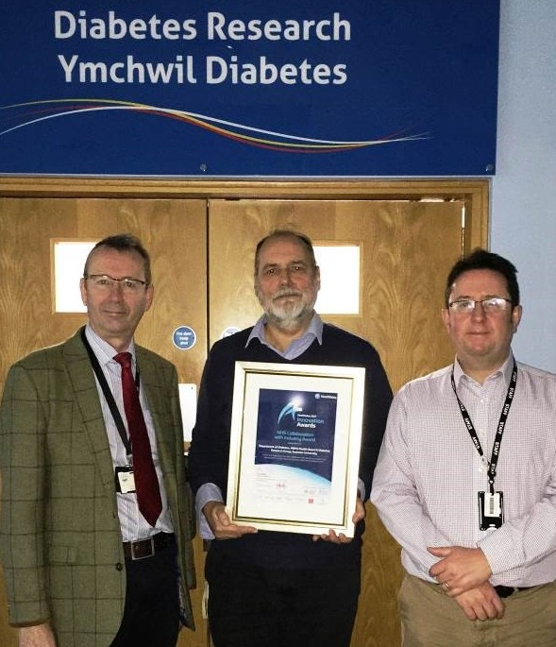
Pictured L-R: Professors Steve Bain, Steve Luzio and, Jeffrey Stephens, with the award outside the Diabetes Research department.

Having major diabetes research going on in Swansea has given local people access to some of the latest clinical trials. It has also allowed them to benefit from early therapies following the approval process for new diabetes therapies and glucose monitoring devices.

Diabetes research has also brought in over £1.5m to the health board and Swansea University.

Innovation within NHS Wales

The Lymphoedema Network Wales is based at Cimla Hospital in Neath, but is part of the NHS Wales Collaborative.

Lymphoedema/chronic oedema is the result of lymphatic system failure, and causes swollen limbs. It can affect people of all ages, and is commonly seen by staff working in community services. In fact, 50% of the workload of community staff is treating chronic oedema and ‘wet legs’, where fluid seeps through extremely swollen limbs.

However, rising pressure on community services has made it more difficult for staff to break away from work to attend education sessions. The ‘on the ground education project’ enabled community nurses in a pilot scheme to receive additional knowledge and skills on the job. Two community lymphoedema specialists and an online educations Pocket-Medic film supported the project, which involved patients in the Cardiff area.
Although 750 patients were seen during the project, 100 were purposely recruited into the research element, to look at how well it worked.

An evaluation by Swansea University’s health Economic Department found that upskilling community staff this way led to fewer dressings being needed, fewer district nurse visits and a better quality of life for patients. Four in 10 became more mobile and independent. Nearly half of the 100 patients reduced their pain and nearly a third became less anxious or depressed.
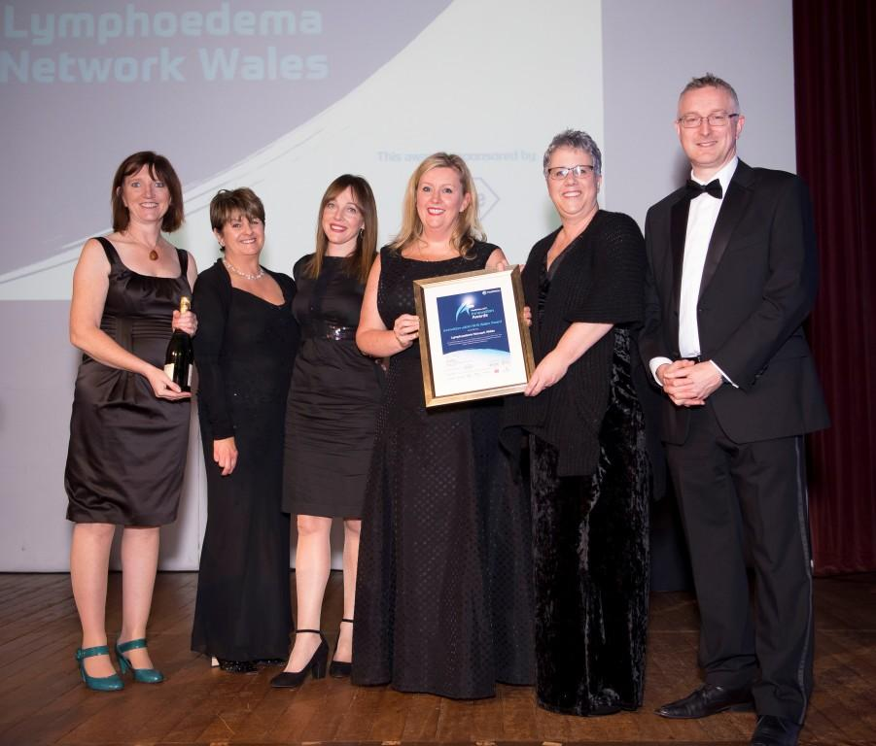
Pictured L-R: Linda Jenkins On the ground educator, Diane Jehu On the ground educator, Caity Thomas Lymphoedema Network Wales Project Manager, Melanie Thomas, National Lead, Karen Morgan National Research and Education Lead, Andrew Goodall, NHS Wales Director General

The cost of hospital admissions caused by cellulitis dropped from £23,000 to £2,500 and dressings from £52,400 to just under £20,000. It also led to the number of community nurse call outs being cut by a quarter.

Melanie Thomas, national lead for the network, said:

“Patients have been central to the design of this innovation. It was they who initiated this forward thinking in collaborating services together to reduce confusion and streamline the process.

“Patients were involved in the project board and were the main stars in the making of the videos. Sharing their experiences created powerful and meaningful stories that will support nurses acquiring knowledge about the implications of living with swelling.”

The scheme was funded by a Welsh Government Health Technology Telehealth fund, and it is hoped to roll this out across ABMU and other health boards from the spring, if an application for further funding is successful.

Source: Abertawe Bro Morgannwg University Health Board

