Rotarians’ early Christmas presents to young emergency patients
Tuesday, 12 December 2017
Young patients being treated in the Emergency Department at Morriston Hospital will be able to bring a cuddly friend home with them, thanks to kind-hearted Rotarians and enthusiastic knitters.
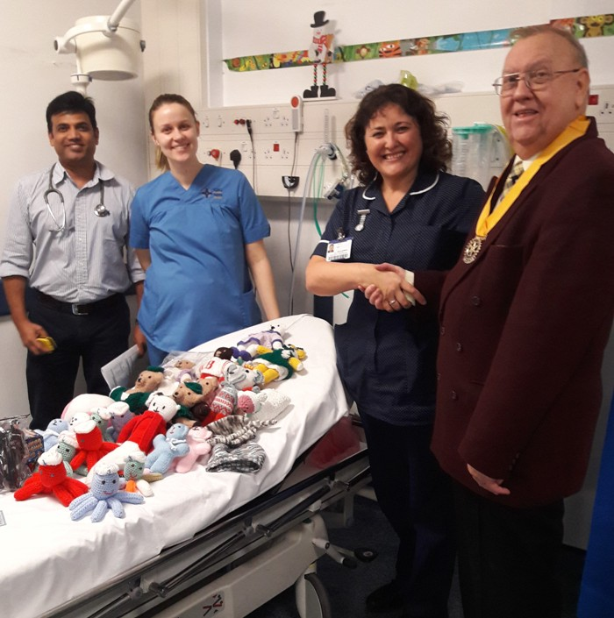
Members of the Rotary Club of Morriston have handed over hand-knitted toys to the hospital which ED staff can now give out to children.

The woolly dolls and animals were made by the ladies’ knitting club at St Peter’s Church at Cockett which donated them to the Rotarians.

Becky Gammon pictured (second right) with Rotary Club senior vice president Roy Richards and ED staff members Dr Sendhil Kumar and staff nurse Jenna Thomas.

The toys will not only give the children comfort while they are being seen by medical staff, but also provide a valuable distraction and help calm them during their time in the department.

And they don’t have to say goodbye to their new favourite when they leave, children can take the toys away with them.

Head of nursing for emergency care at Morriston Hospital Becky Gammon said: “We are very grateful to the Rotarians for this wonderful gift.

“Being in hospital, particularly in the Emergency Department, can be very scary for children and anything that helps ease their fears is really valuable – these little toys are a great addition to the care we will be offering them.”

Source: Abertawe Bro Morgannwg University Health Board

