New chief executive for ABMU
Monday, 4 December 2017
ABMU Chairman, Andrew Davies, has today welcomed the appointment of the Health Board’s new Chief Executive Officer.

He said:

“I am delighted to announce the appointment of Tracy Myhill to Chief Executive of Abertawe Bro Morgannwg University Health Board.
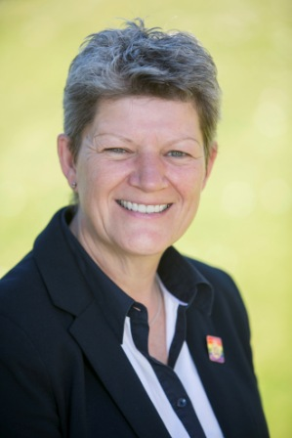
“Tracy is currently the Chief Executive of the Welsh Ambulance Service Trust (WAST) and has worked within the NHS in Wales for over 30 years, in several Board roles including Deputy Chief Executive, Executive Director and National Director in a range of healthcare and government settings.
“Tracy has shown outstanding leadership in her career, particularly in leading WAST through major transformation, and I look forward to working with her in taking ABMU forward.
“Our newly appointed Chief Executive will join us on 1st February 2018. I am sure you will join me in congratulating Tracy and welcoming her to ABMU Health Board.”
Tracy said:

“It is a privilege to be given the opportunity to lead ABMU as its new Chief Executive. I look forward to joining the Health Board and working with colleagues and partners ‎for the benefit of the population served by ABMU. The Welsh Ambulance Service will remain very close to my heart and I'm very grateful for the opportunities it has provided for me in helping prepare me for the role at ABMU.”
Ends

Source: Abertawe Bro Morgannwg University Health Board

