New chapter for hospital worker as first poetry collection is published
Wednesday, 13 December 2017
Seeing your first book published is a thrill for any writer – but for Stephen Banfield it’s an achievement in more ways than one.
The Morriston Hospital biomedical support worker’s first collection of poems, My Thoughts in Rhyme, is now available on Kindle.

Its publication comes four decades after a car crash that still affects father-of-three Stephen today.

“Forty years ago, when I was aged 18, I was involved in a very serious car accident,” explained Stephen, who lives in Gorseinon and works in Morriston’s pathology department.

“I was on a life-support machine. I had brain injuries which affected my balance, my sense of taste and smell. I was in hospital for nearly three months.

“Fortunately I have made a really good recovery and to come from that to having my book published is quite an amazing thing for me. I’m just so pleased and want to share it with people.”

In the foreword to My Thoughts in Rhyme, Stephen dedicates the book to his mum, who sadly passed away before its publication.

The foreword continues: “Also all the brain injured accident victims who believe life has passed them by. Stand up and be strong. I did.”

The collection features 36 poems, which were written over the last two or three years after Stephen rediscovered his interest in verse.

“I can remember when I was a teenager I used to buy pamphlets with song lyrics. I used to read them and study them. It wasn’t poetry but it was about the combination of words.

“I got married and all that got pushed to the background but a few years ago it reappeared. I wrote a poem and it just continued from there.

“I can be walking down the road and an idea will come into my head. Once I get the first line the rest will follow.

“You’ve got to have a good first line because that is what gets the reader interested.”

The 36 poems that appear in the collection were selected from the more than 50 Stephen has penned over the last few years. One of them, Beware Your Soul, (reprinted below) was inspired by his road accident.

Stephen said: “Rather than have the poems sitting on a shelf I thought it was time I put them into a book and let people read them.”

My Thoughts in Rhyme is now available as a Kindle download.

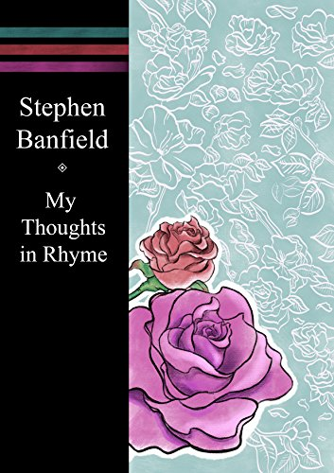
BEWARE YOUR SOUL

We like to think we’re the
Authors of our lives,
The architects of our fate
The paths we take, the decisions
We make are ours to forsake or break

But don’t underestimate your Soul
It plays an important role
He opposes all your
Decisions and thoughts
It will get you to do
What he thinks you ought

Right or wrong, good
Or bad he will get you to comply
For it makes no difference
To him whether you live or die

He will live on forever
This is what is planned
Because the course of your
Life is mapped out,
It is written in the palm of your hand!

Source: Abertawe Bro Morgannwg University Health Board

