Mentors rewarded for dedication to future nurses and midwives
Friday, 1 December 2017
The innovative work going on to support and develop future nursing and midwifery staff has been recognised at a special event.

The 2017 Swansea University, ABMU & Hywel Dda University Health Boards Mentor Presentation and Awards provided an opportunity to celebrate partnership working and excellence in nursing and midwifery mentorship.

Student nurses and midwives nominated mentors who had inspired them during their progression through the nursing and midwifery programmes for five awards.
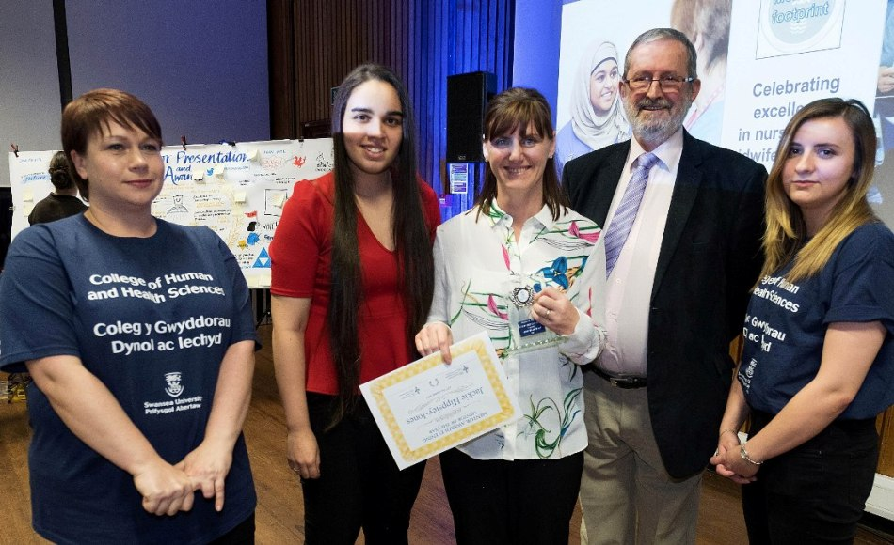
Each category had a recipient from ABMU and Hywel Dda with one being named overall Mentor of the Year. This year that title went to Jackie Hippsley-Jones (centre), of Ward B2, Neath Port Talbot Hospital.

Practice education facilitator lead Simon Cassidy, who is also honorary lecturer at the university, said the nominations revealed the superb creativity and innovation behind student learning and assessment that goes on everyday but is not always available to outsider view.

The importance of gate-keeping the profession and the infrastructure required to ensure consistency and continuity of the future nursing and midwifery workforce was a major theme of Chief Nursing Officer for Wales Professor Jean White’s address.

These themes were echoed by Associate Professor Jayne Cutter, head of the Department of Nursing, Dr Sarah Norris, head of Department of Midwifery, Professor Ceri Phillips, head of the College of Human and Health Sciences and Stephen Griffiths, Wales Workforce Education Development Service Director.

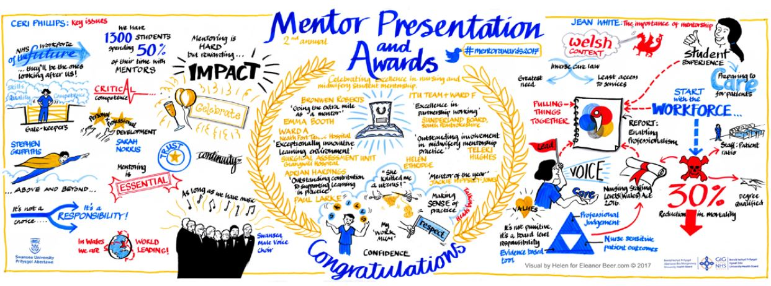
The importance of mentorship was captured in film of service users, students, nurses, midwives and practice educators where they shared their passion and commitment to practice education.

Simon Cassidy said: “As each of the nominations was read out, the extraordinary efforts of mentors in supporting, nurturing and educating students became apparent.

“The pride each of them took in their role and the esteem in which they held the nursing and midwifery professions was clearly evident. For those in the audience, listening to the testimonials from students was both inspiring and humbling.”

The event began with an uplifting recital by Swansea Male Choir and a graphic artist was on hand to create an evolving pictorial record (pictured above) detailing mentors’ support of nursing and midwifery students in practice.

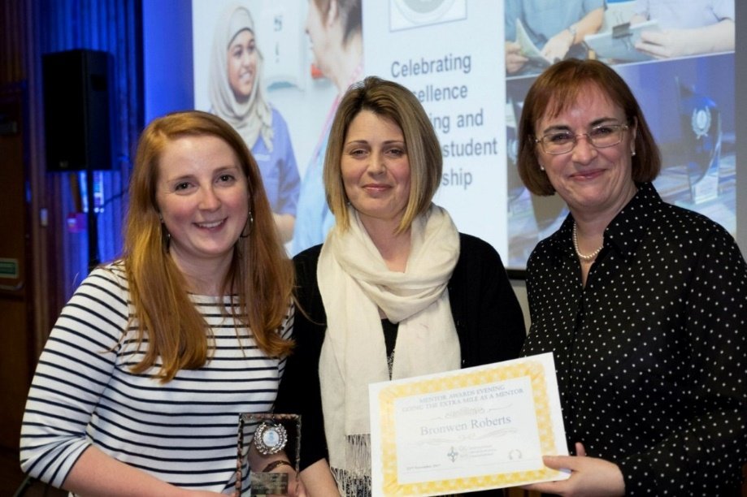
Simon added: “The evening was a resounding success and thanks go to all those involved.”

The other ABMU award recipients were:

Going the Extra Mile as a Mentor
Bronwen Roberts, Ward 19, Singleton Hospital (left)

Outstanding Contribution to Support Learning in Practice
Adrian Hardinges, Ty Olwen/Y Bwthyn Newydd (below, top left)

Exceptionally Innovative Learning Environment
Ward A, Neath Port Talbot Hospital (below, top right)

Outstanding Involvement in Midwifery Mentorship Practice
Helen Etheridge, Singleton Hospital Labour Ward (below, bottom, left)
Excellence in Partnership Working
Ward F Team, Neath Port Talbot Hospital and ITU, Morriston Hospital (joint winners - below, bottom right)

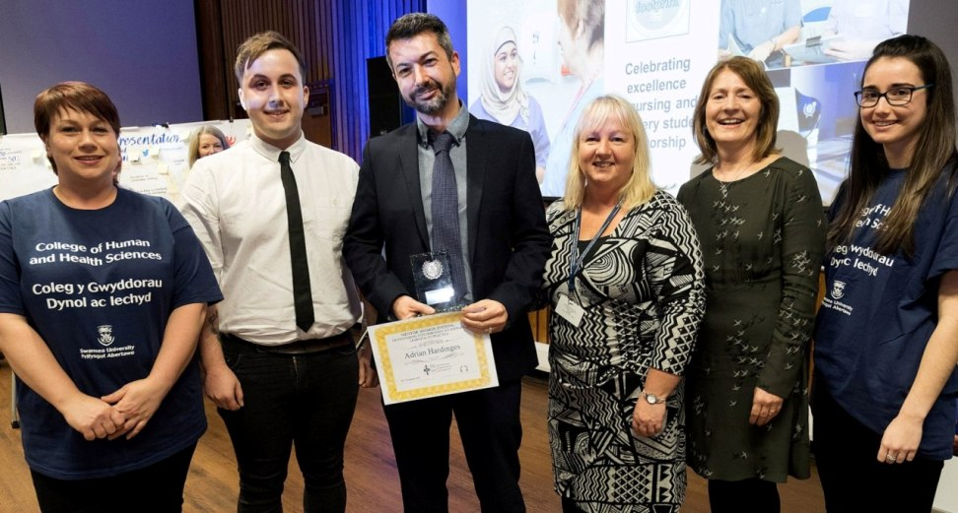 | 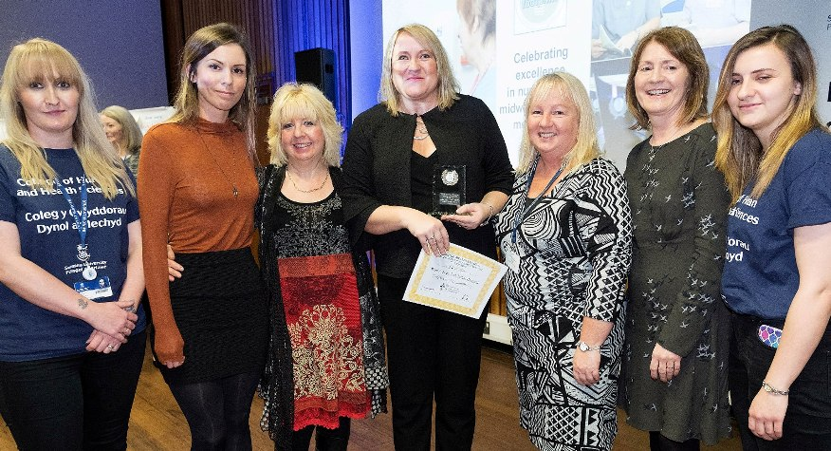
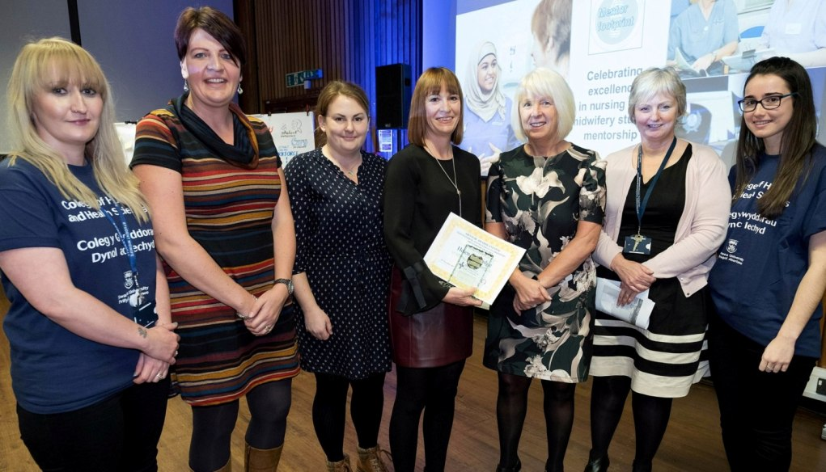 | 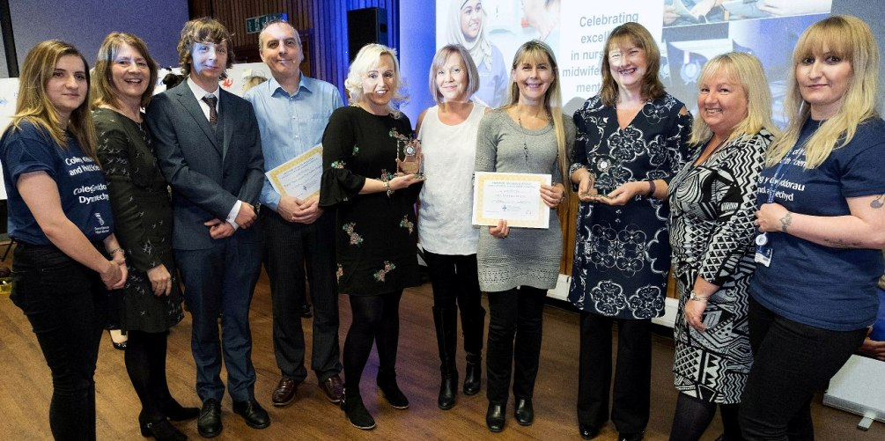

To view pictures of the evening please visit https://flic.kr/s/aHsks9nbE1

Source: Abertawe Bro Morgannwg University Health Board

